Washington Commanders
August 19, 2022
Location of Dental Clinic: FedEx Field
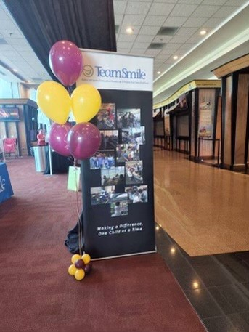
Health Fair
89 Children Served
98 Children Educated

Total Preventative Care & Education Provided $24,822
Average Dental Care & Oral Health Education per patient visiting Program $229.34
Sponsored by:
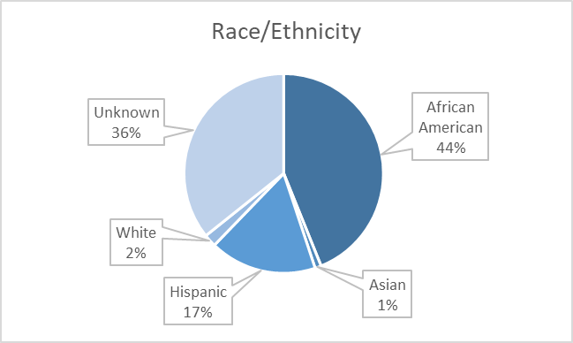
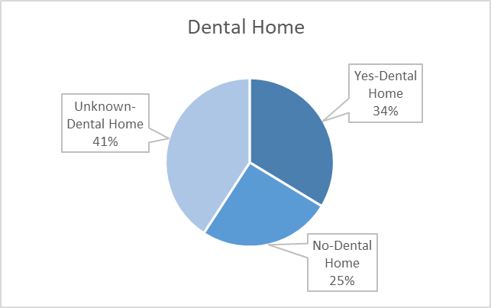
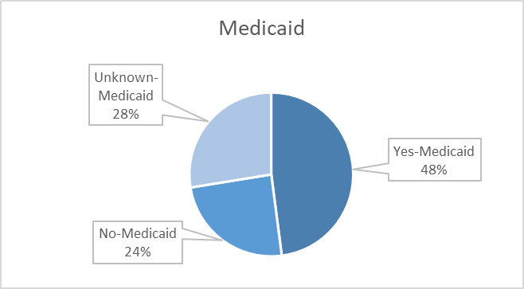
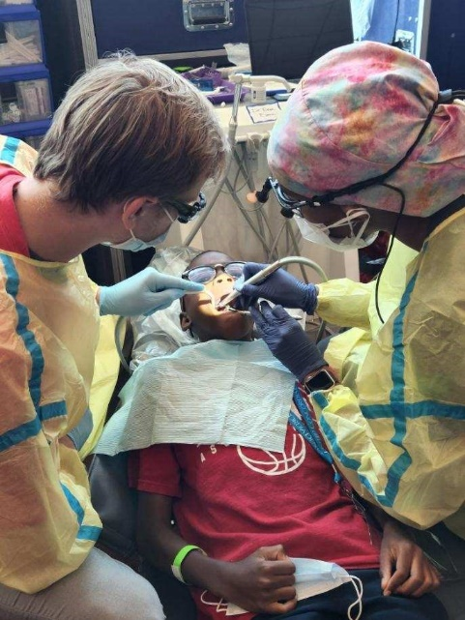
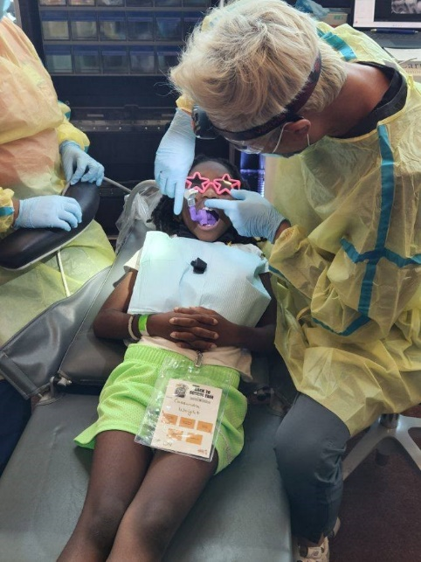
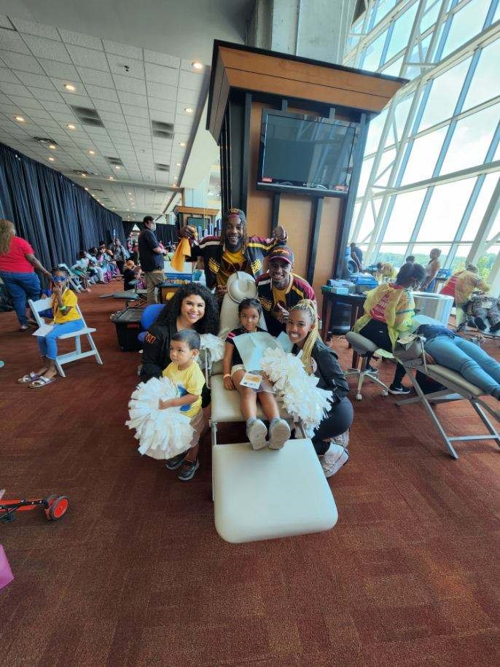
Volunteers
Thank you to our volunteers for your time and talents.
Dentists | 10 | 4
Hygienists | 3 | 2
Dental Assistants | 8 | 6
Dental School Students | 20 | 11
General Volunteers | 27 | 27
Total Volunteers | 68 | 50

Signed up Attended
74% Of the volunteers that signed up through our website attended the event.
Screenings | 88
X-Rays | 12
Prophy Cleanings | 71
Fluoride Varnish | 69
Sealants | 12
Fillings | 4
Extractions | 9
Silver diamine fluoride | 24
Oral Health Education | 98

Services

Total Value: $24,822
Dental Services: $20,412
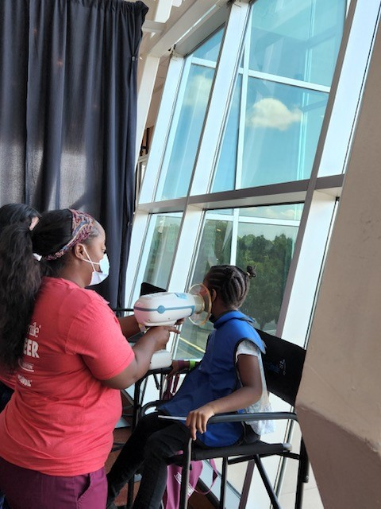
Education: $4,410

