Utah Jazz
April 4, 2022
Location of Dental Clinic: West Jordan Middle School
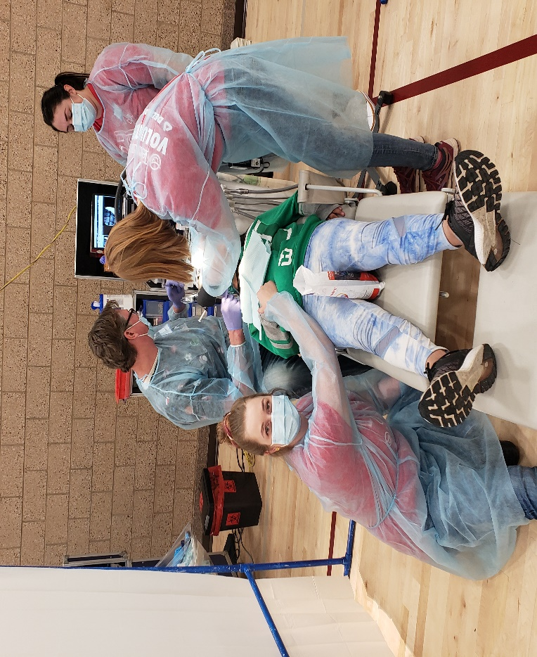
Jordan District Schools
Helping 143 kids

Total Preventative Care & Education Provided $73,759
Average Dental Care & Oral Health Education per patient visiting Program $370

Sponsored by :
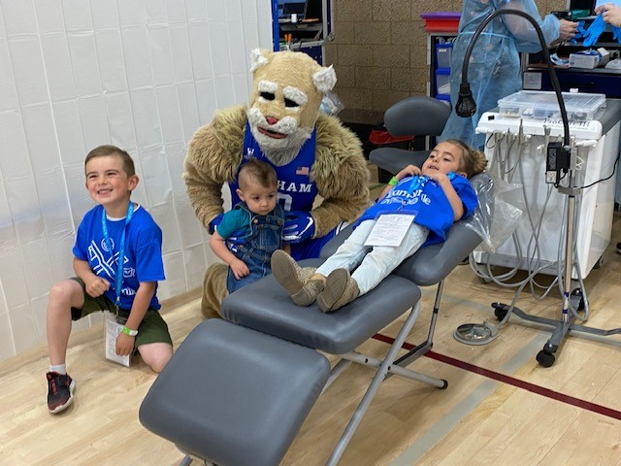
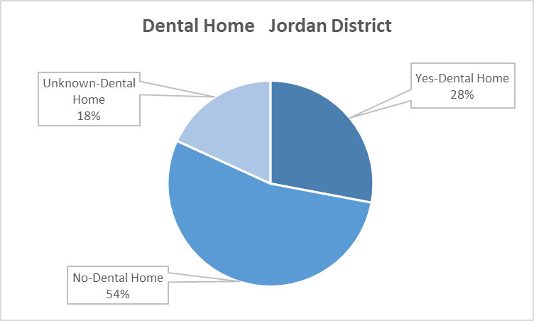
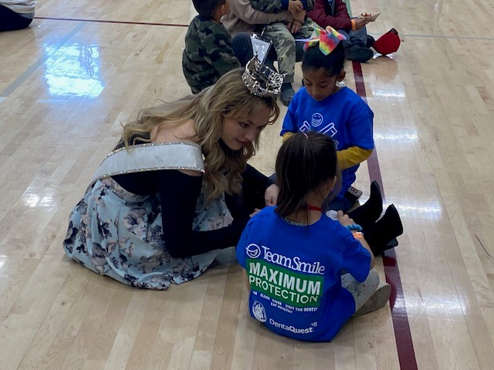
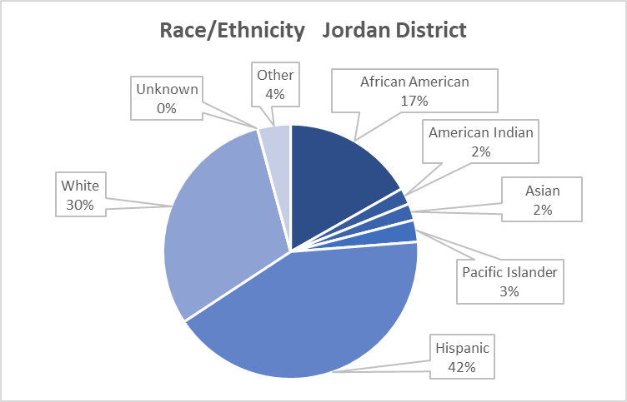

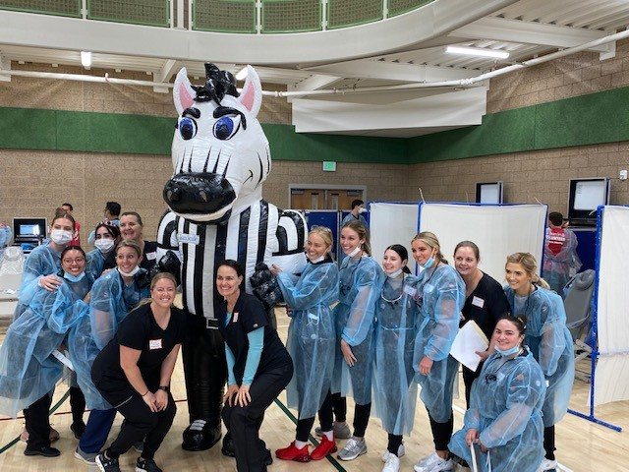
Volunteers
Thank you to our volunteers, for your time and talents.
Dentists | 3 | 3
Hygienists | 3 | 3
Dental Assistants | 17 | 12
Dental School Students | 29 | 22
General Volunteers | 62 | 45
Total Volunteers | 114 | 85

Signed up Attended
75% Of the volunteers that signed up through our website attended the event.
Screenings | 143
X-Rays | 74
Prophy Cleanings | 143
Fluoride Varnish | 140
Sealants | 32
Fillings | 98
Extractions | 24
Silver Diamine Fluoride | 94
Oral Health Education | 143
Services
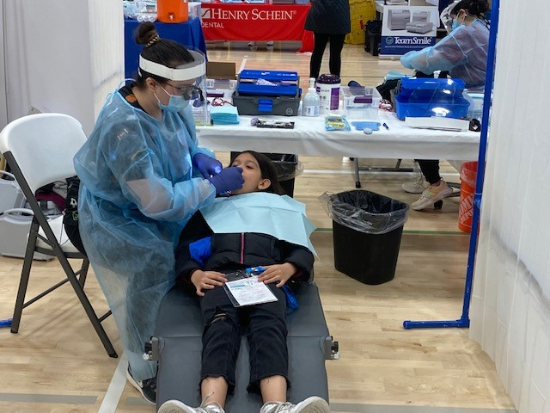

Total Value: $73,759

Dental Services: $67,324
Education: $6,435

