Tampa Bay Rays
September 29, 2023
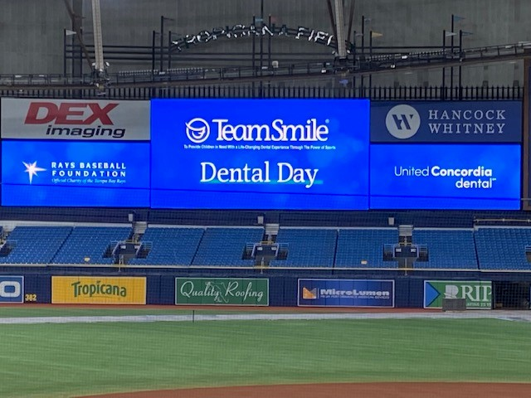
Location of Dental Clinic: Tropicana Field

100 Children Served
108 Children Educated
Total Dental Care and Oral Health Education Provided $45,146
Average Dental Care & Oral Health Education per patient visiting Program $418.01

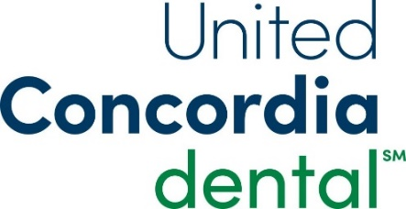
Sponsored by:
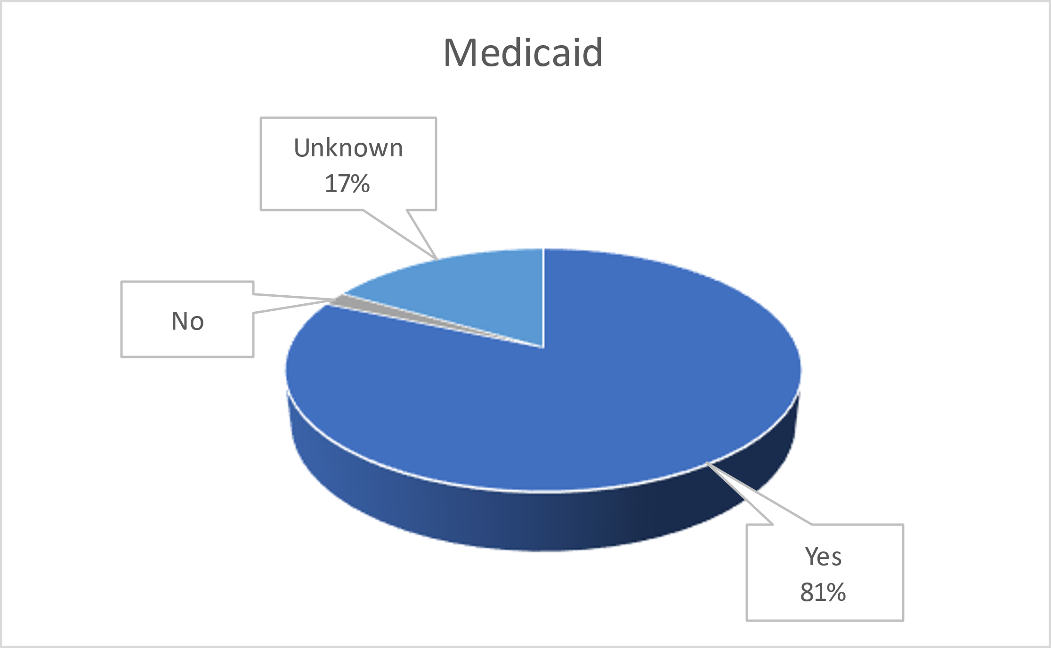
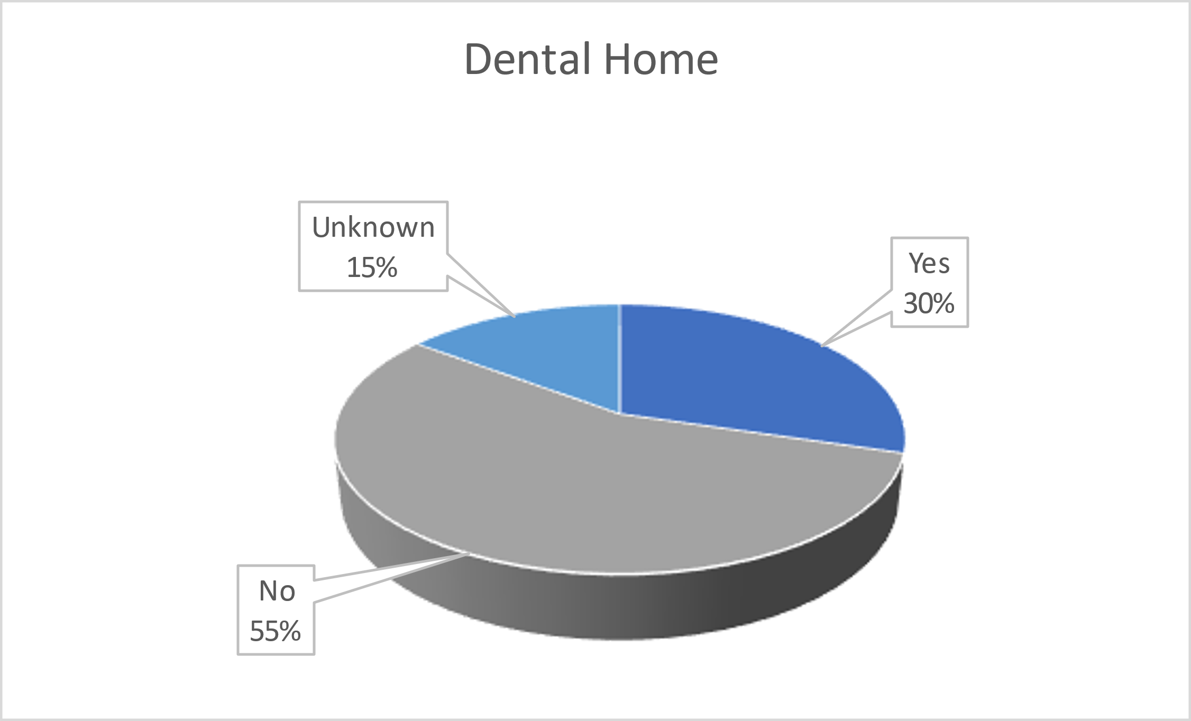
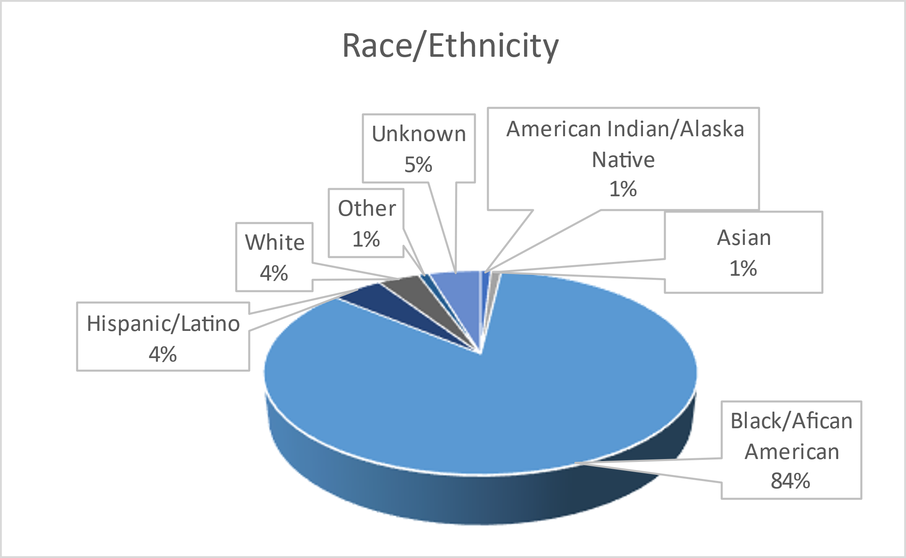
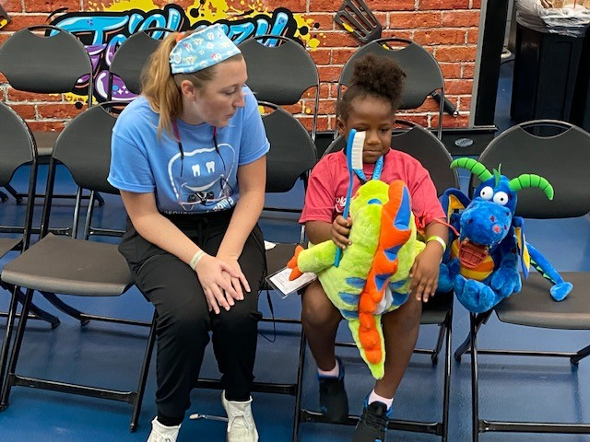
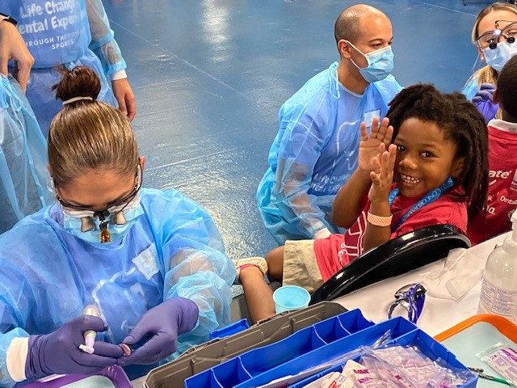
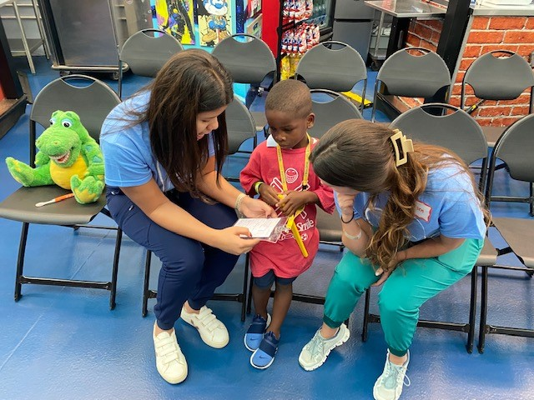
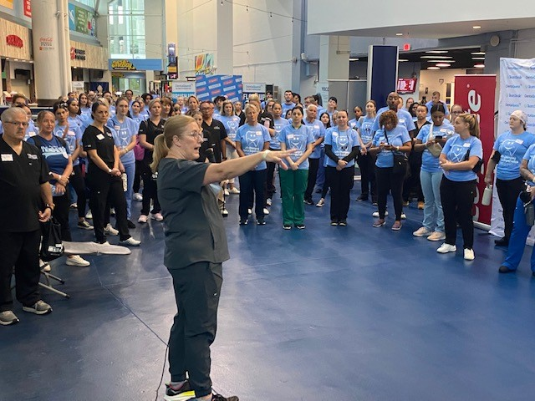
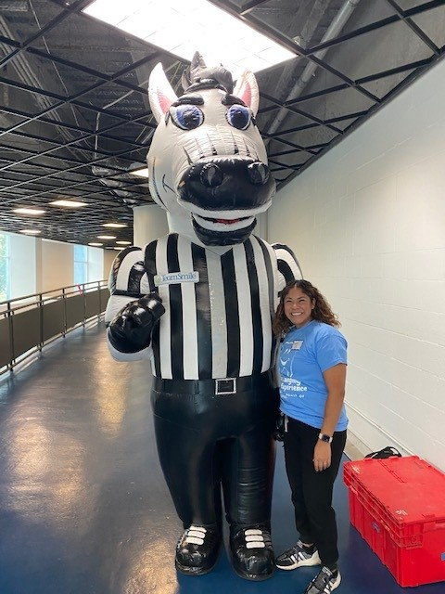
Volunteers
Thank you to our volunteers for your time and talents.
Dentists | 22 | 13
Hygienists | 24 | 21
Dental Assistants | 19 | 12
Dental School Students | 25 | 22
General Volunteers | 79 | 59
Total Volunteers | 169 | 127

Signed up Attended
75% Of the volunteers that signed up through our website attended the event.

Services

Screenings | 100
X-Rays | 102
Prophy Cleanings | 96
Fluoride Varnish | 96
Sealants | 103
Fillings | 16
Extractions | 16
Silver diamine fluoride | 20
Pulpotomy | 1
Oral Health Education | 108
Total Value: $45,146
Dental Services: $40,286
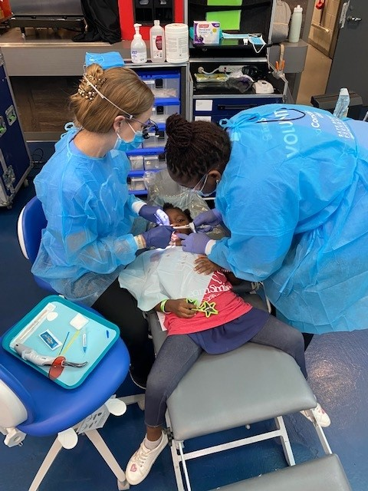
Education: $4,860

