Tampa Bay Rays
April 29, 2022
Location of Dental Clinic: John Hopkins Middle School

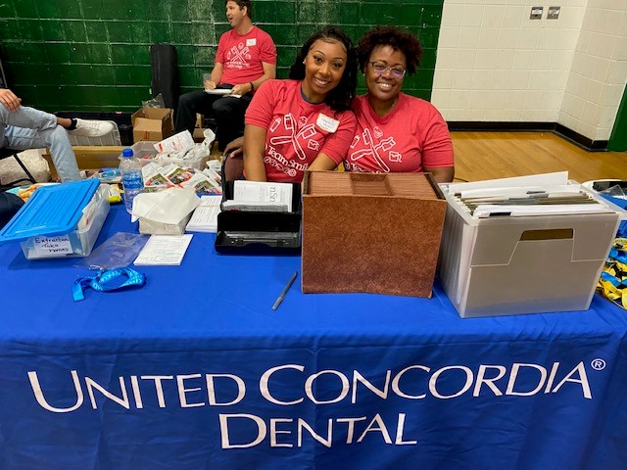
John Hopkins Middle School
Campbell Park Elementary
Helping 141 Children

Total Preventative Care & Education Provided $52,365
Average Dental Care & Oral Health Education per patient visiting Program $370

Sponsored by: 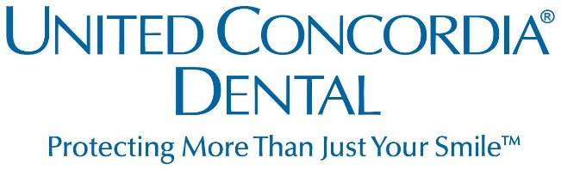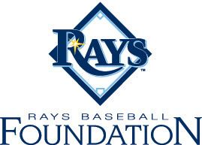
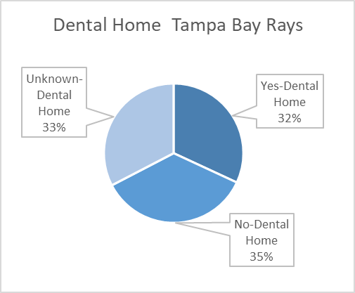
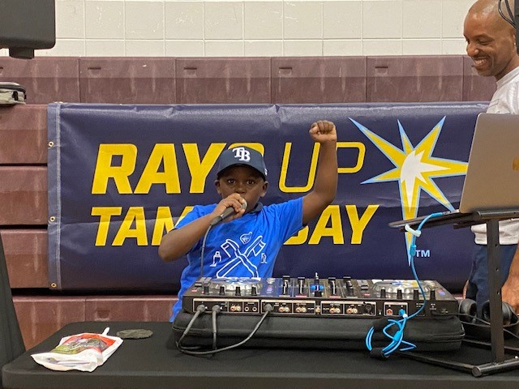
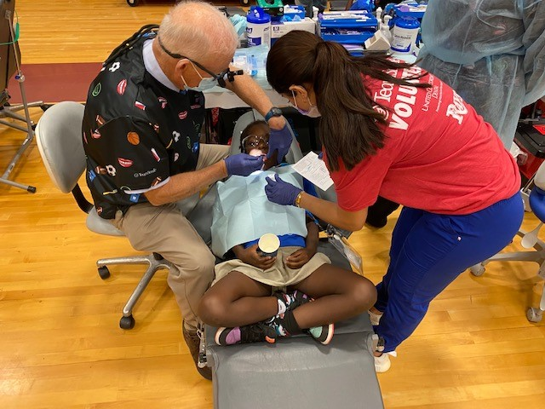
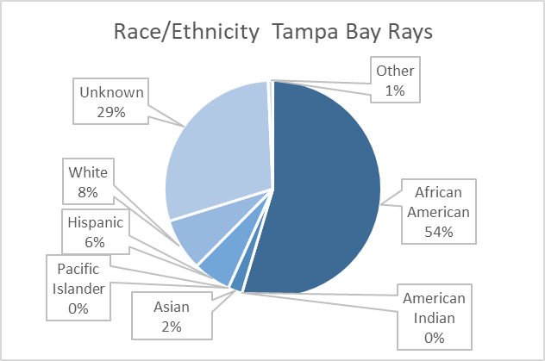

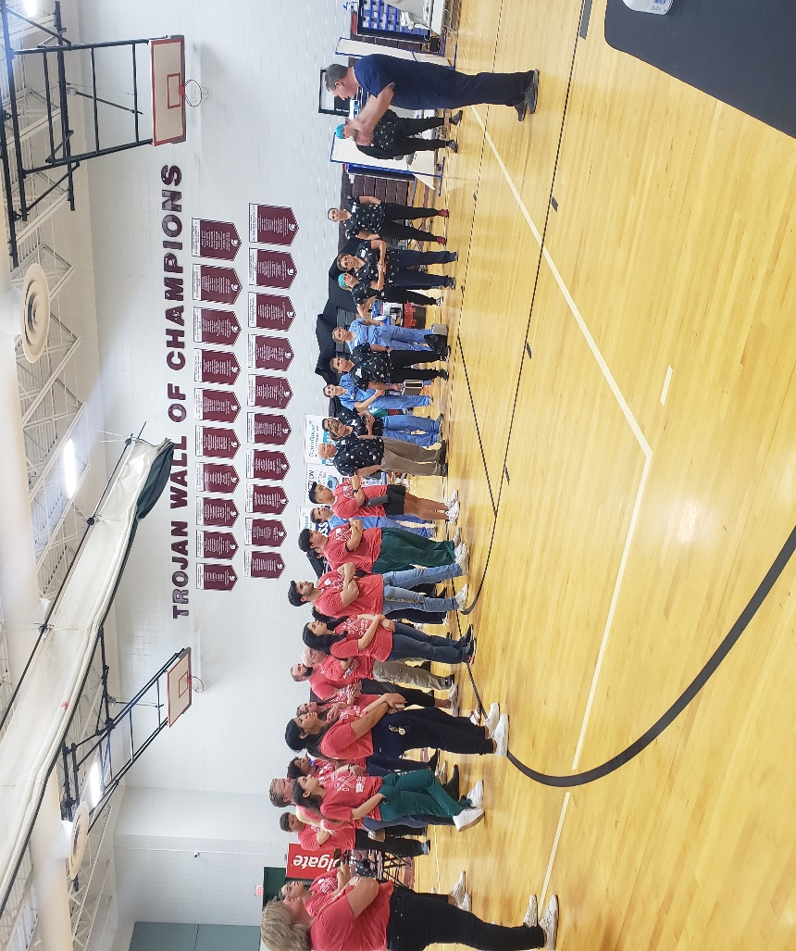
Volunteers
Thank you to our volunteers, for your time and talents.
Dentists | 11 | 7
Hygienists | 9 | 8
Dental Assistants | 14 | 7
Dental School Students | 13 | 5
General Volunteers | 53 | 33
Total Volunteers | 100 | 60

Signed up Attended
60% Of the volunteers that signed up through our website attended the event.
Screenings | 141
X-Rays | 79
Prophy Cleanings | 141
Fluoride Varnish | 135
Sealants | 0
Fillings | 15
Extractions | 32
Silver Diamine Fluoride | 183
Oral Health Education | 157
Services

Total Value: $52,365

Dental Services: $45,300
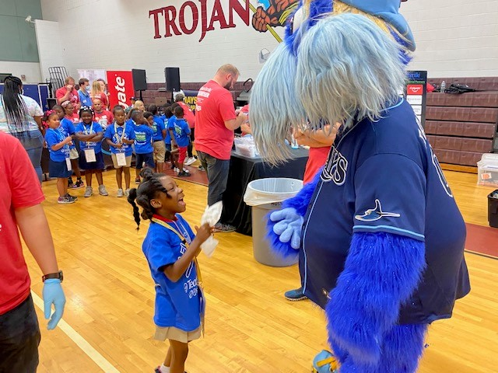
Education: $7,065

