Tampa Bay Buccaneers Program
July 29, 2023
Location of Dental Clinic: Raymond James Stadium
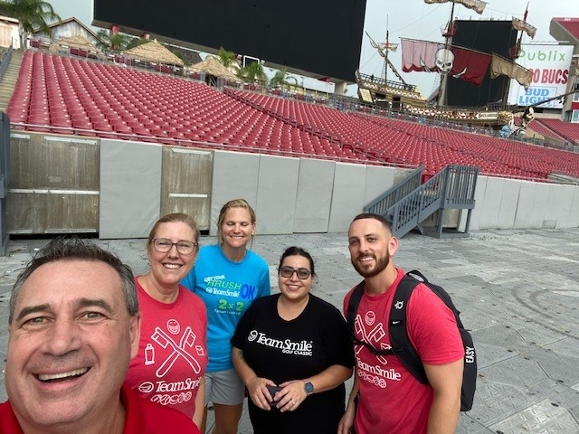

106 Children Served
109 Children Educated

Total Preventative Care & Education Provided $53,919
Average Dental Care & Oral Health Education per patient visiting Program $494.66
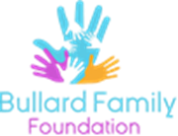
Sponsored by:
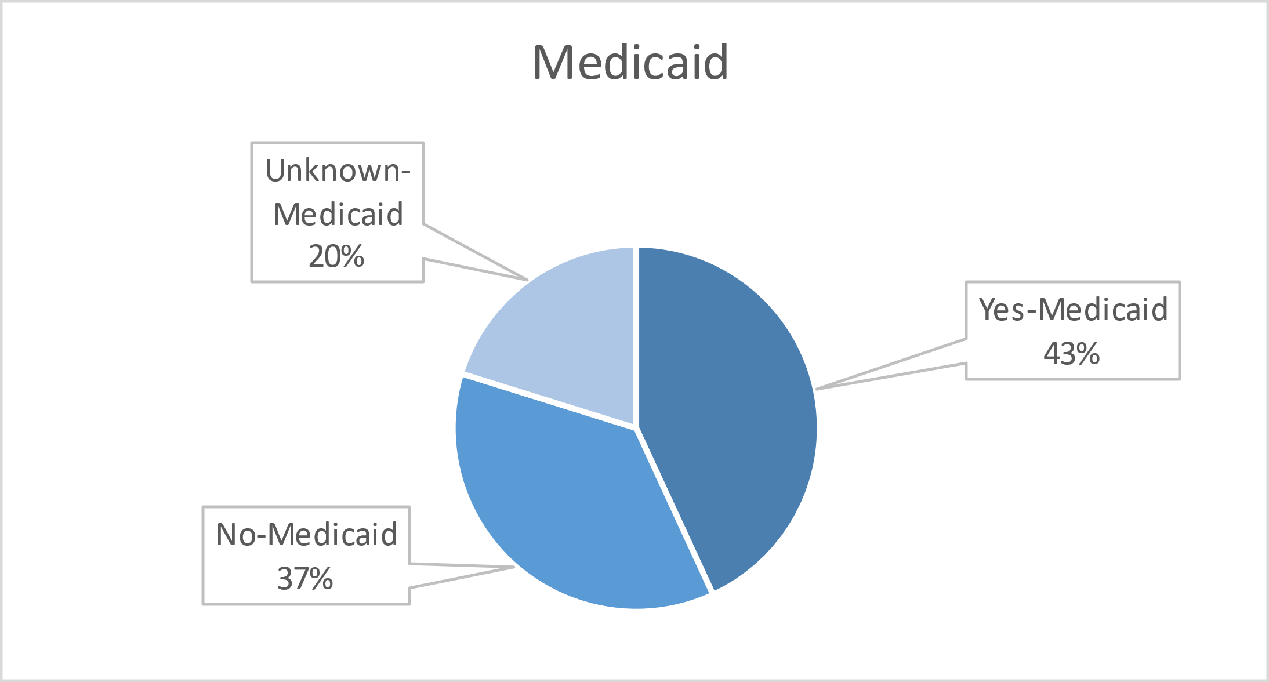
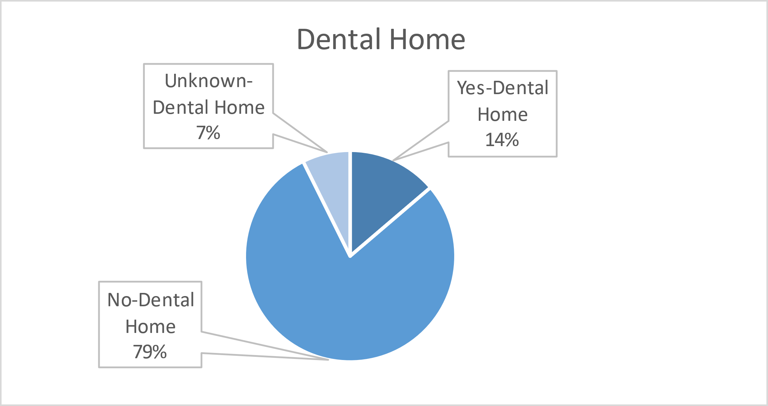
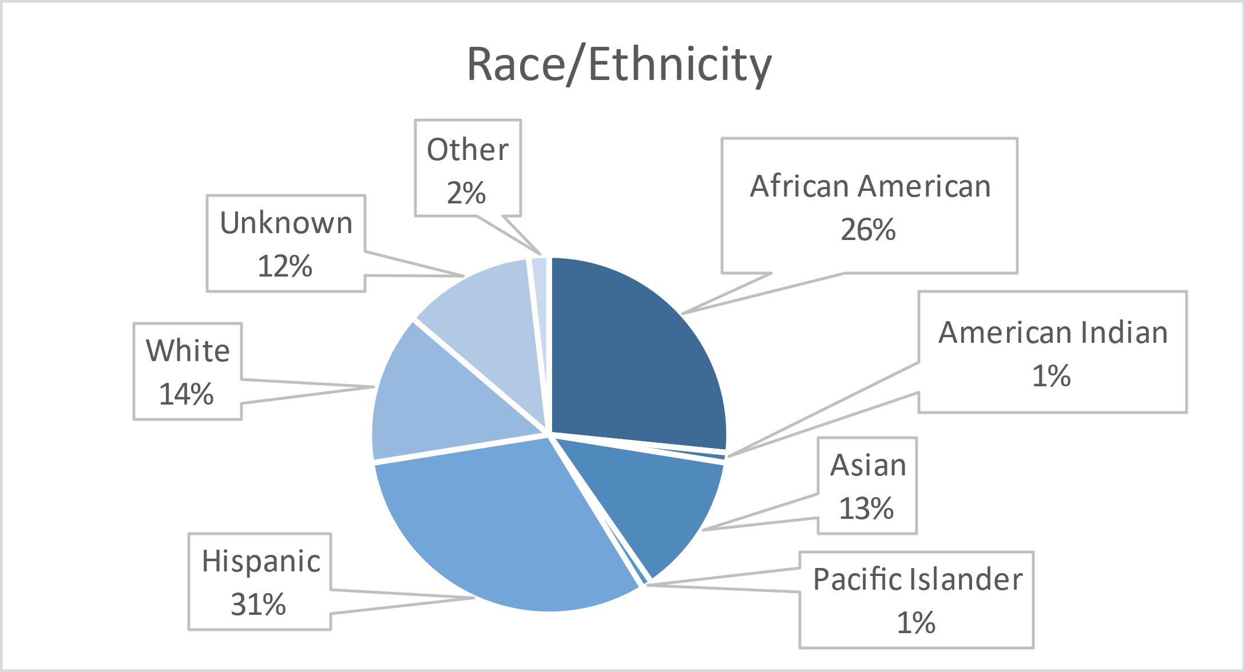
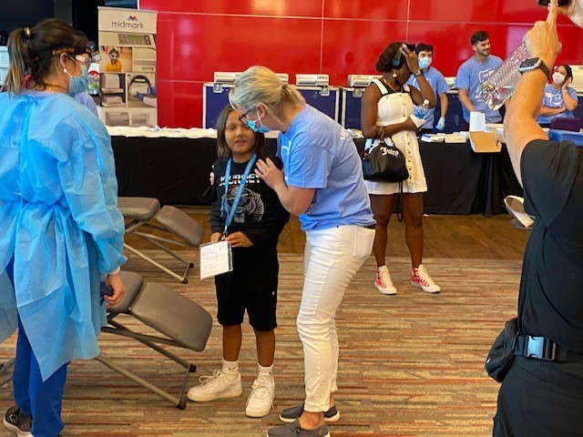
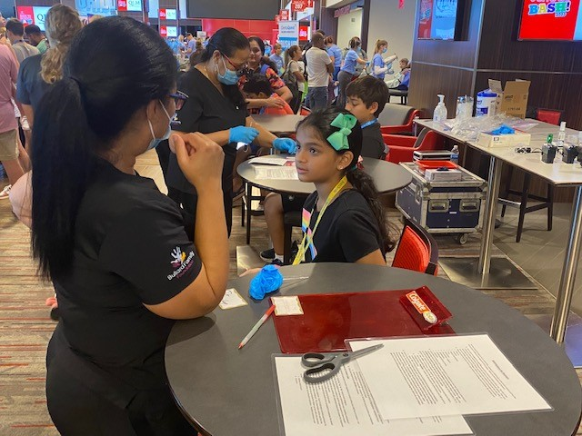
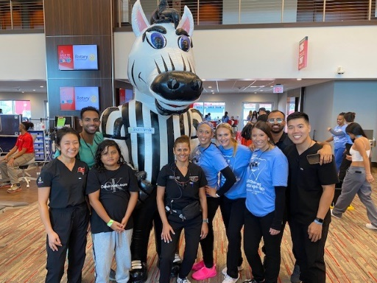
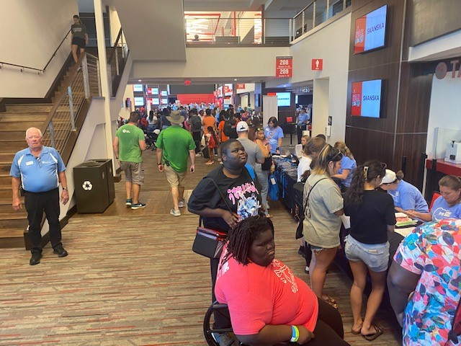
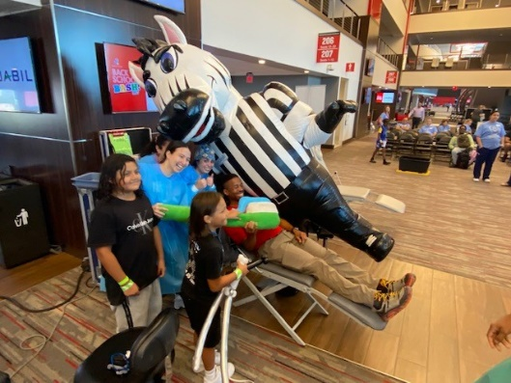
Volunteers
Thank you to our volunteers for your time and talents.
Dentists | 18 | 17
Hygienists | 20 | 14
Dental Assistants | 18 | 9
Dental Students | 25 | 21
General Volunteers | 55 | 36
Total Volunteers | 136 | 97

Signed up Attended
68% Of the volunteers that signed up through our website attended the event.

Services

Screenings | 106
X-Rays | 234
Prophy Cleanings | 73
Fluoride Varnish | 58
Sealants | 167
Fillings | 30
Extractions | 15
Silver diamine fluoride | 6
Oral Health Education | 109
Total Value: $53,919
Dental Services: $49,824
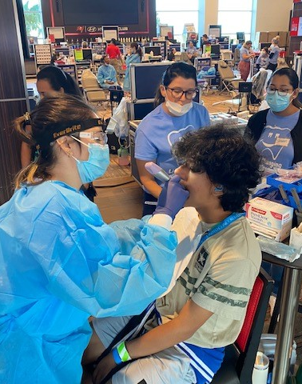
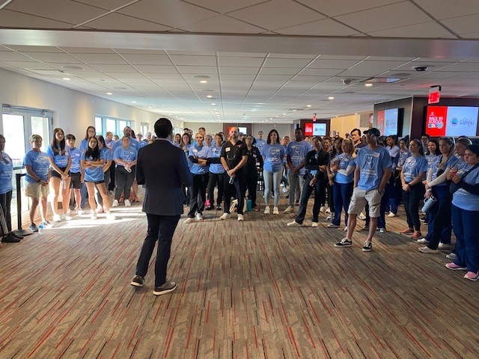
Education: $4,905

