Tampa Bay Buccaneers
August 6, 2022
Location of Dental Clinic: Raymond James Field
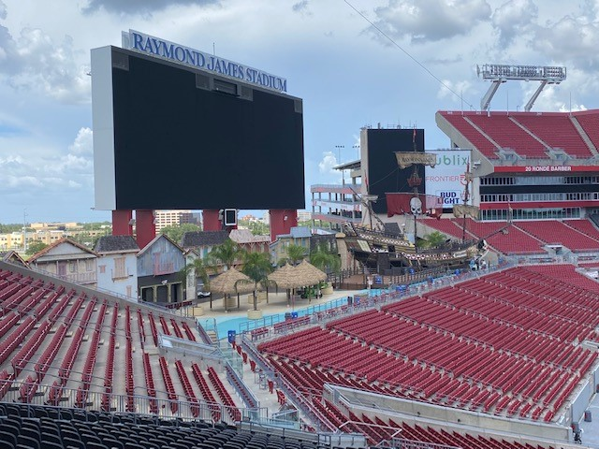
Health Fair
222 Children Served
236 Children Educated

Total Preventative Care & Education Provided $64,711
Average Dental Care & Oral Health Education per patient visiting Program $229.19
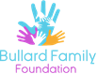
Sponsored by:
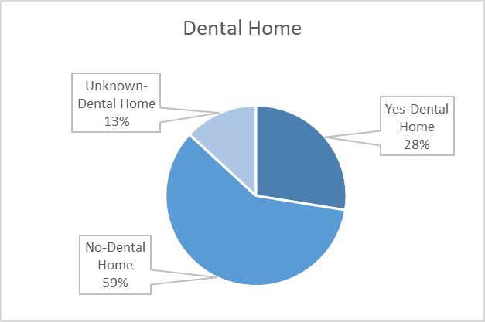
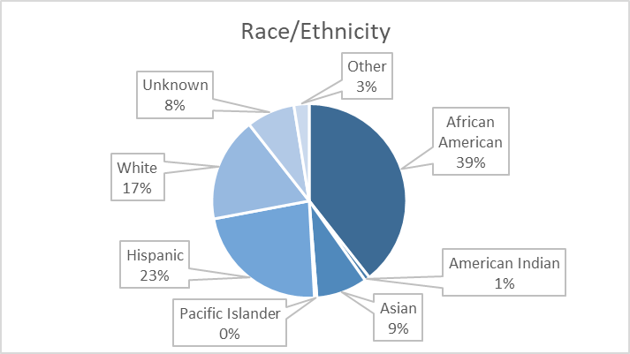
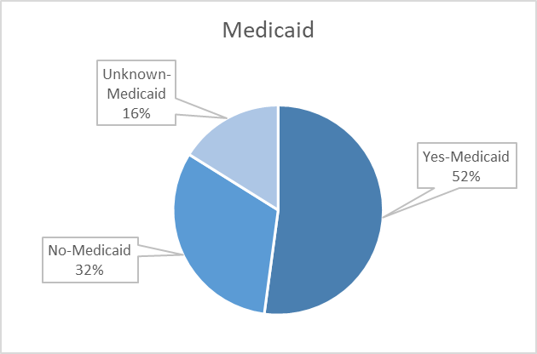
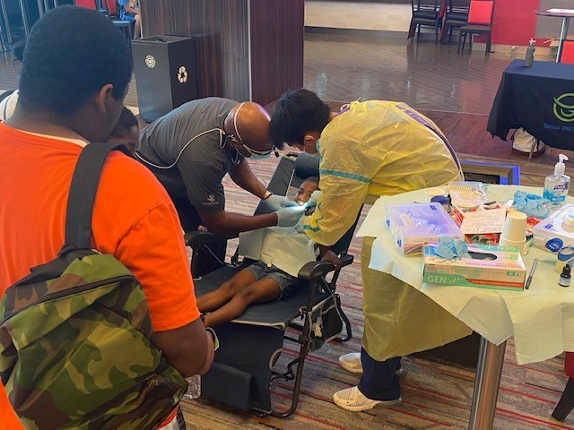
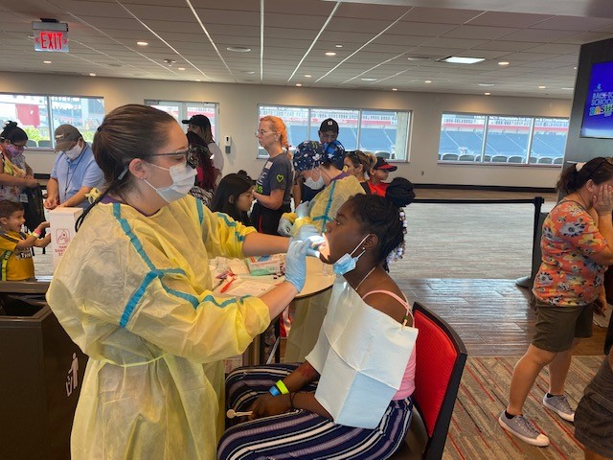
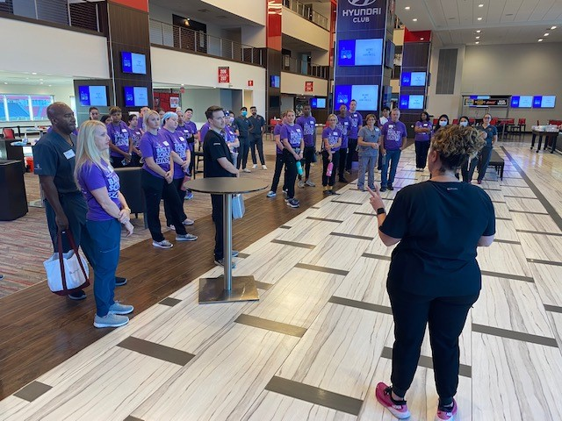
Volunteers
Thank you to our volunteers for your time and talents.
Dentists | 6 | 6
Hygienists | 16 | 13
Dental Assistants | 5 | 3
Dental School Students | 17 | 11
General Volunteers | 13 | 9
Total Volunteers | 57 | 42

Signed up Attended
74% Of the volunteers that signed up through our website attended the event.

Services
Screenings | 236
Silver diamine fluoride | 315
Prophy Cleanings | 216
Education | 236

Total Value: $64,711
Dental Services: $54,091
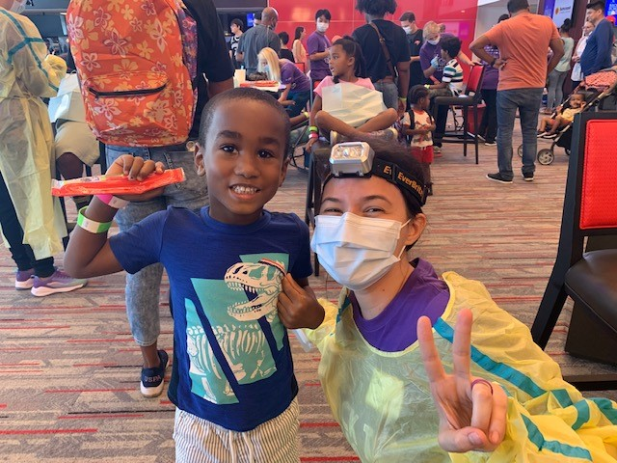
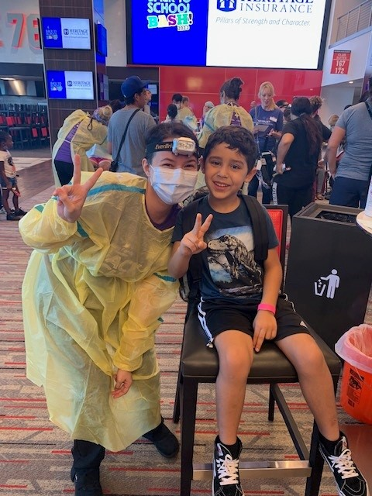
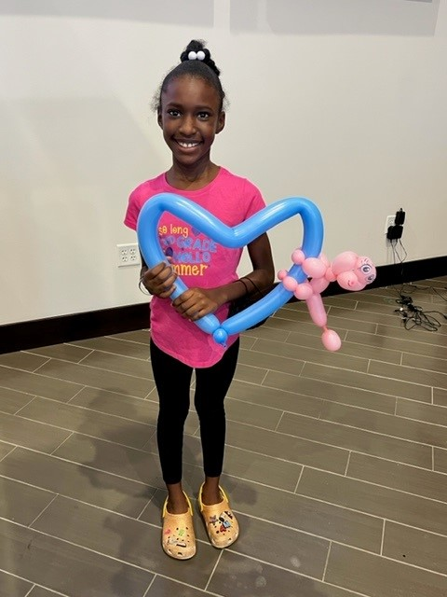
Education: $10,620

