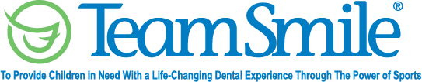
Philadelphia Eagles
July 18, 2023
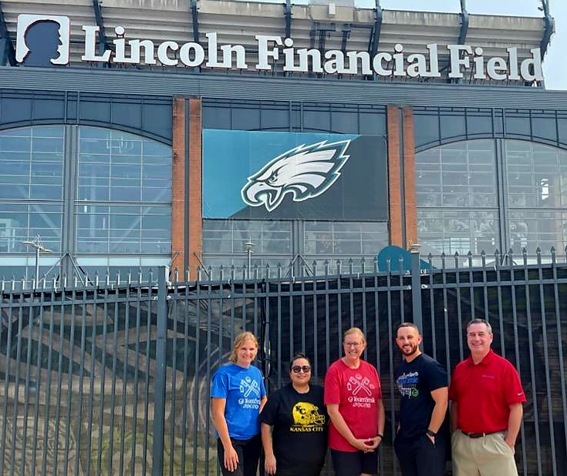
Location of Dental Clinic: Lincoln Financial Field

25 Children Served
26 Children Educated

Total Preventative Care & Education Provided $15,716
Average Dental Care & Oral Health Education per patient visiting Program $604.46
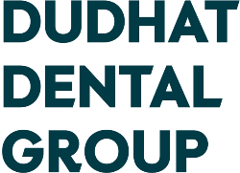
Sponsored by:
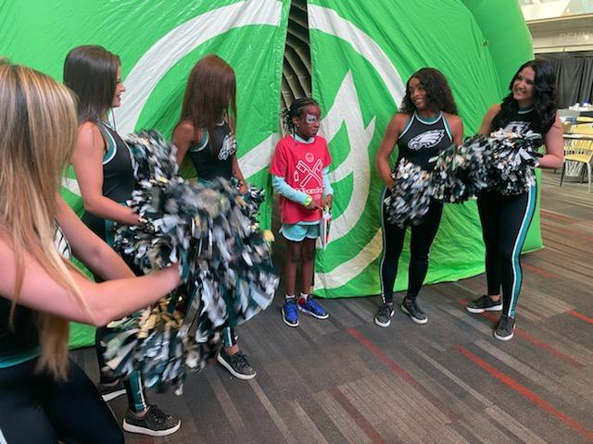
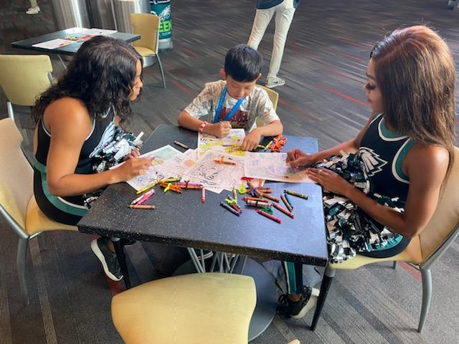
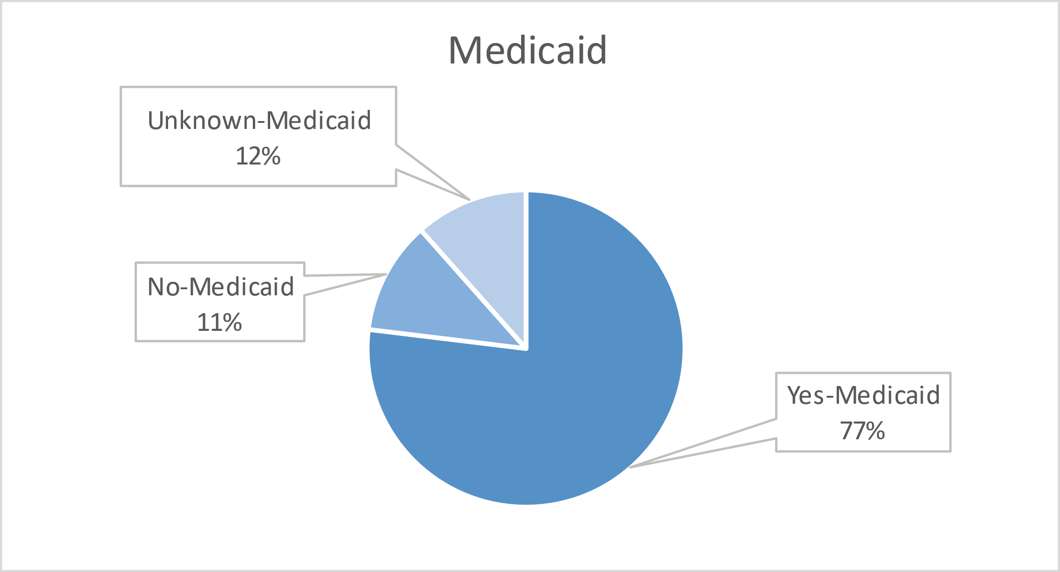
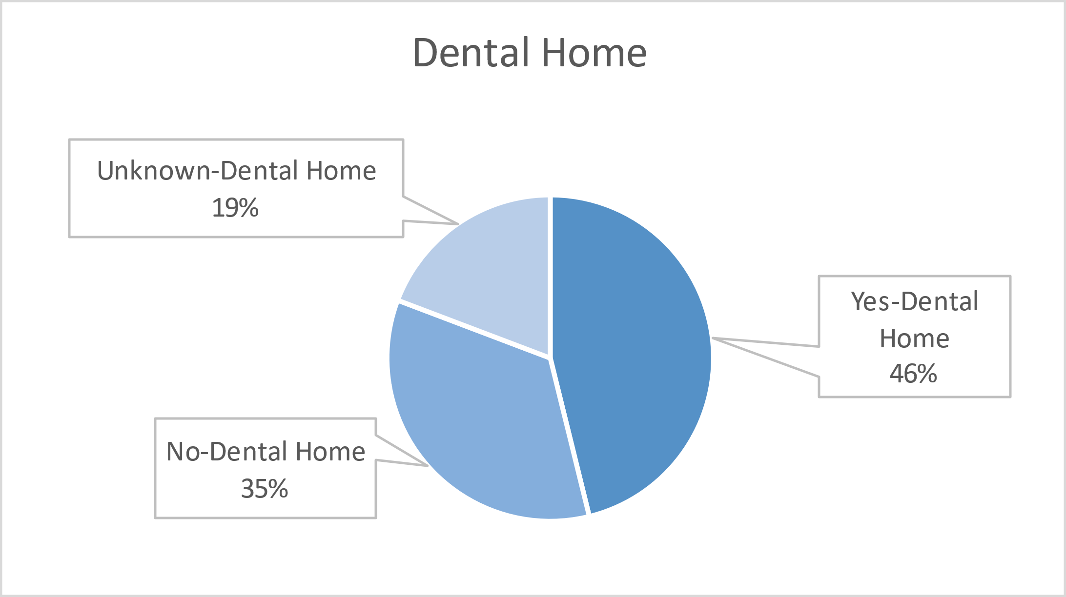
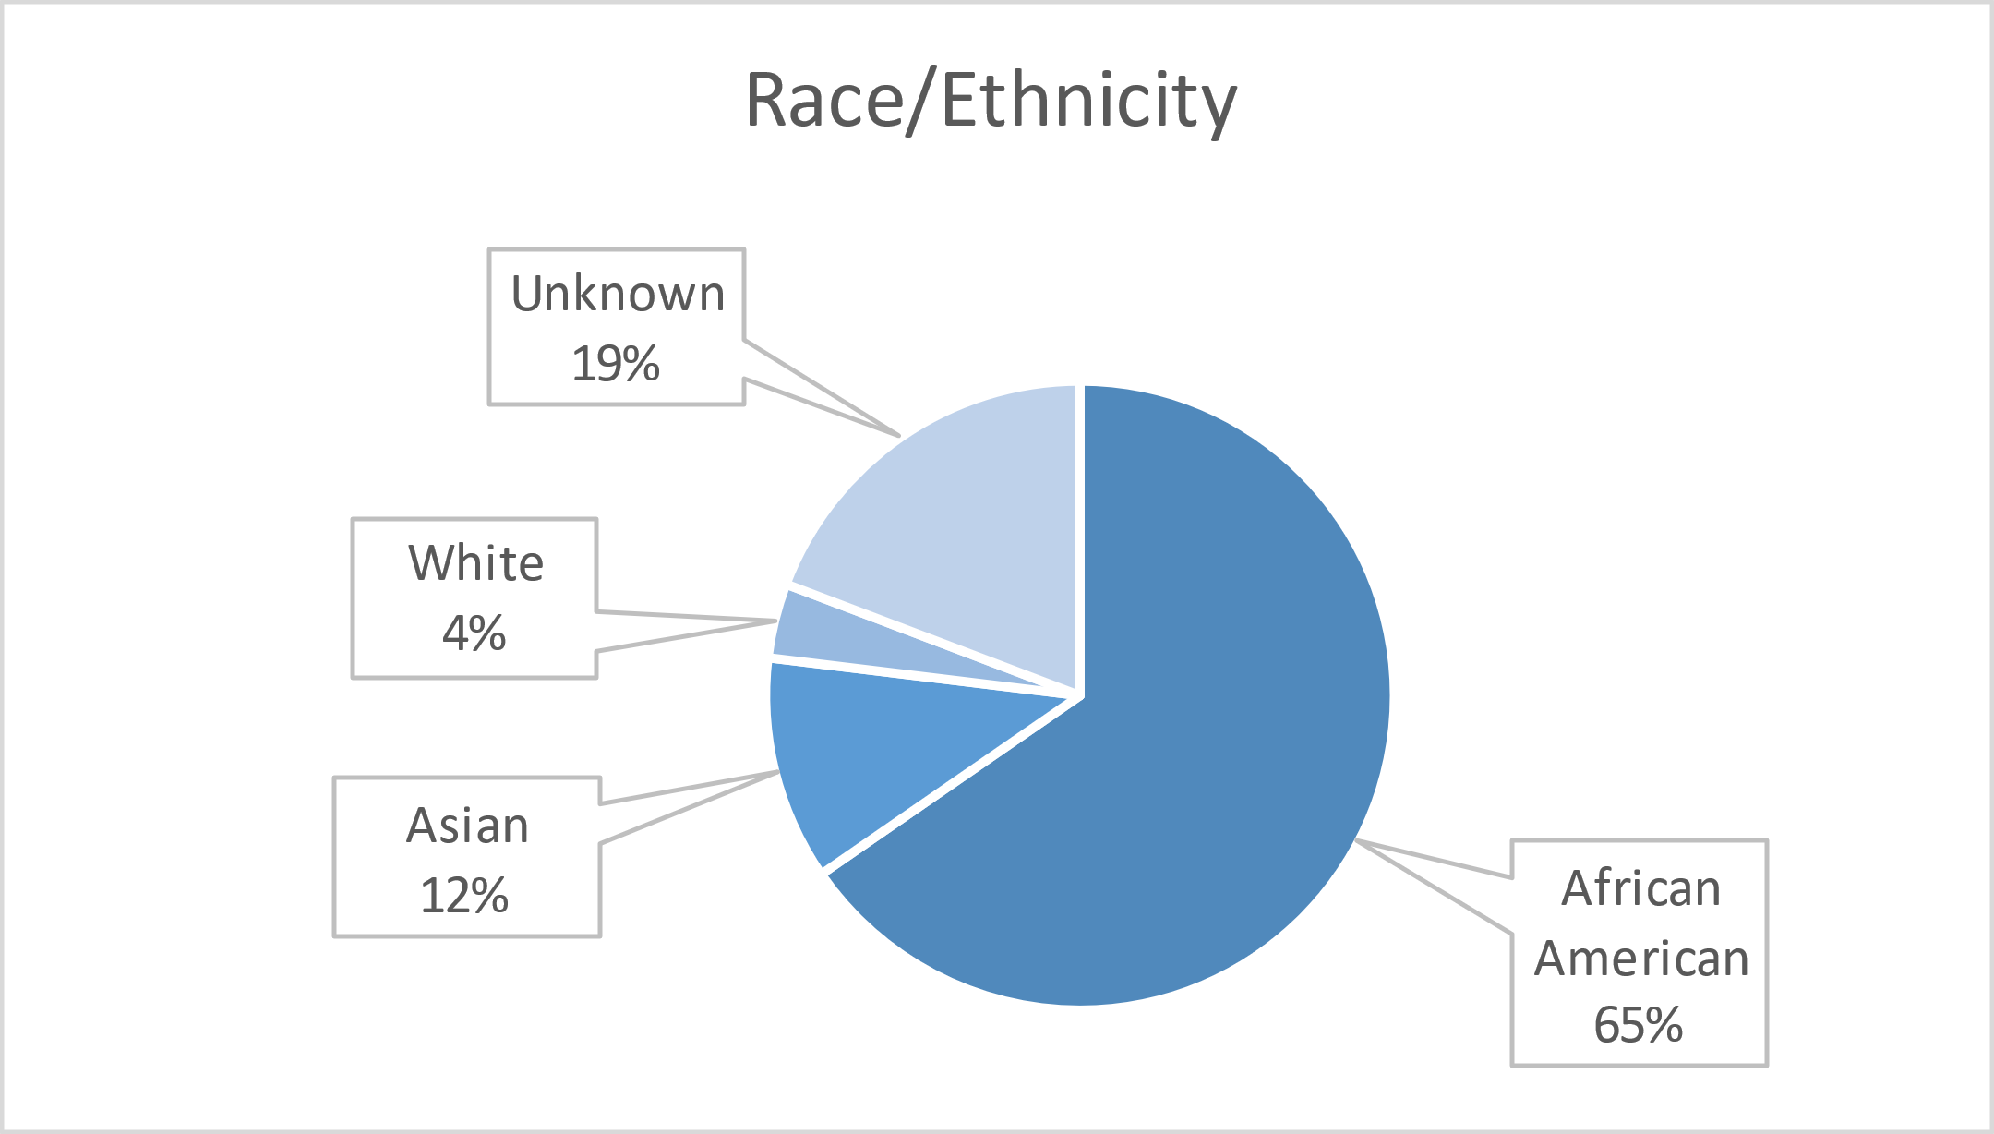

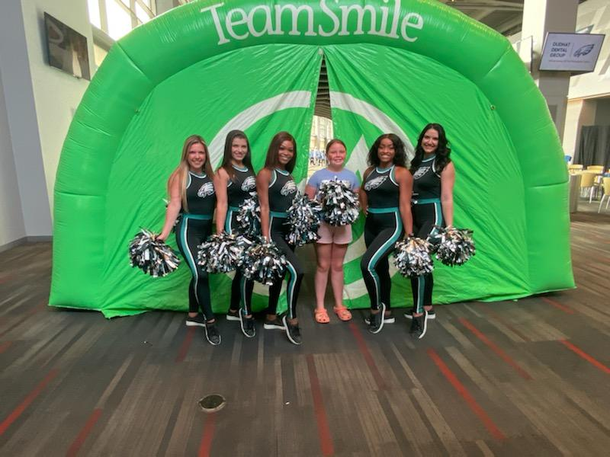
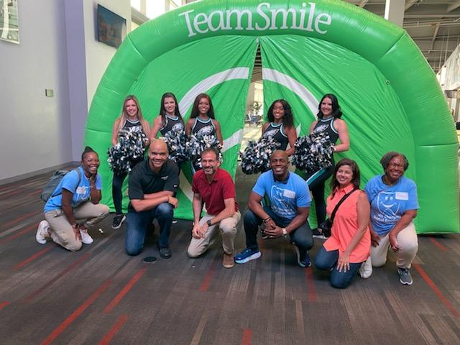
Volunteers
Thank you to our volunteers for your time and talents.
Dentists | 13 | 11
Hygienists | 17 | 15
Dental Assistants | 18 | 13
General Volunteers | 96 | 87
Total Volunteers | 144 | 126

Signed up Attended
88% Of the volunteers that signed up through our website attended the event.

Services

Screenings | 25
X-Rays | 36
Prophy Cleanings | 16
Fluoride Varnish | 15
Sealants | 43
Fillings | 22
Extractions | 3
Silver diamine fluoride | 3
Oral Health Education | 26
Total Value: $15,716
Dental Services: $14,546
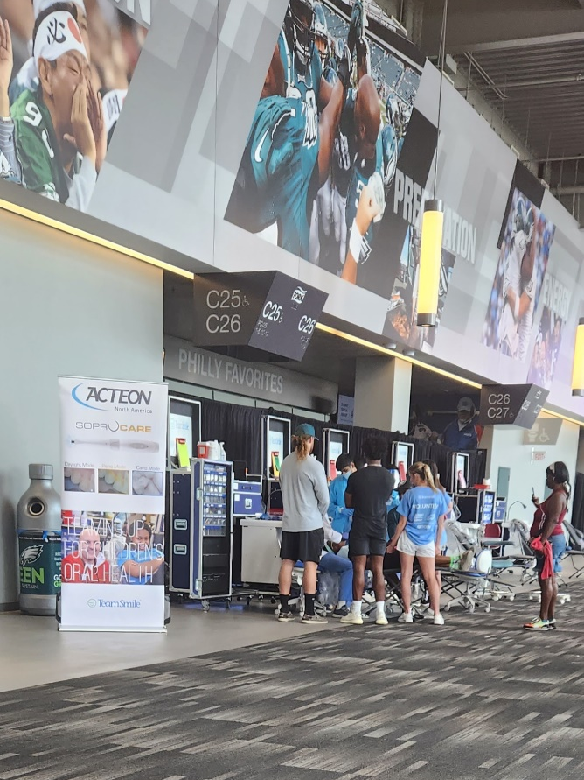
Education: $1,170

