North Carolina Panthers
November 29, 2022
Location of Dental Clinic : Bank of America Stadium
186 children served
186 children educated

Total Preventative Care & Education Provided $77,205
Average dental care provided for each patient in the dental clinic $370.08
Sponsored by:
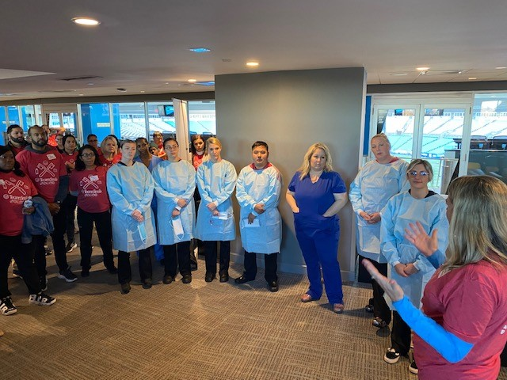
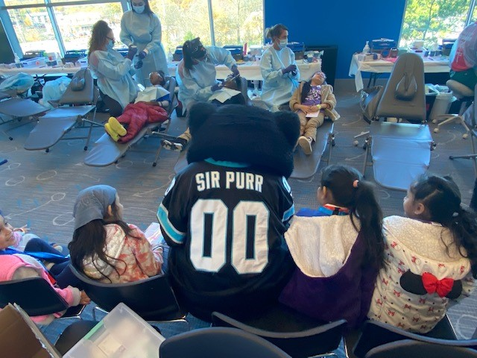
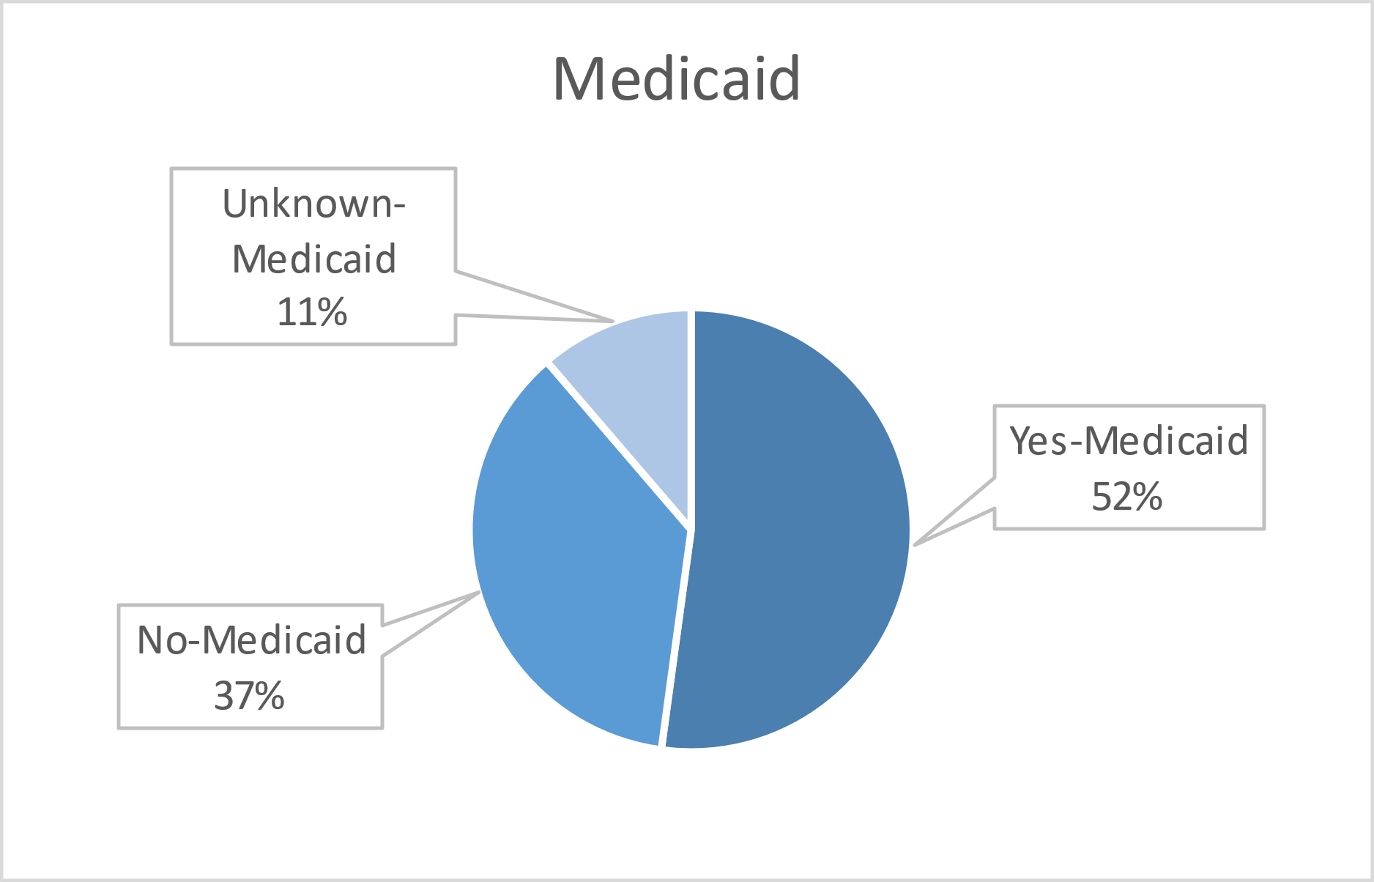
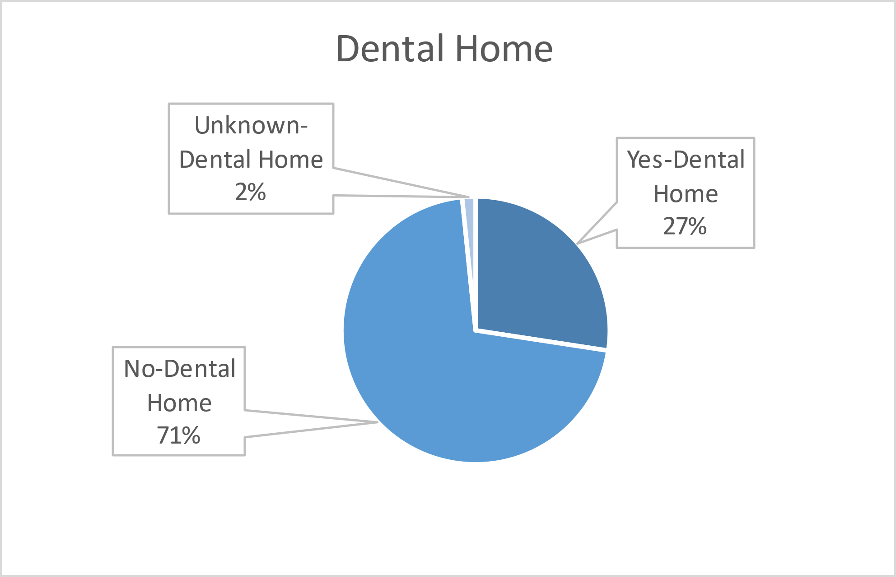
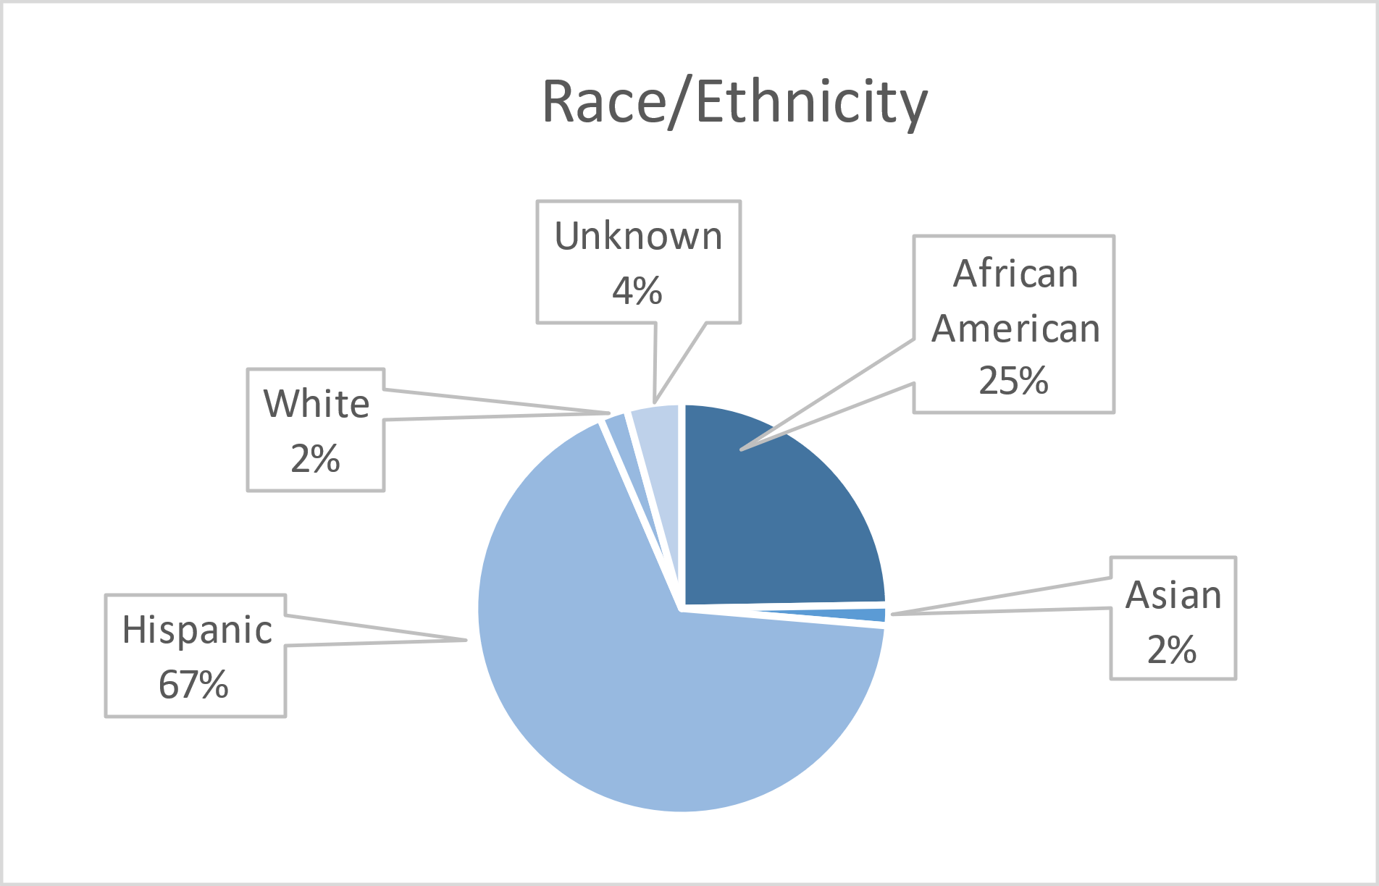

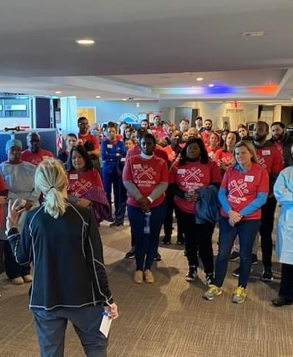
Volunteers
Thank you to our volunteers for your time and talents.
Dentists | 15 | 10
Hygienists | 7 | 1
Dental Assistants | 24 | 15
Dental School Students | 18 | 15
General Volunteers | 74 | 45
Total Volunteers | 138 | 86
Signed up Attended
60% Of the volunteers that signed up through our website attended the event.

Screenings | 186
X-Rays | 162
Prophy Cleanings | 124
Fluoride Varnish | 116
Sealants | 64
Fillings | 47
Extractions | 80
Silver diamine fluoride | 65
Oral Health Education | 186
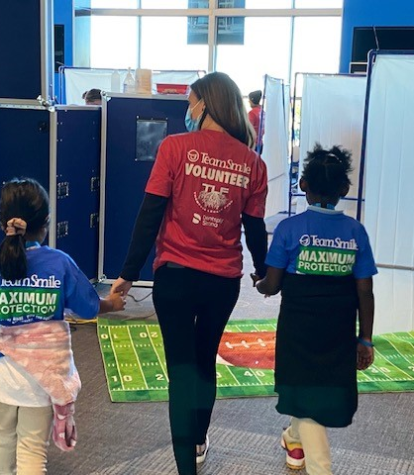
Services
Total Value: $77,205
Dental Services: $68,835
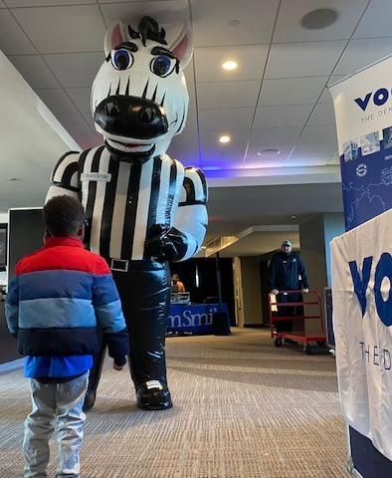
Education: $8,370

