Missoula, MT
April 12, 2022
Location of Dental Clinic: Hellgate Elementary

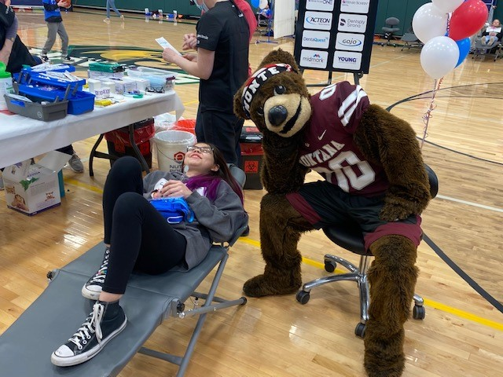
Hellgate Elementary
Helping 142 Children

Total Preventative Care & Education Provided $42,785
Average Dental Care & Oral Health Education per patient visiting Program $370

Sponsored by :
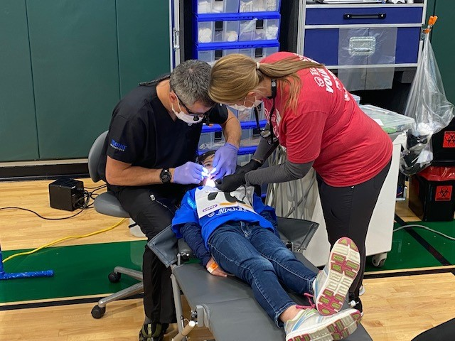
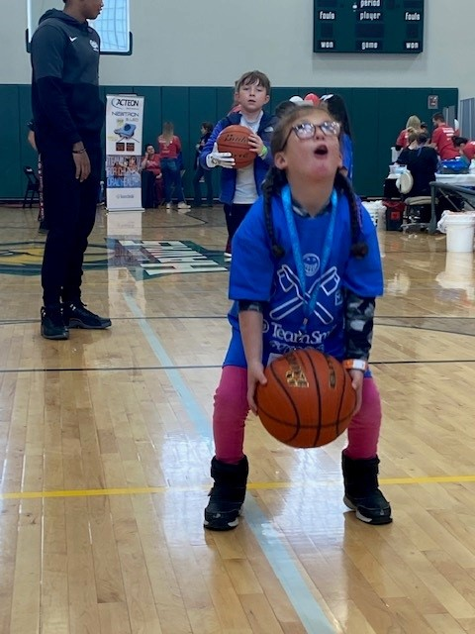
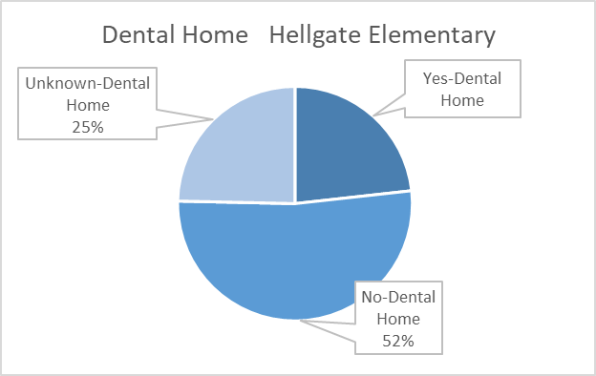
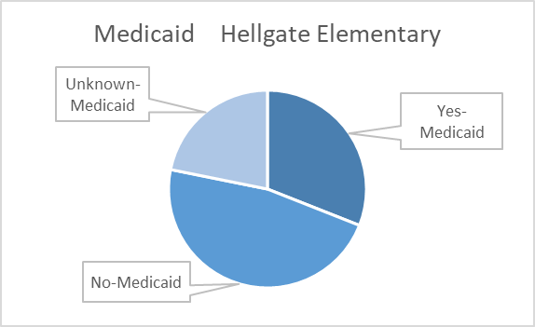
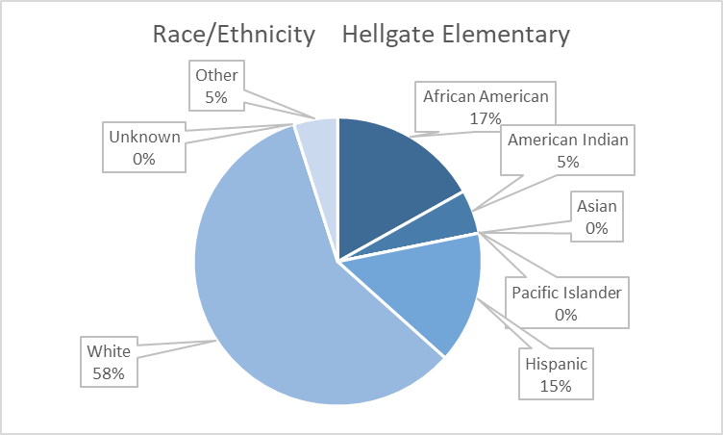
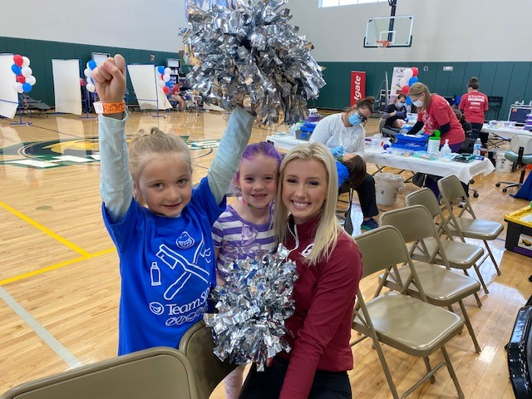

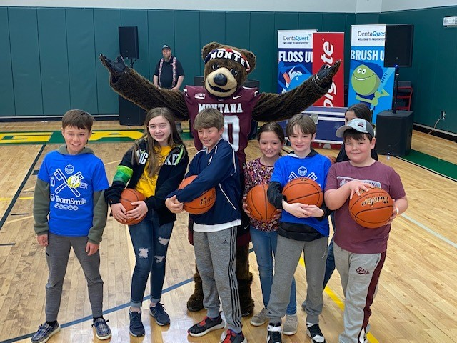
Volunteers
Thank you to our volunteers, for your time and talents.
Dentists | 3 | 3
Hygienists | 5 | 4
Dental Assistants | 13 | 12
Dental School Students | 1 | 1
General Volunteers | 15 | 15
Total Volunteers | 37 | 35

Signed up Attended
95% Of the volunteers that signed up through our website attended the event.
Screenings | 142
Prophy Cleanings | 142
Fluoride Varnish | 139
Crowns | 4
Fillings | 6
Extractions | 6
Silver Diamine Fluoride | 71
Oral Health Education | 142
Services

Total Value: $42,785

Dental Services: $36,395
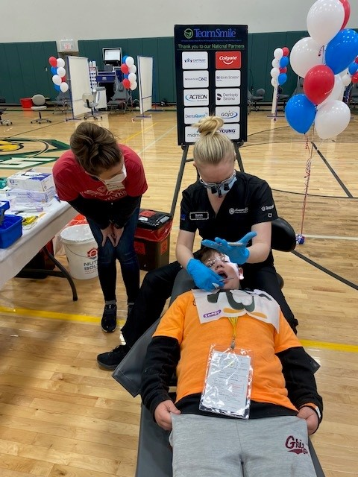
Education: $6,390

