Minnesota Twins
May 18, 2022
Location of Dental Clinic: Target Field
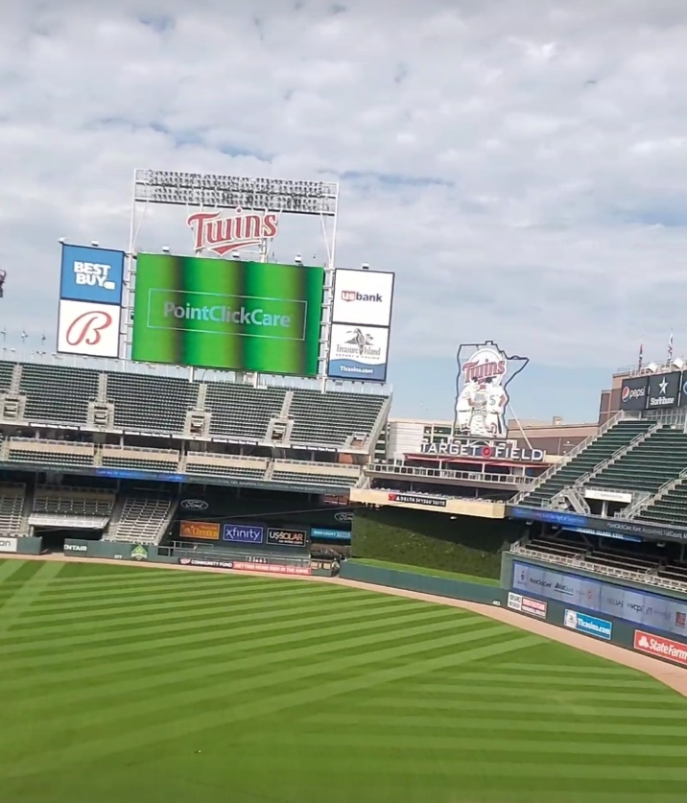
The Journey School
Life Prep School
Helping 188 Children

Total Preventative Care & Education Provided $92,839
Average Dental Care & Oral Health Education per patient visiting Program $370

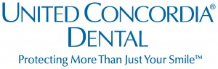
Sponsored by :
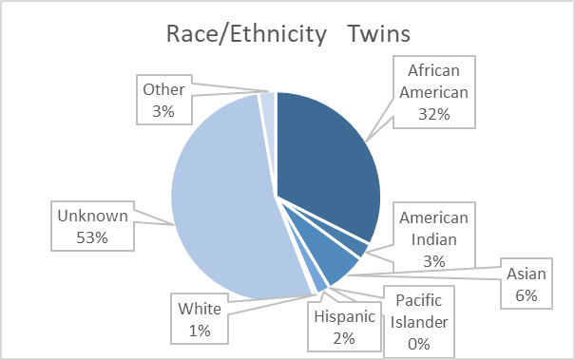
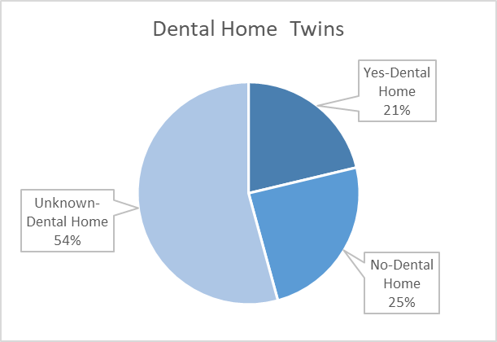
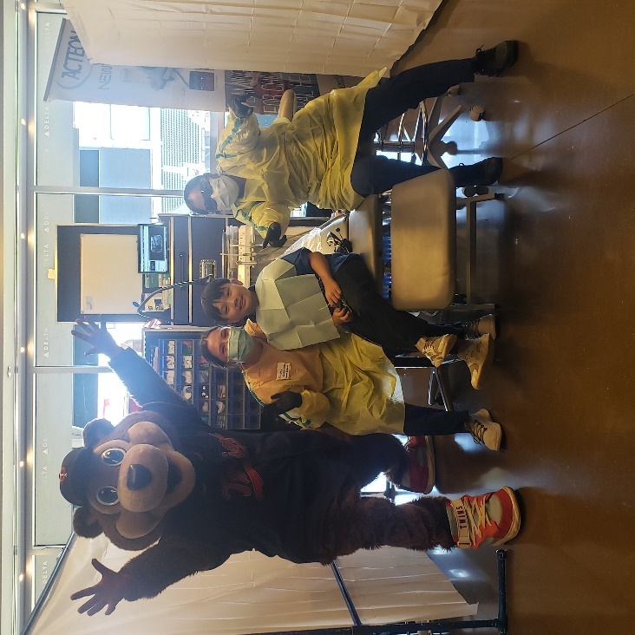
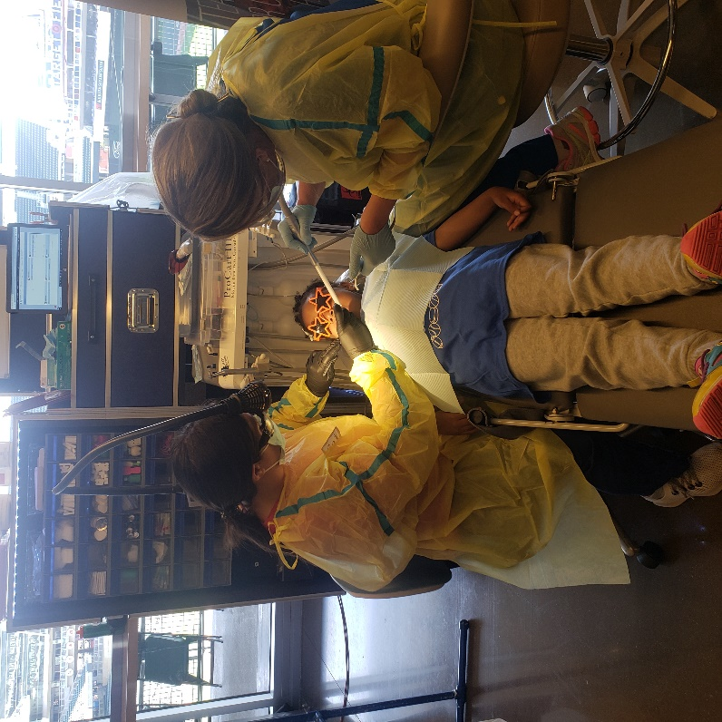

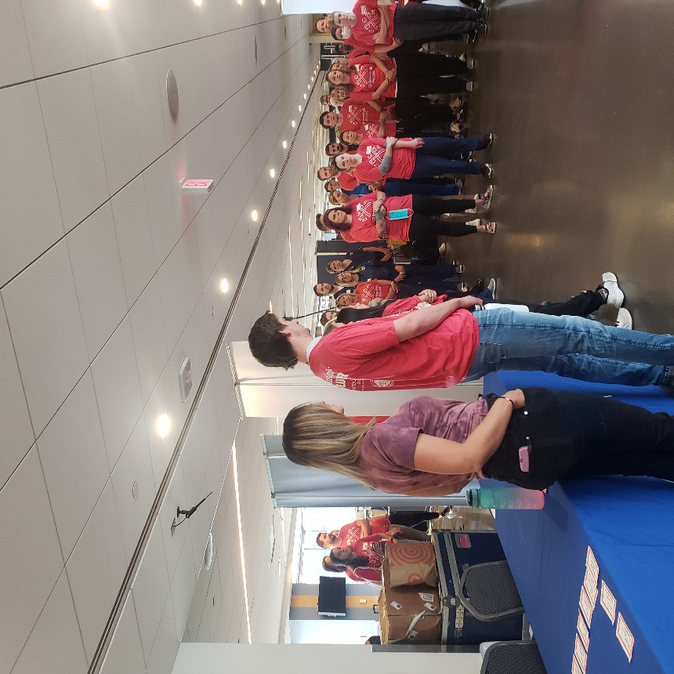
Volunteers
Thank you to our volunteers, for your time and talents.
Dentists | 16 | 12
Hygienists | 17 | 14
Dental Assistants | 21 | 13
Dental School Students | 12 | 8
General Volunteers | 63 | 39
Total Volunteers | 129 | 86

Signed up Attended
67% Of the volunteers that signed up through our website attended the event.
Screenings | 188
X-Rays | 148
Prophy Cleanings | 188
Fluoride Varnish | 176
Sealants | 142
Fillings | 66
Extractions | 24
Silver Diamine Fluoride | 79
Crowns | 5
Pulpotomies | 6
Oral Health Education | 238
Services

Total Value: $92,839

Dental Services: $82,129
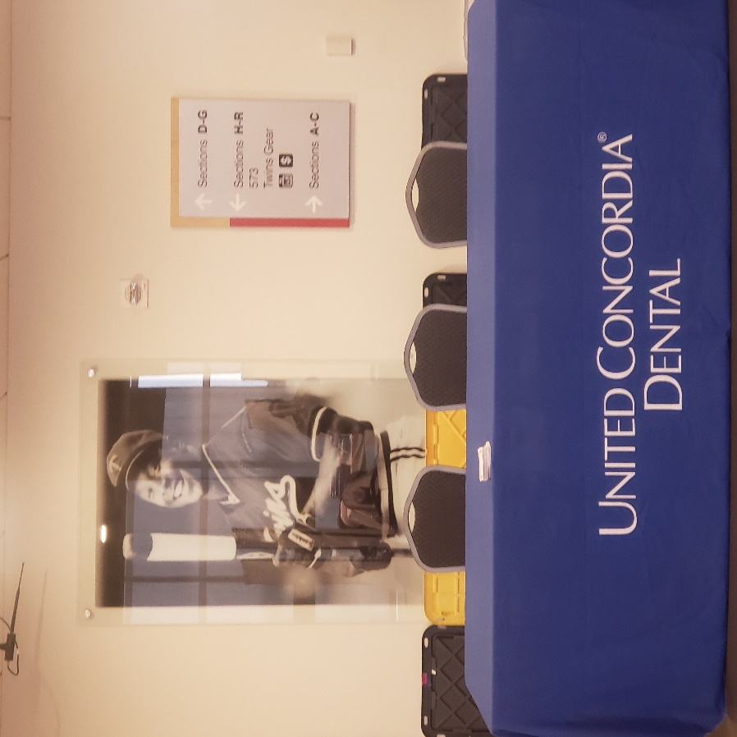
Education: $10,710

