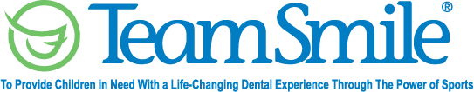
Detroit
June 10, 2022
Location of Dental Clinic: Brenda Scott Academy
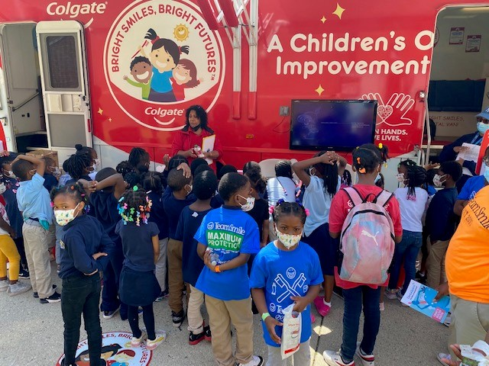
Brenda Scott Academy
246 Children Served
727 Children Education with Colgate

Total Preventative Care & Education Provided $114,631
Average Dental Care & Oral Health Education per patient visiting Program $333

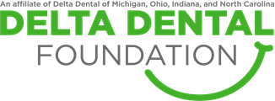
Sponsored by:
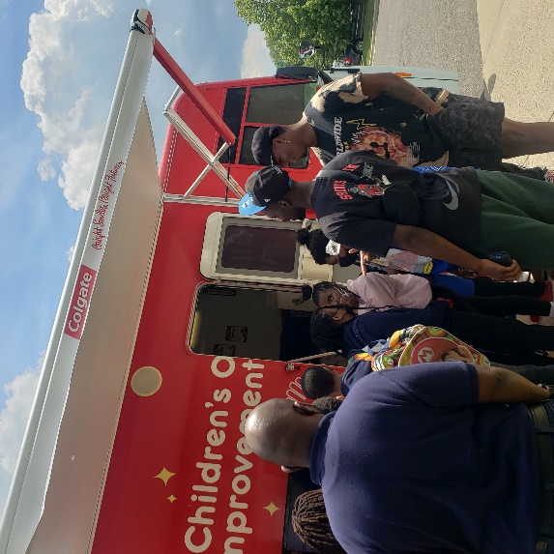
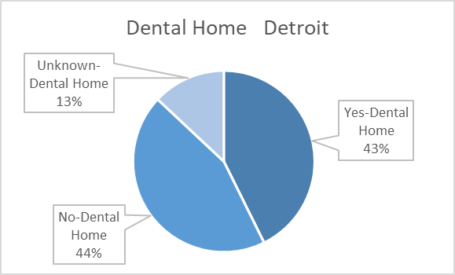
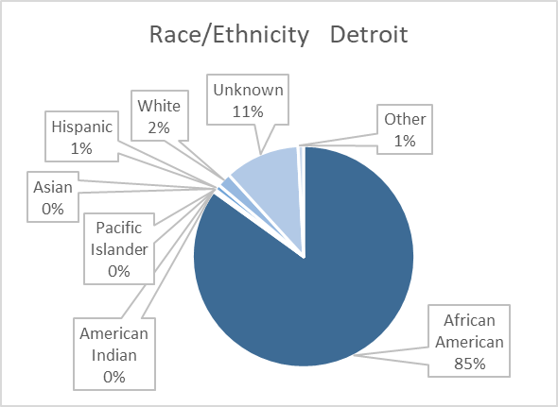
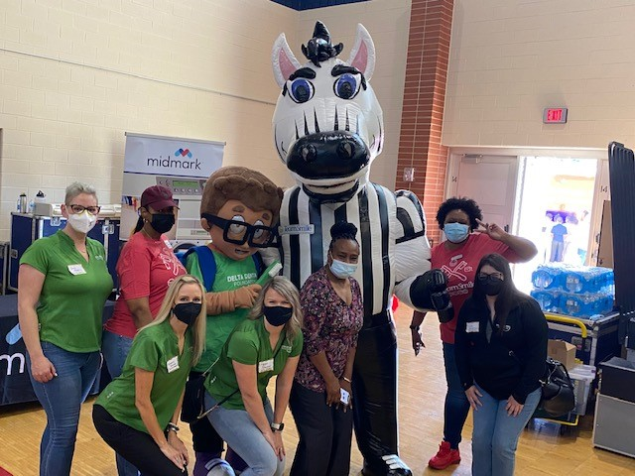
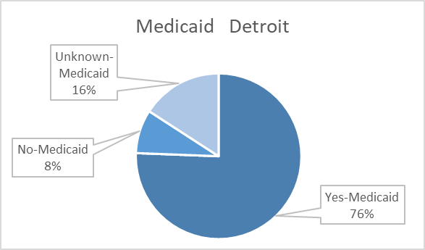

Thank you to tight end Derrick Deese, Jr and safety Kerby Joseph with the Detroit Lions.
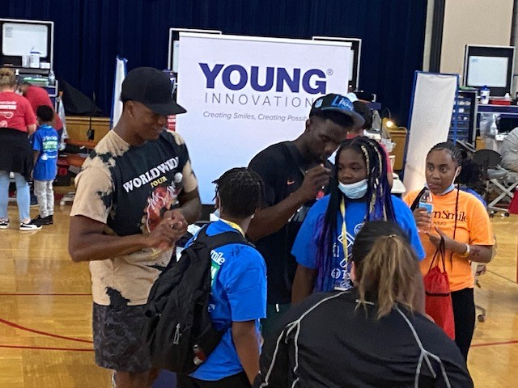
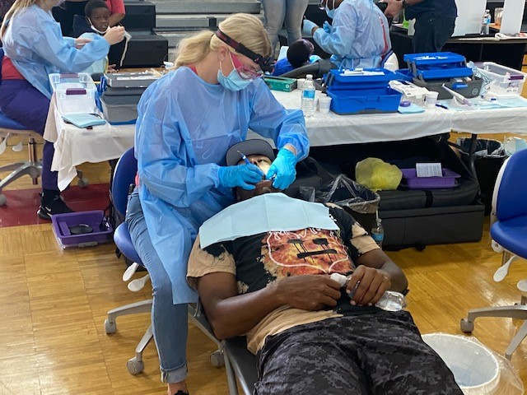
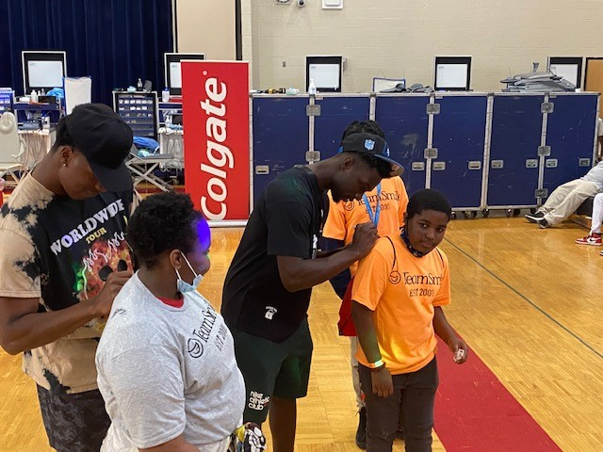

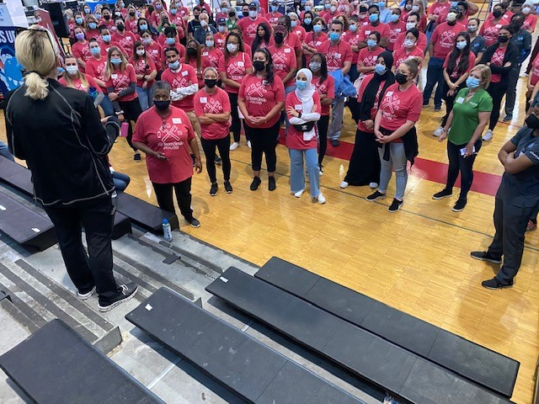
Volunteers
Thank you to our volunteers, for your time and talents.
Dentists | 12 | 8
Hygienists | 12 | 6
Dental Assistants | 16 | 7
Dental School Students | 42 | 29
Delta Dental Foundation | 18 | 16
General Volunteers | 72 | 44
Total Volunteers | 172 | 110

Signed up Attended

64% Of the volunteers that signed up through our website attended the event.
Screenings | 246
X-Rays | 175
Prophy Cleanings | 204
Fluoride Varnish | 227
Sealants | 209
Fillings | 51
Extractions | 8
Root Canals | 2
Oral Health Education | 727

Services

Total Value: $114,631
Dental Services: $81,916
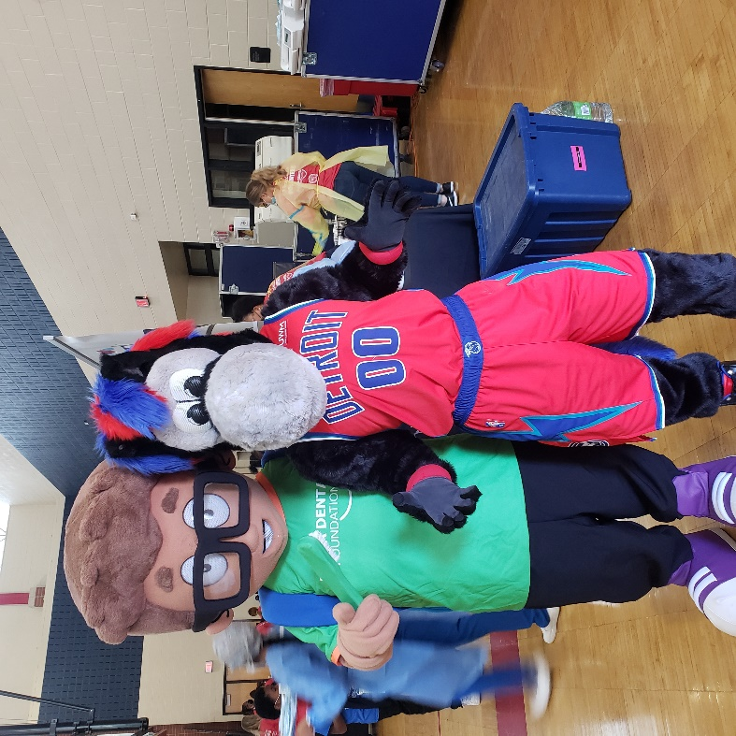
Education: $32,715

