Colorado Rockies
September 08, 2023
Location of Dental Clinic: Coors Field

149 Children Served
168 Children Educated

Total Preventative Care & Education Provided $57,538
Average Dental Care & Oral Health Education per patient visiting Program $342.48
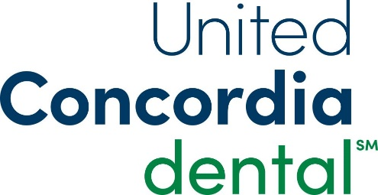
Sponsored by:
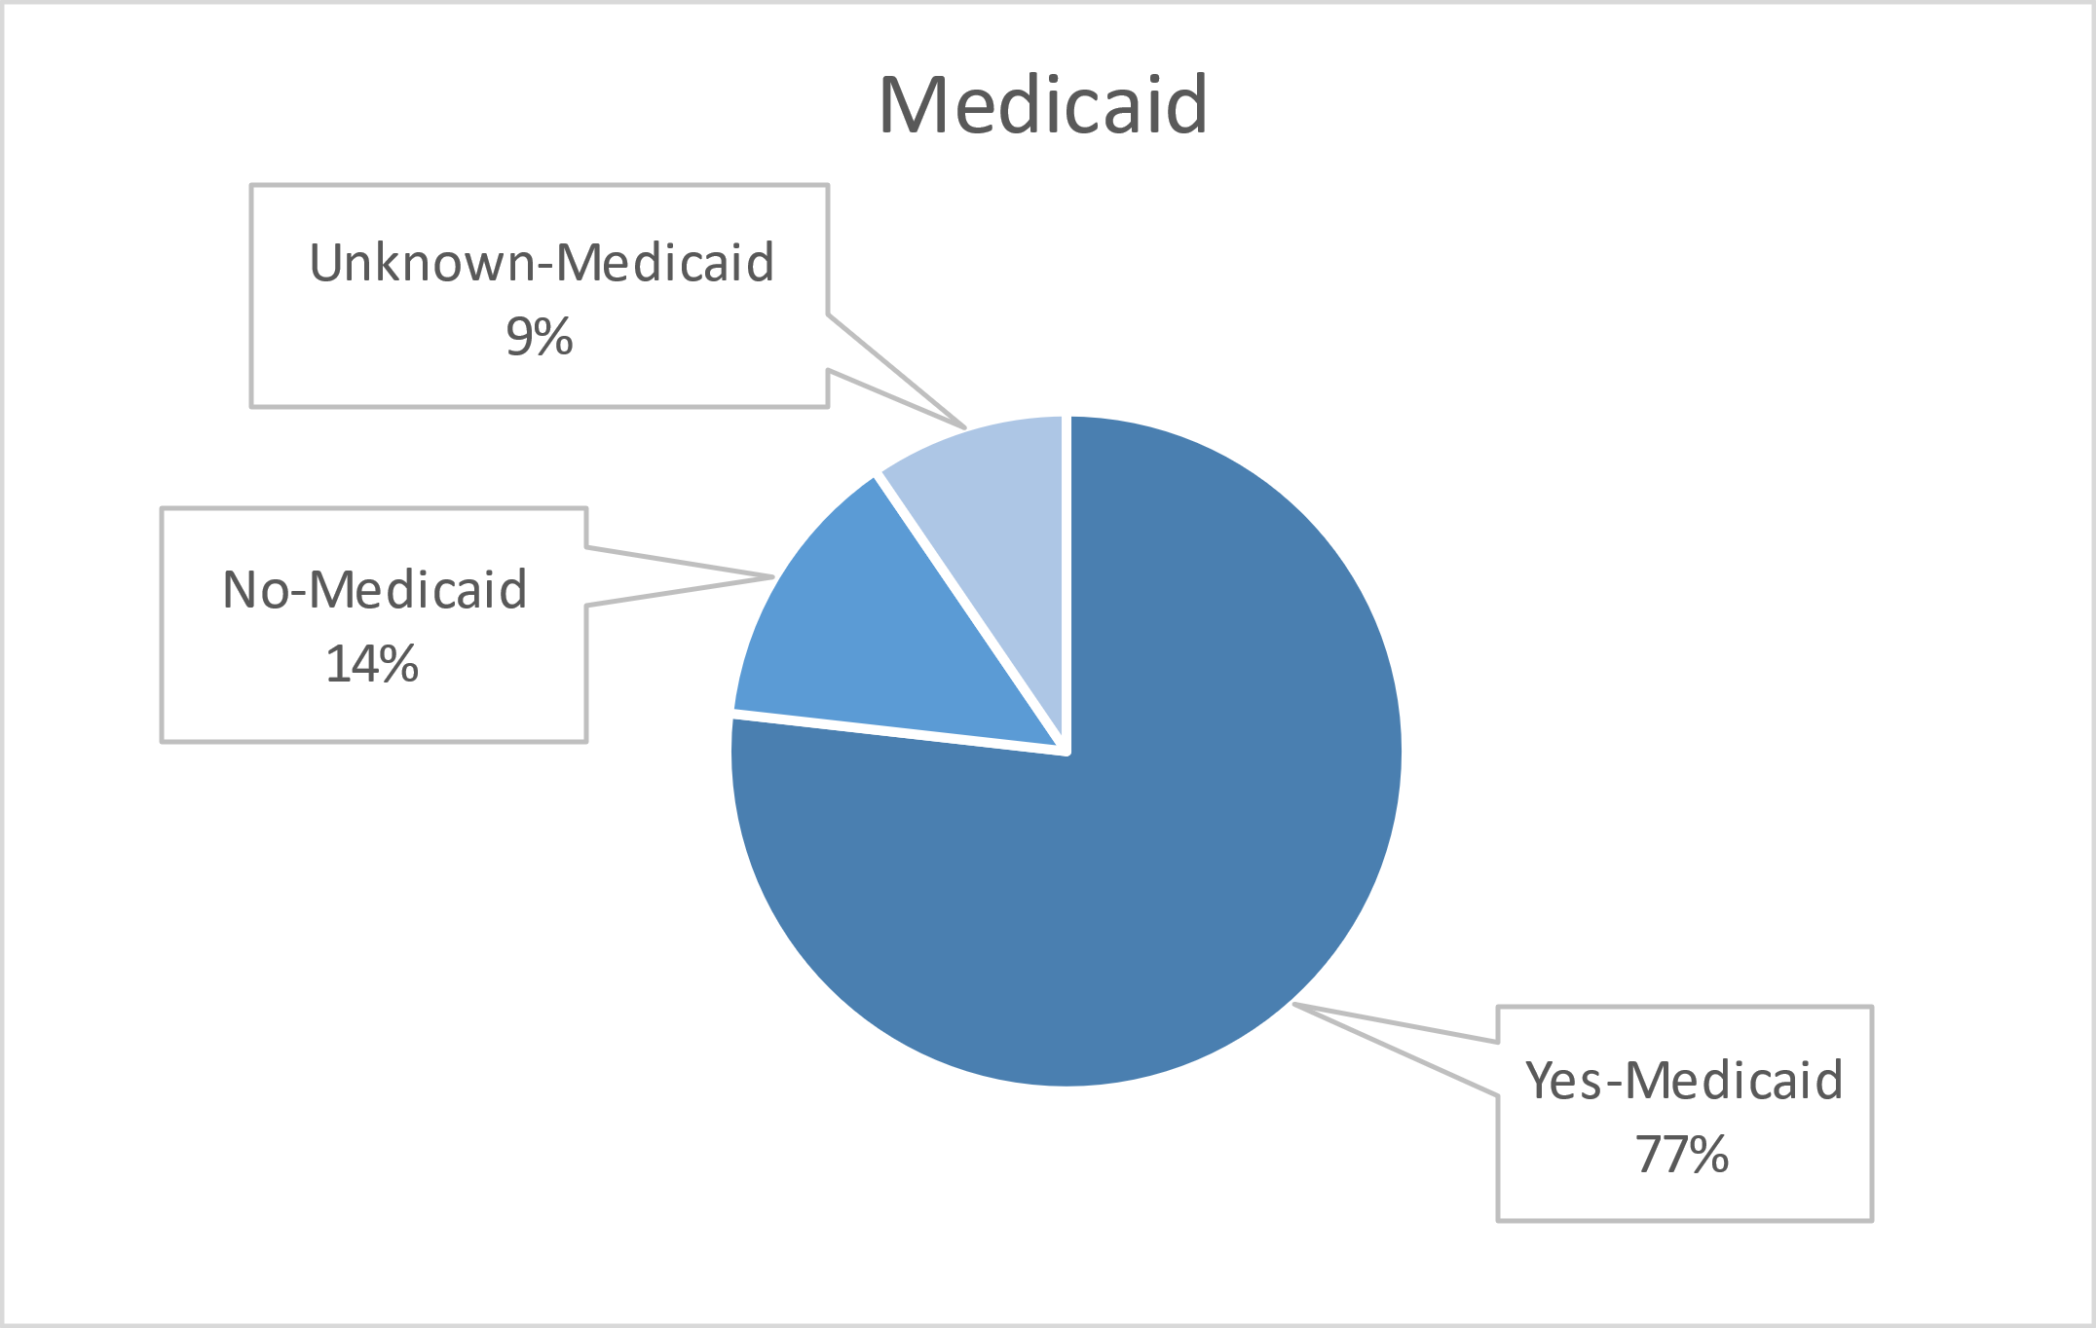
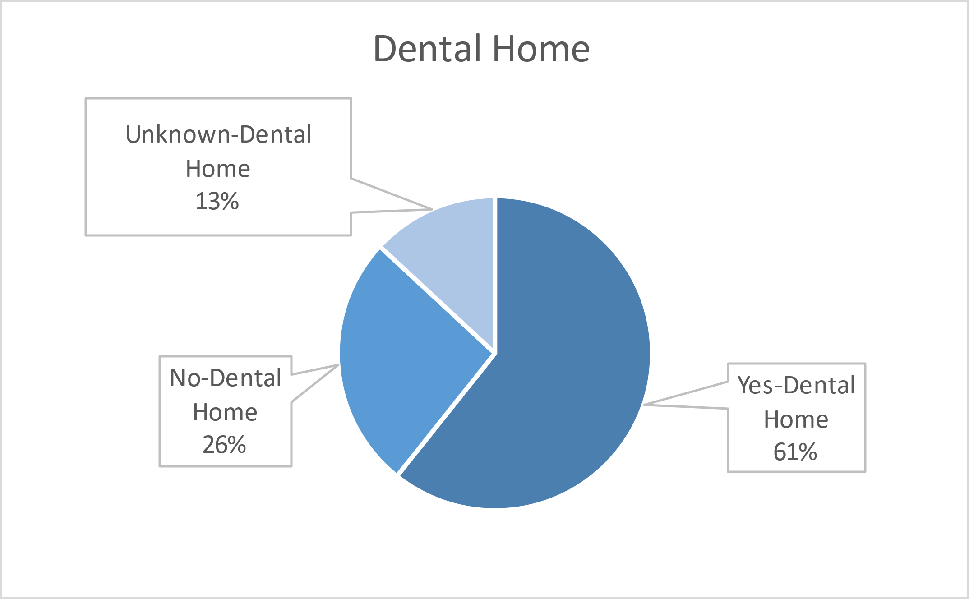
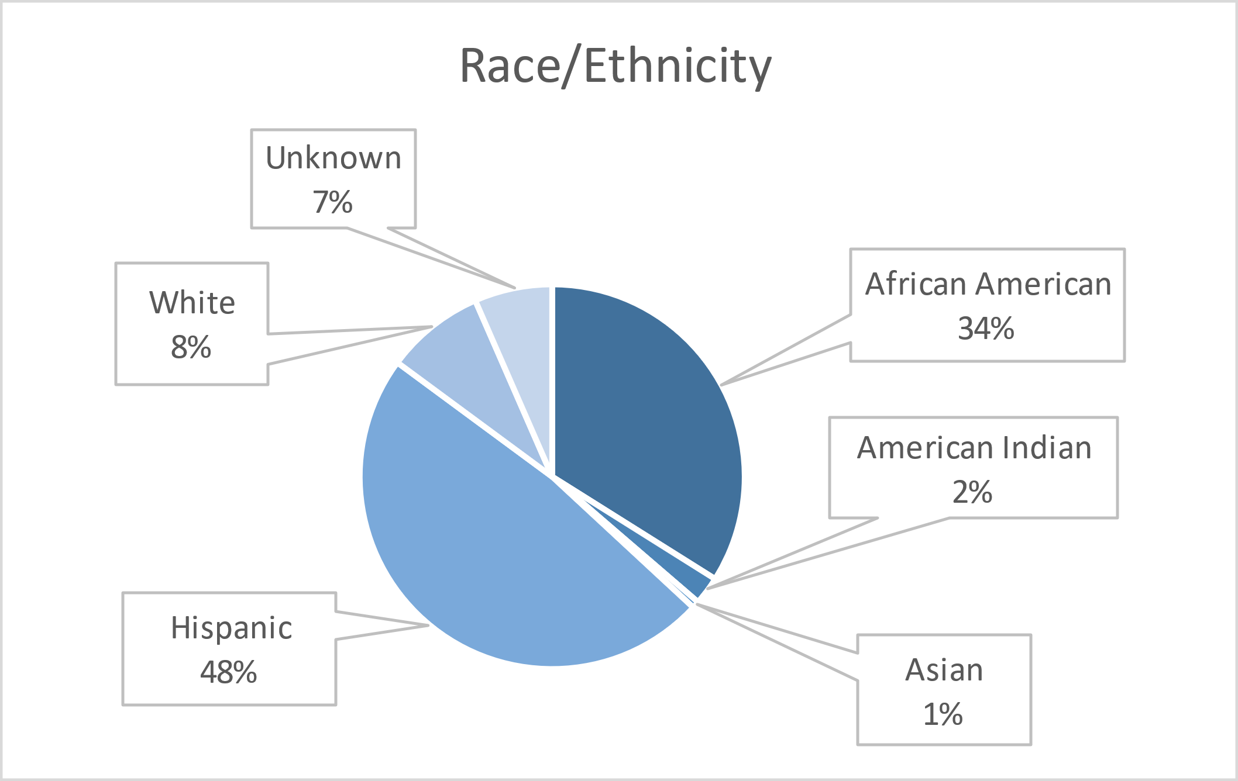
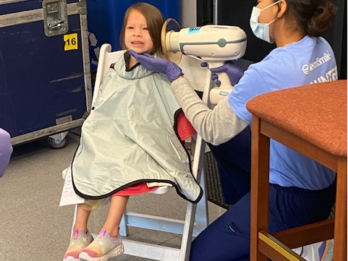
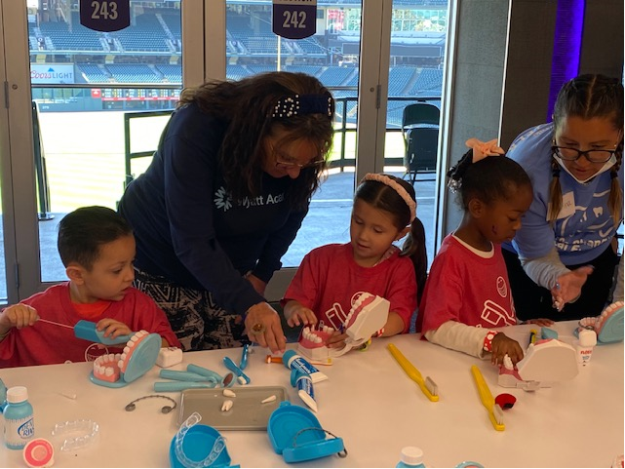
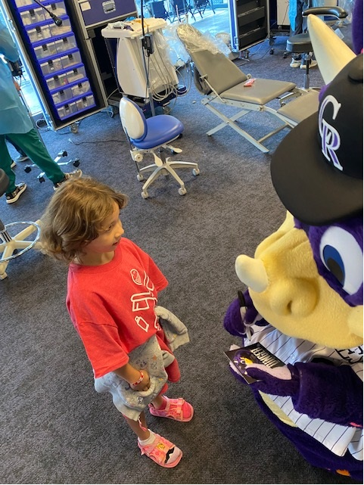
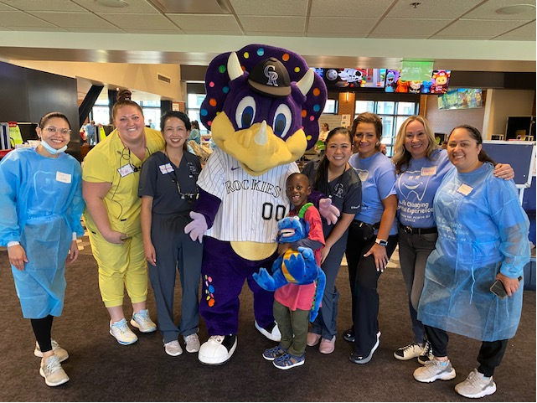
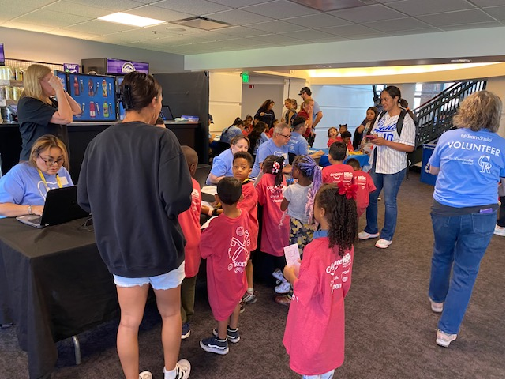
Volunteers
Thank you to our volunteers for your time and talents.
Dentists | 17 | 16
Hygienists | 18 | 08
Dental Assistants | 12 | 11
Dental School Students | 30 | 29
General Volunteers | 58 | 39
Total Volunteers | 135 | 103

Signed up Attended
76% Of the volunteers that signed up through our website attended the event.

Services

Screenings | 149
X-Rays | 120
Prophy Cleanings | 118
Fluoride Varnish | 118
Sealants | 132
Fillings | 27
Extractions | 5
Silver diamine fluoride | 26
Crowns | 1
Pulpotomy | 1
Oral Health Education | 168
Total Value: $57,538
Dental Services: $49,978
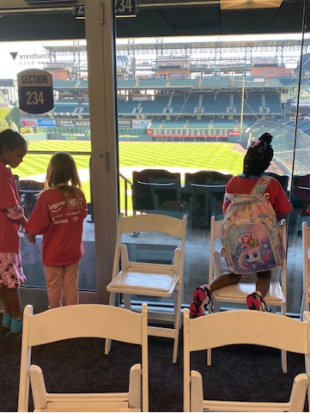
Education: $7,560

