Colorado Rockies
November 11, 2022
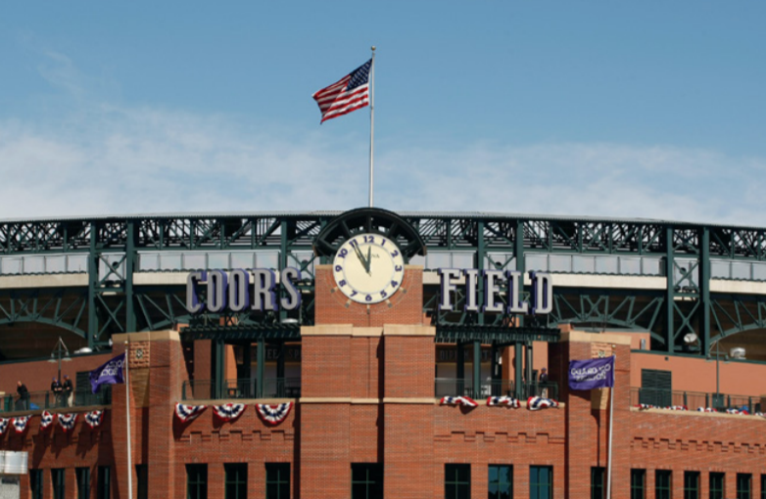
Location of Dental Clinic : Coors Field
111 children served
132 children educated

Total Preventative Care & Education Provided $47,171
Average dental care provided for each patient in the dental clinic $371.45
Sponsored by:
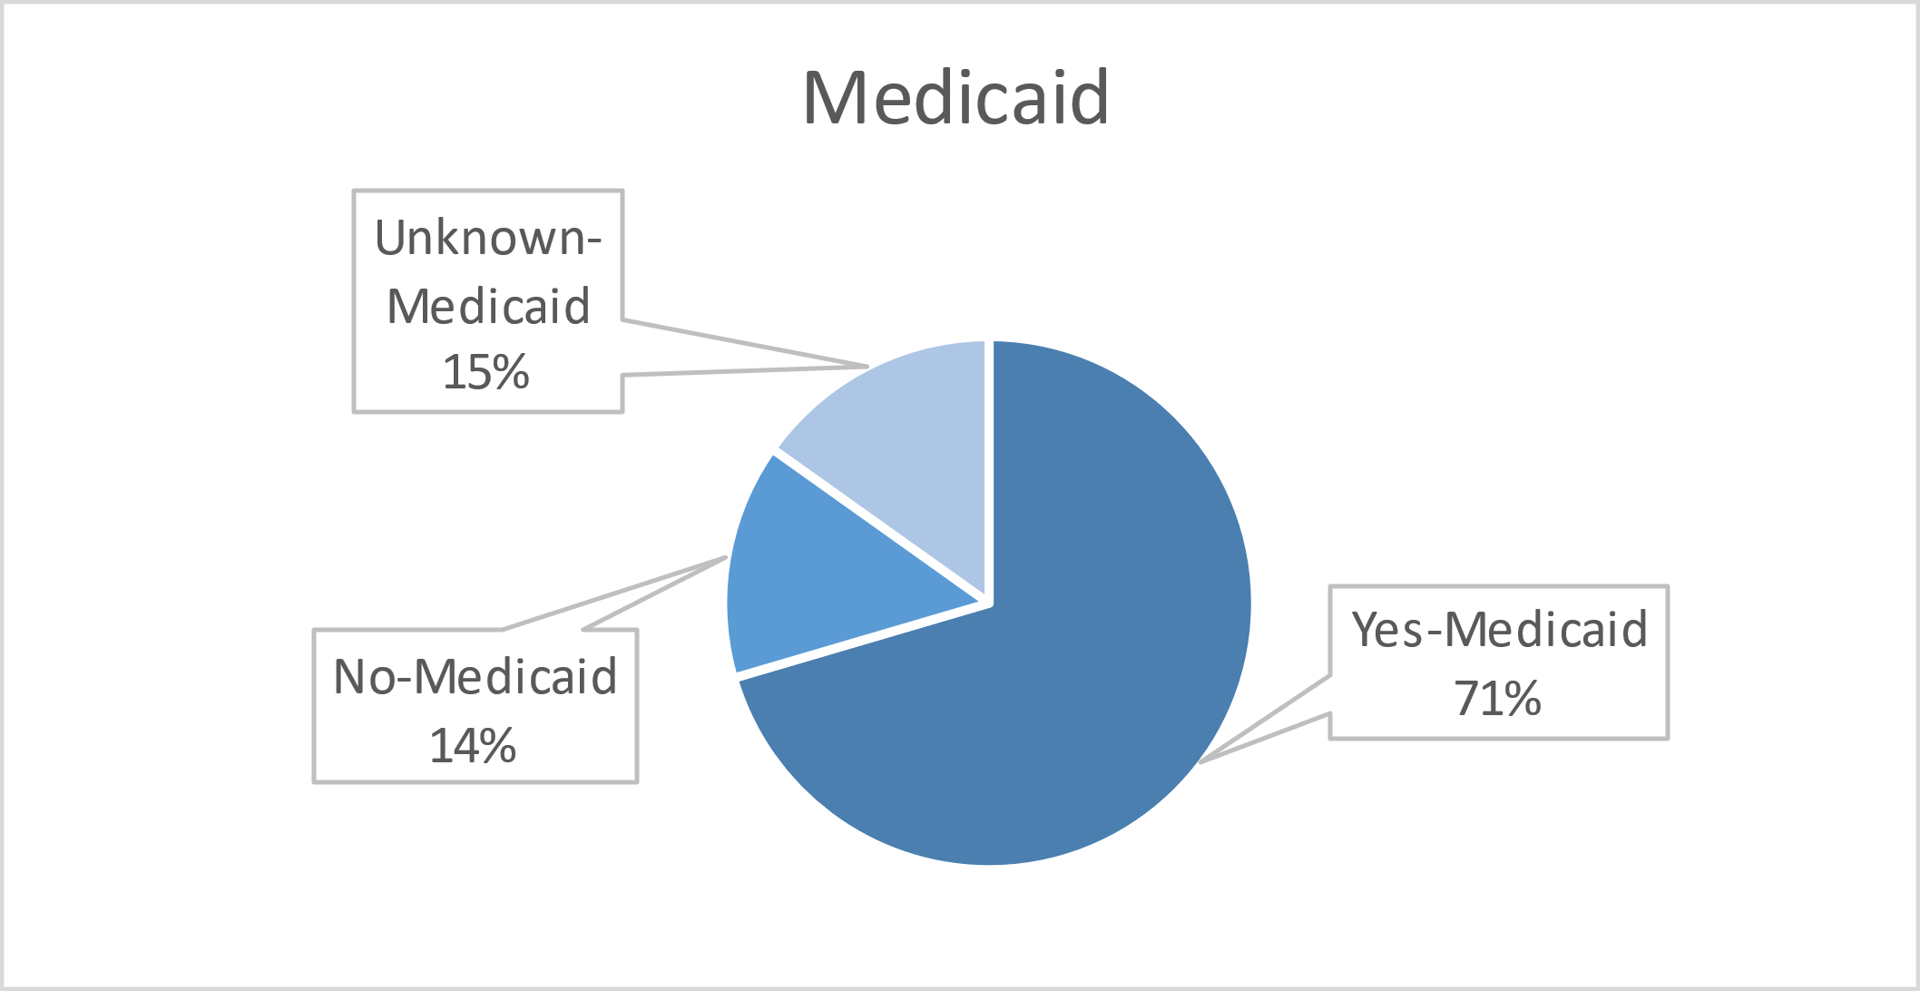
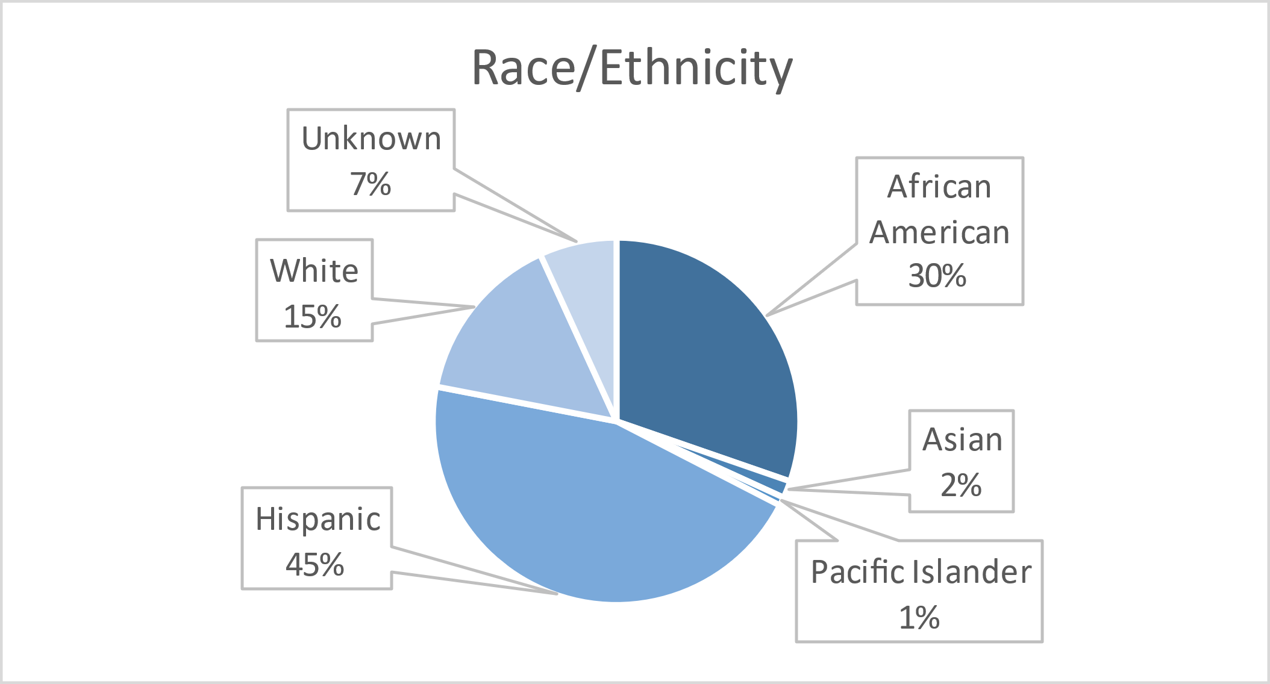
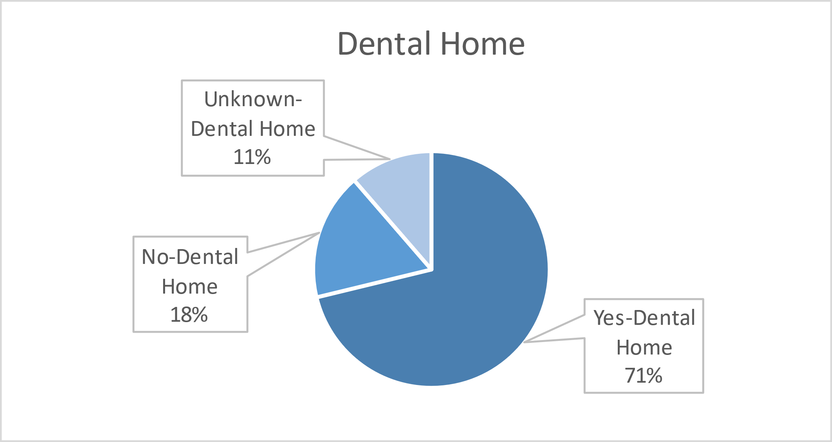
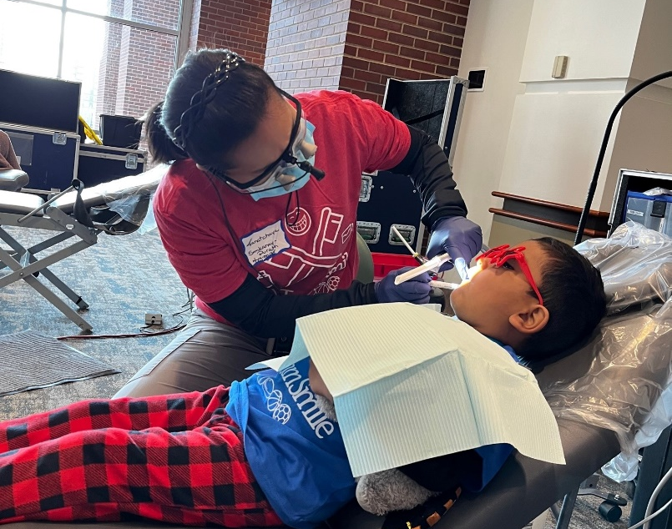
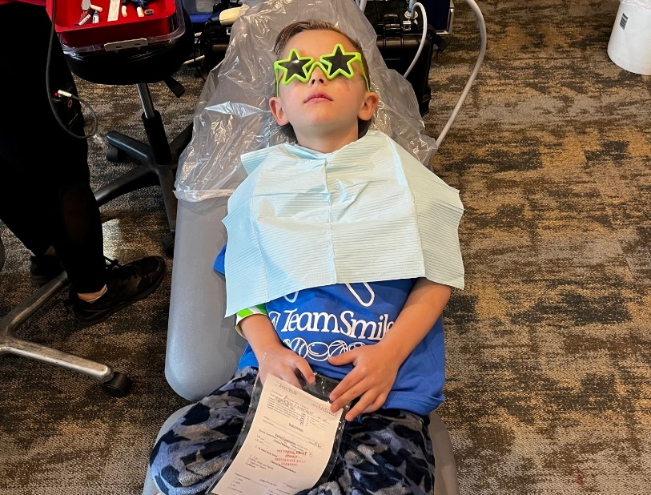
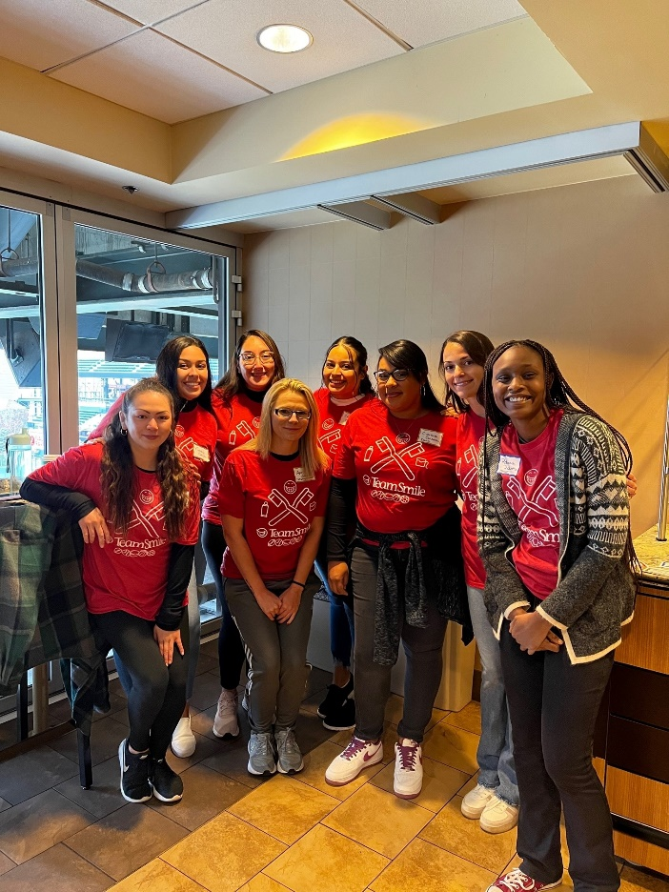
Volunteers
Thank you to our volunteers for your time and talents.
Dentists | 18 | 17
Hygienists | 14 | 9
Dental Assistants | 12 | 9
Dental School Students | 20 | 14
General Volunteers | 42 | 33
Total Volunteers | 106 | 82
Signed up Attended
77% Of the volunteers that signed up through our website attended the event.

Screenings | 111
X-Rays | 96
Prophy Cleanings | 90
Varnish | 79
Sealants | 169
Fillings | 13
Extractions | 6
Pulpotomies | 2
Crowns | 3
Silver diamine fluoride | 18
Oral Health Education | 132

Services
Total Value: $47,171
Dental Services: $41,231
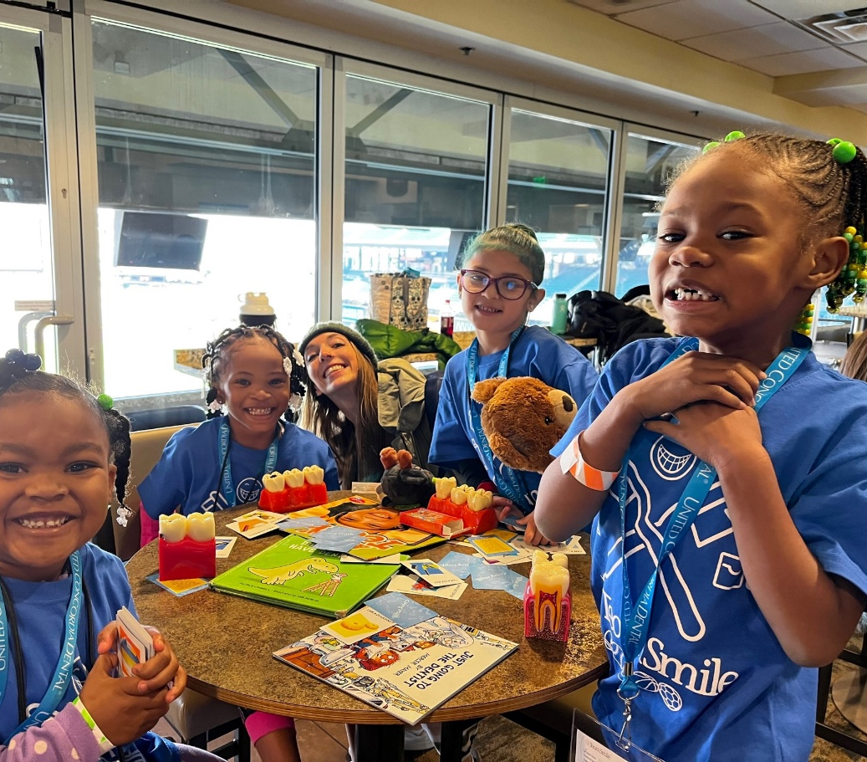
Education: $5,940

