Cincinnati Bengals
Phase II Back-to-school Program
August 15, 2023
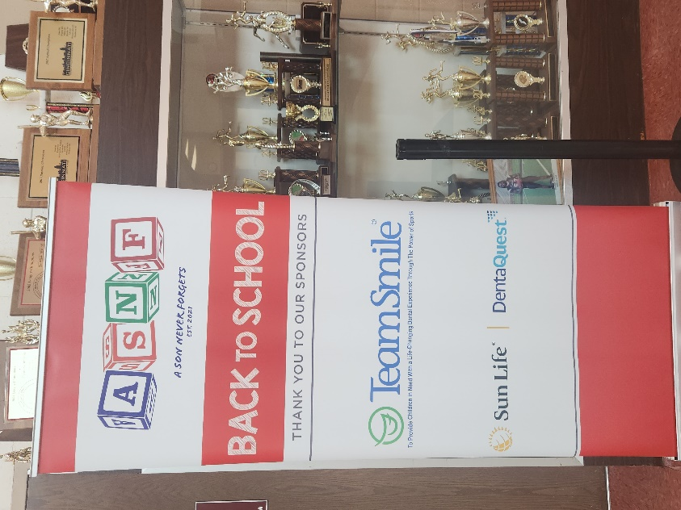
Location of Dental Clinic: Shroder High School
Back-to-school fair
26 Children Served
38 Children Educated

Total Preventative Care & Education Provided $9,151
Average Dental Care & Oral Health Education per patient visiting Program $240.81
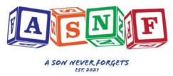
Sponsored by:
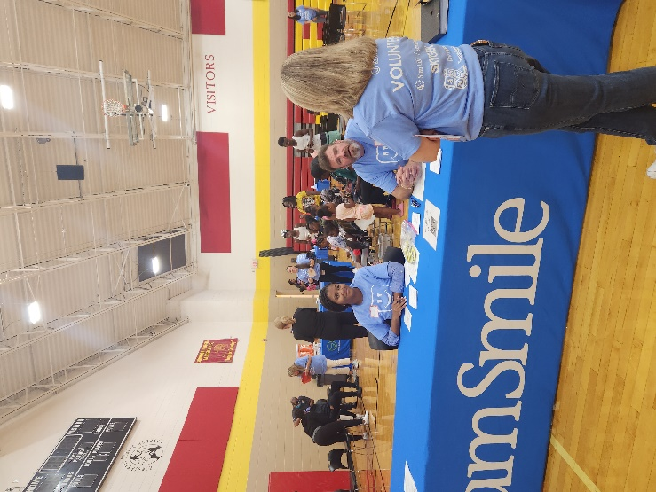
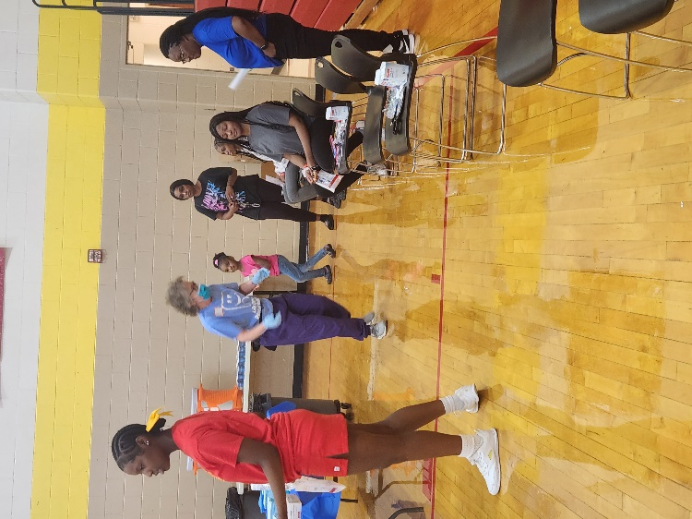
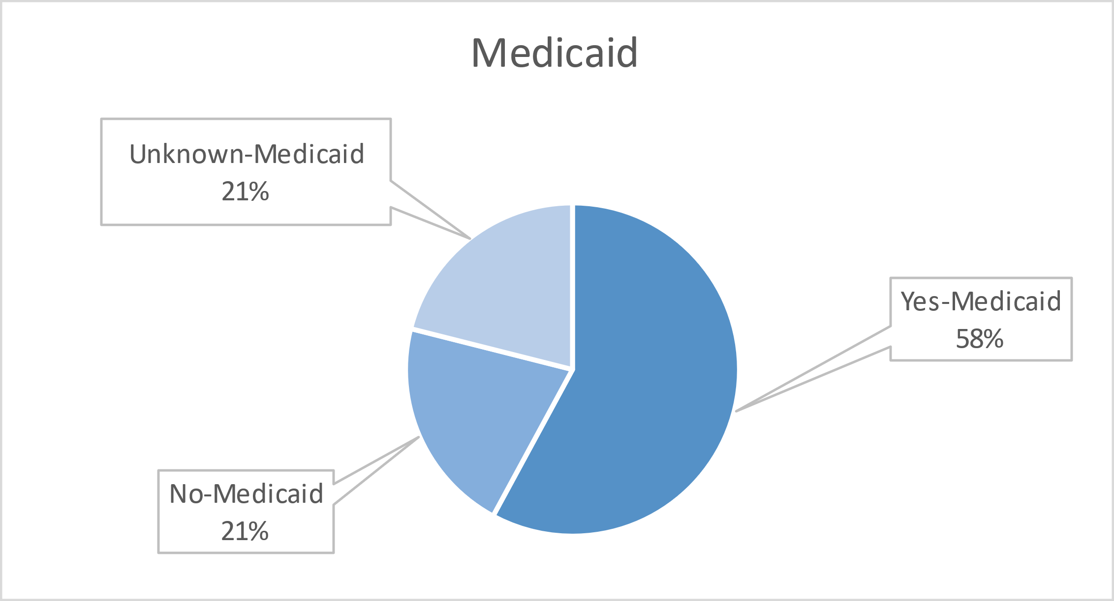
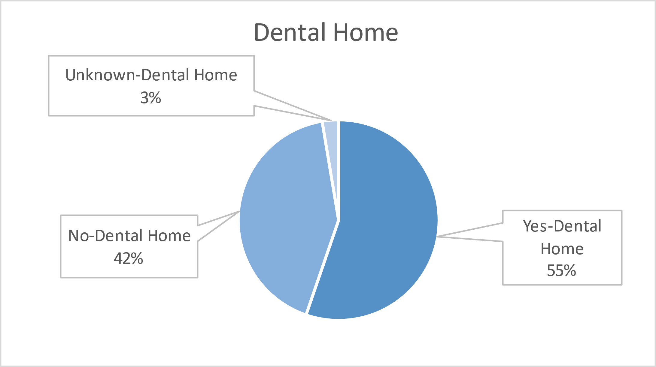
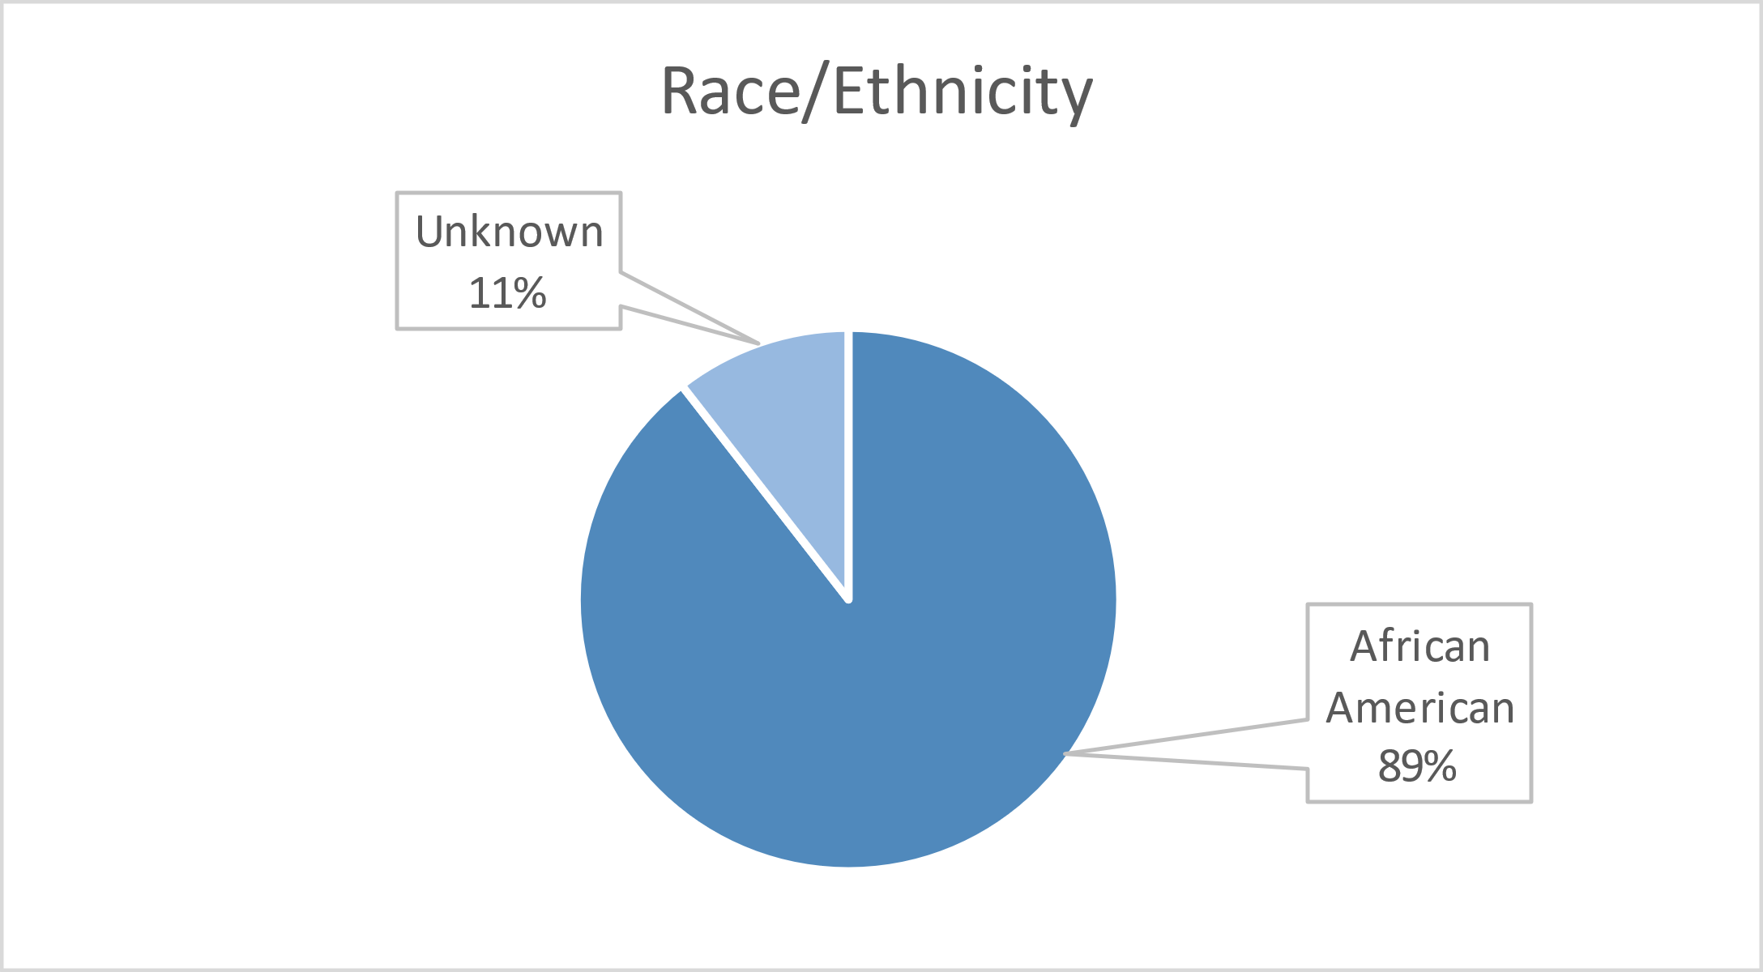
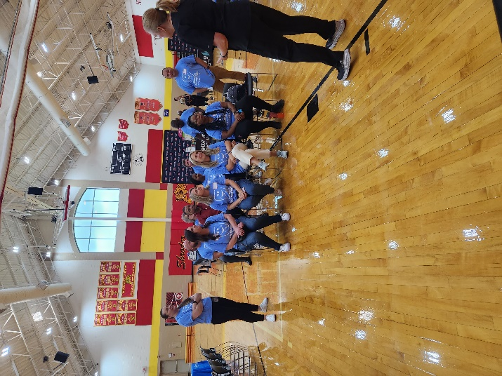
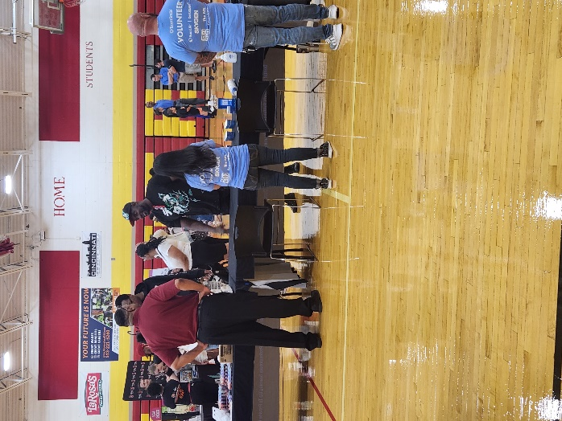
Volunteers
Thank you to our volunteers for your time and talents.
Dentists | 2 | 1
Hygienists | 2 | 1
Dental Volunteers | 3 | 0
General Volunteers | 13 | 06
Total Volunteers | 29 | 16

Signed up Attended
55% Of the volunteers that signed up through our website attended the event.

Service
Total Value: $9,151
Dental Services: $7,441
Screenings | 38
Cleanings | 26
Silver diamine fluoride | 29
Fluoride Varnish | 26
Education | 38
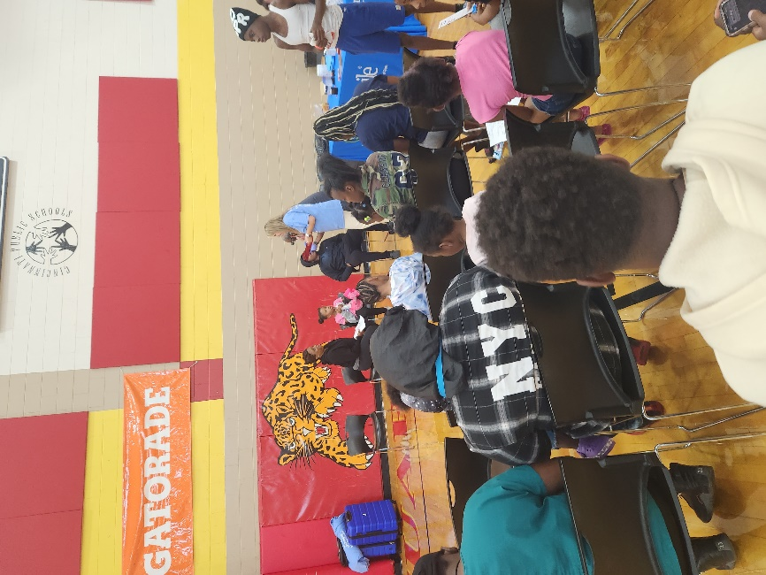
Education: $1,710

