Cincinnati Bengals
April 22, 2022
Location of Dental Clinic: Paul Brown Stadium

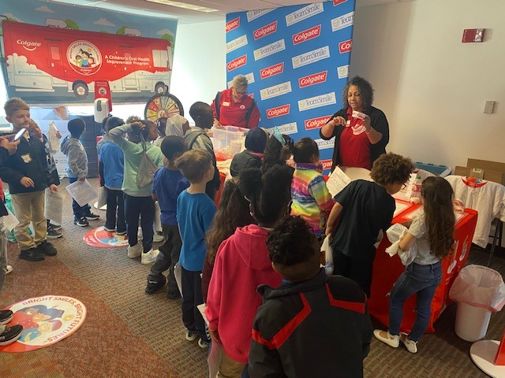
Midway School
Citizens of the World Charter
Helping 76 Children

Total Preventative Care & Education Provided $30,067
Average Dental Care & Oral Health Education per patient visiting Program $370

Sponsored by : The Dental Care Plus Group, A DentaQuest Company
Education by : Colgate Team
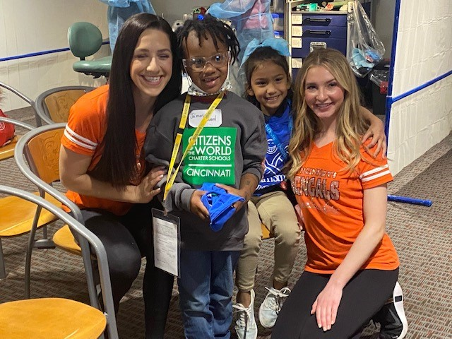
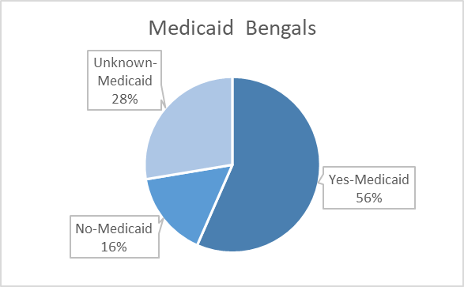
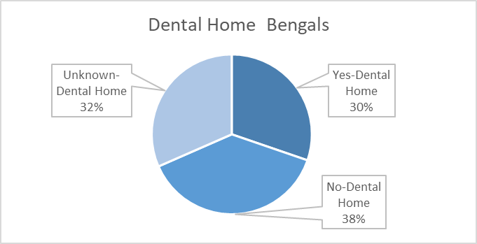
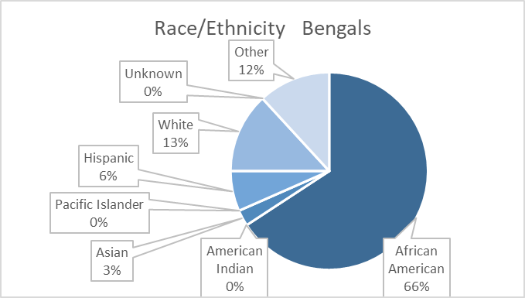
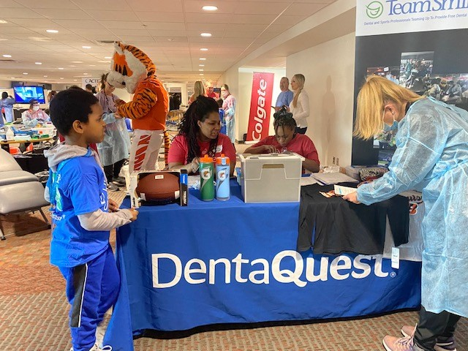

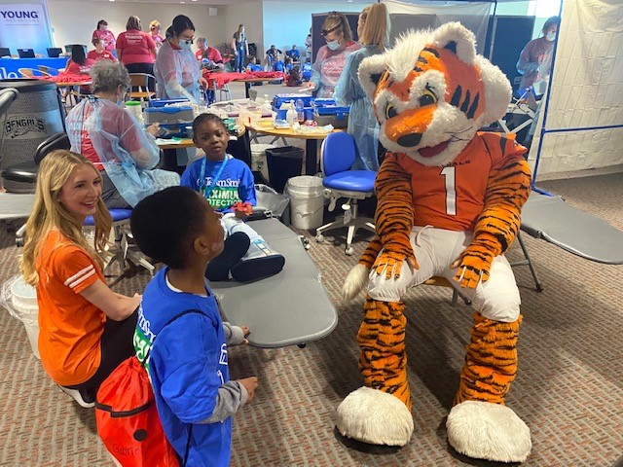
Volunteers
Thank you to our volunteers, for your time and talents.
Dentists | 12 | 10
Hygienists | 17 | 18
Dental Assistants | 28 | 17
Dental School Students | 14 | 5
General Volunteers | 51 | 32
Total Volunteers | 122 | 77

Signed up Attended
63% Of the volunteers that signed up through our website attended the event.
Screenings | 76
X-Rays | 54
Prophy Cleanings | 76
Fluoride Varnish | 76
Sealants | 72
Fillings | 19
Extractions | 9
Silver Diamine Fluoride | 31
Pulpotomies | 2
Crowns | 1
Oral Health Education | 76
Services

Total Value: $30,067

Dental Services: $26,647
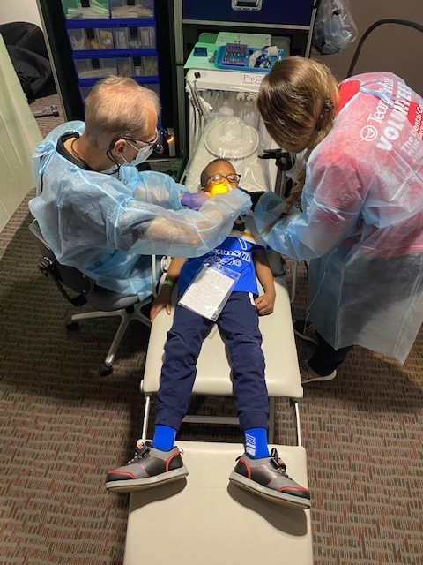
Education: $3,420

