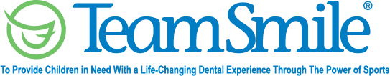
Chicago Bears
Phase II Back-to-school Program
August 5, 2023
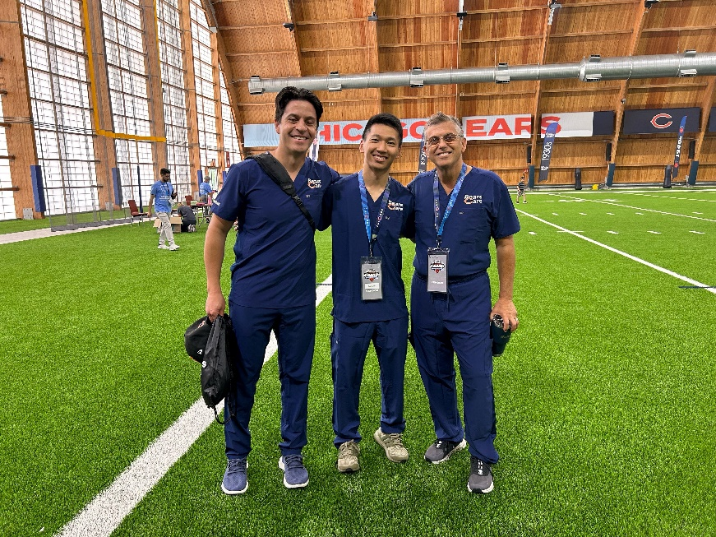
Location of Dental Clinic: Halas Hall

Back-to-school fair
86 Children Served
94 Children Educated

Total Preventative Care & Education Provided $22,871
Average Dental Care & Oral Health Education per patient visiting Program $243.30
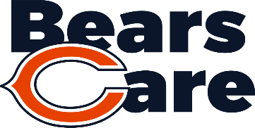
Sponsored by:
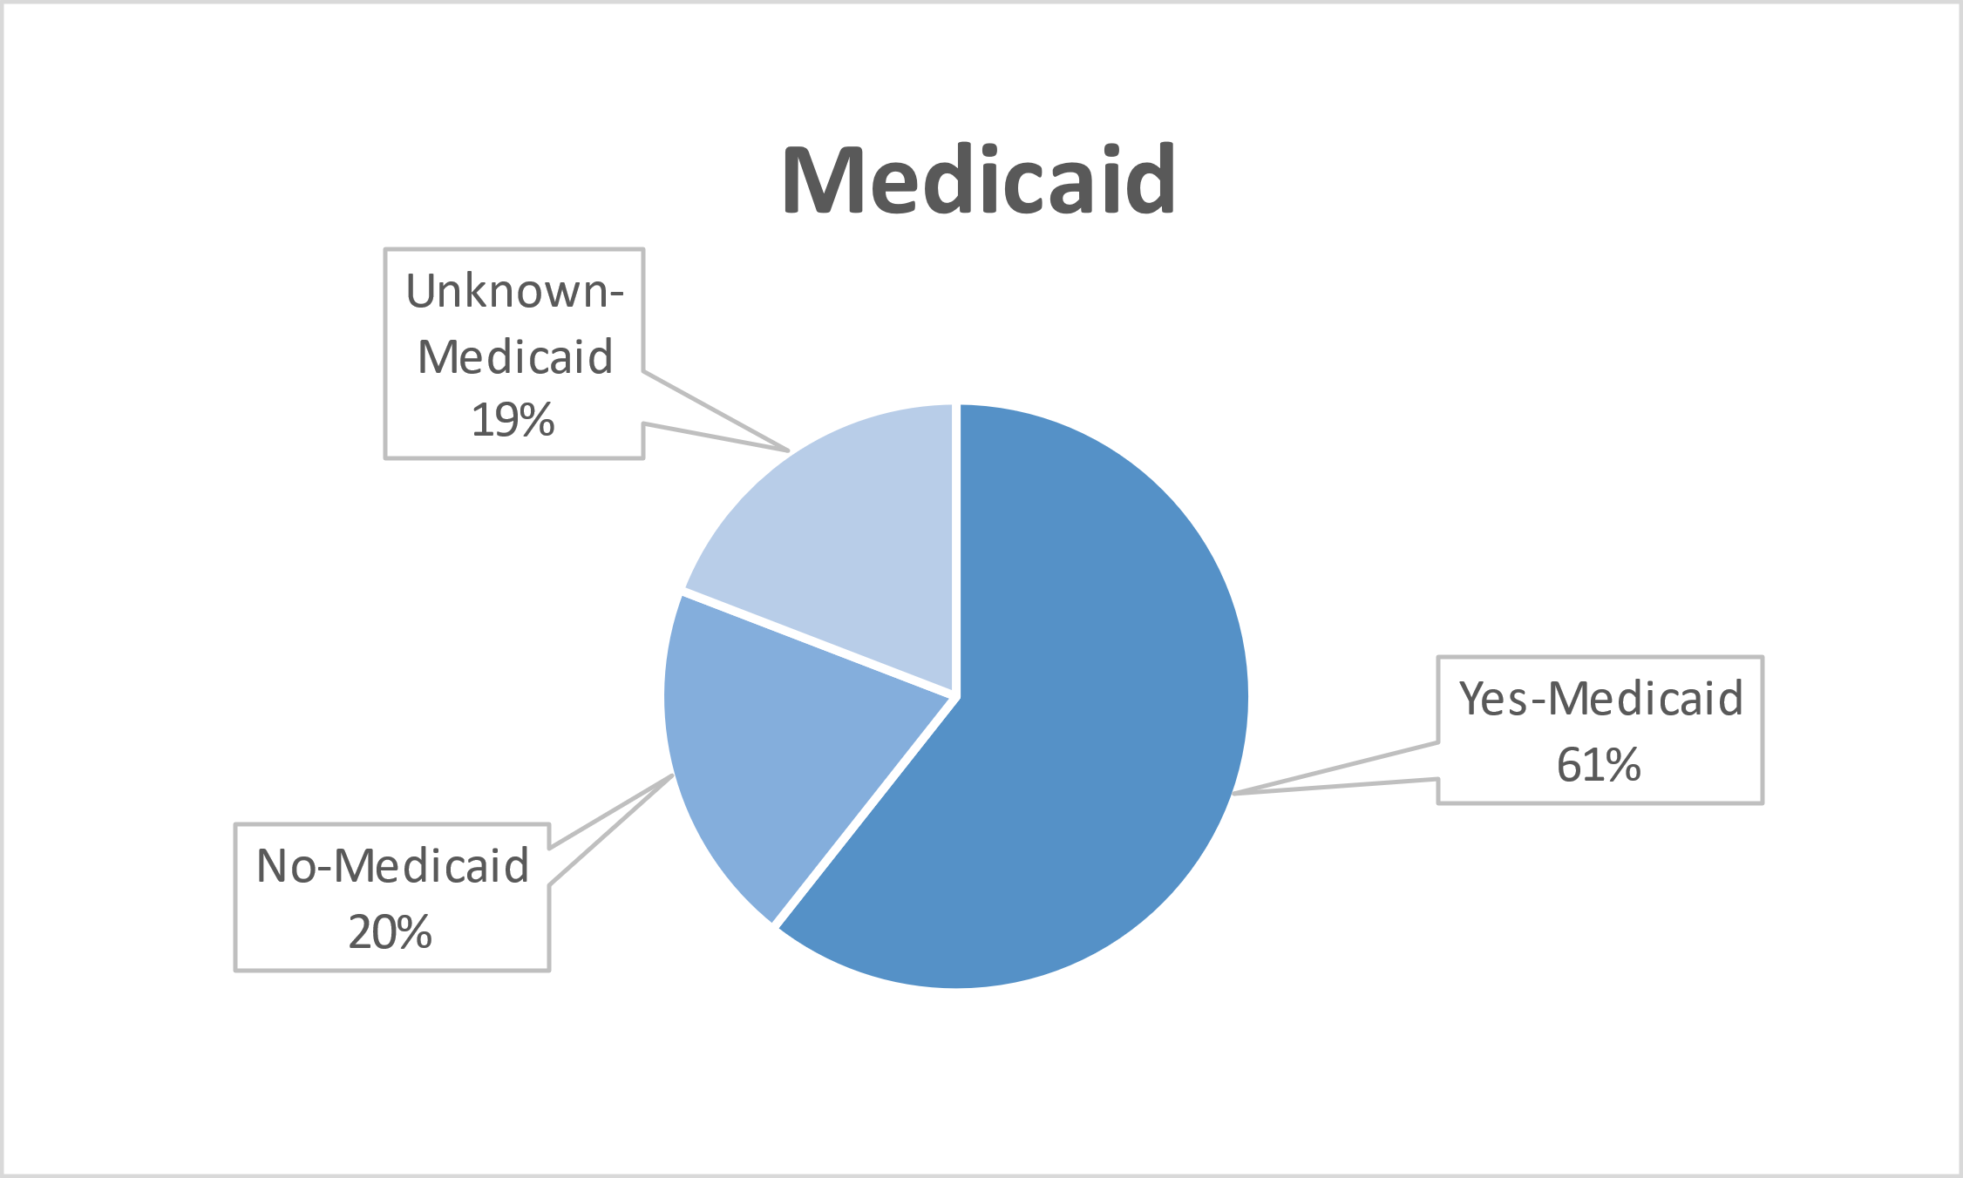
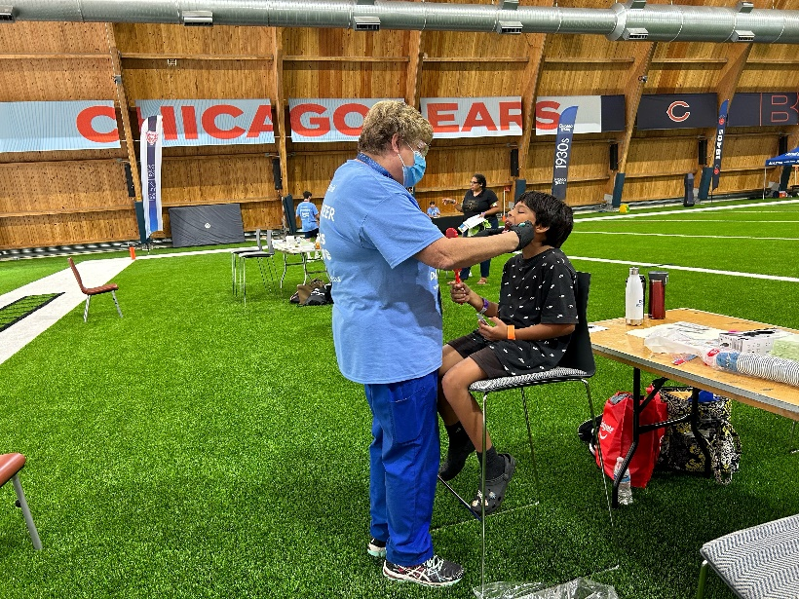
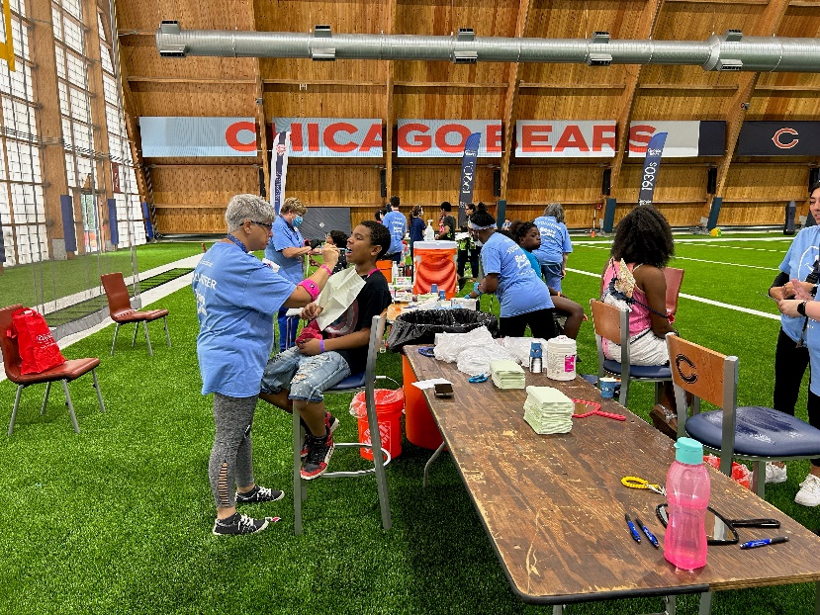
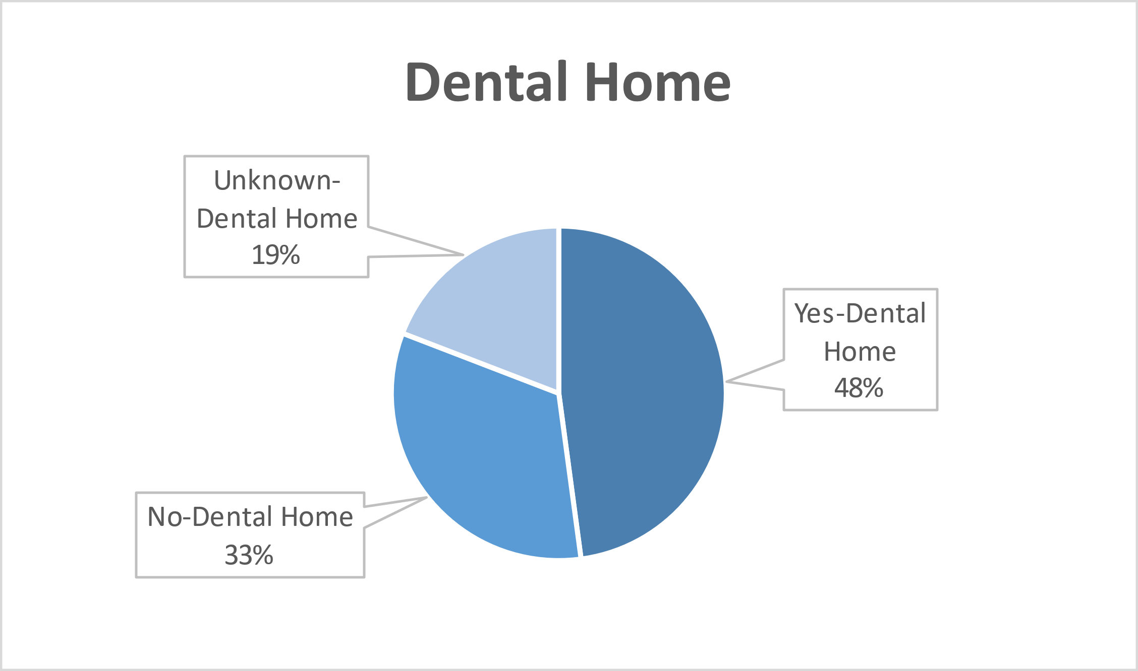
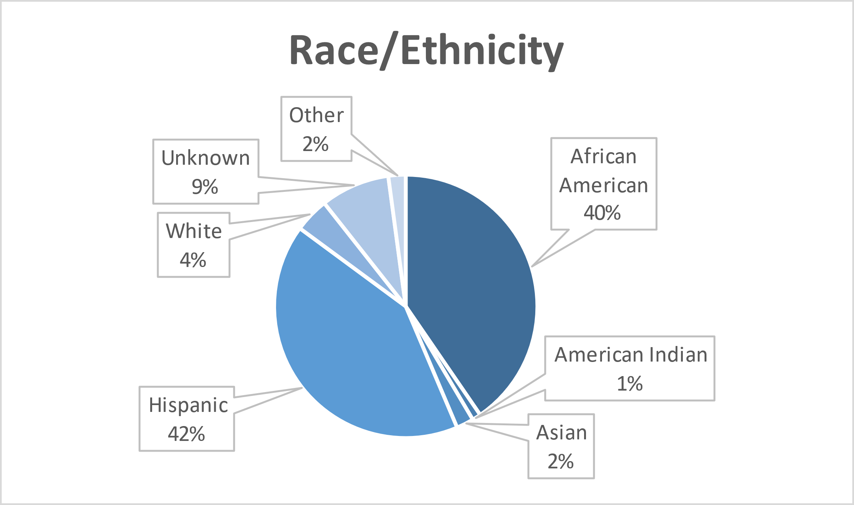
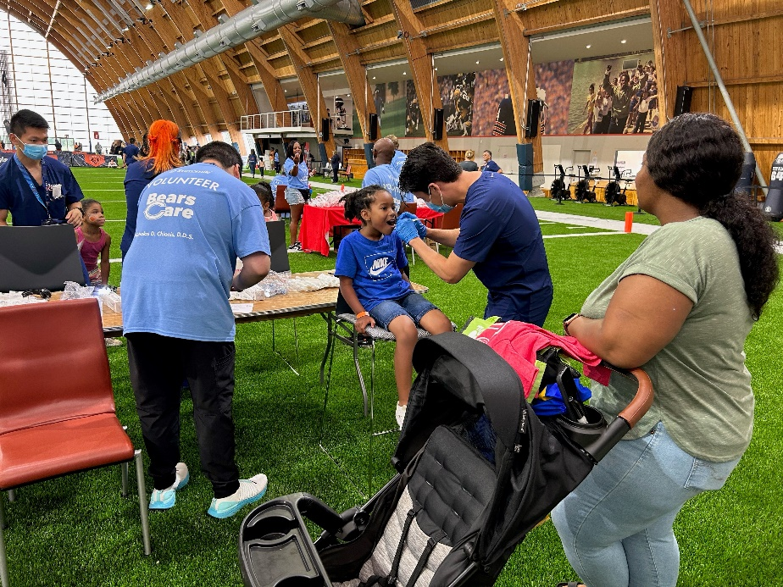
Volunteers
Thank you to our volunteers for your time and talents.
Dentists | 8 | 7
Hygienists | 5 | 5
Dental Assistants | 4 | 4
Students | 3 | 2
General Volunteers | 16 | 15
Total Volunteers | 36 | 33

Signed up Attended
92% Of the volunteers that signed up through our website attended the event.

Services

Total Value: $22,871
Dental Services: $18,641
Screenings | 94
Silver diamine fluoride | 9
Cleanings | 86
Education | 94
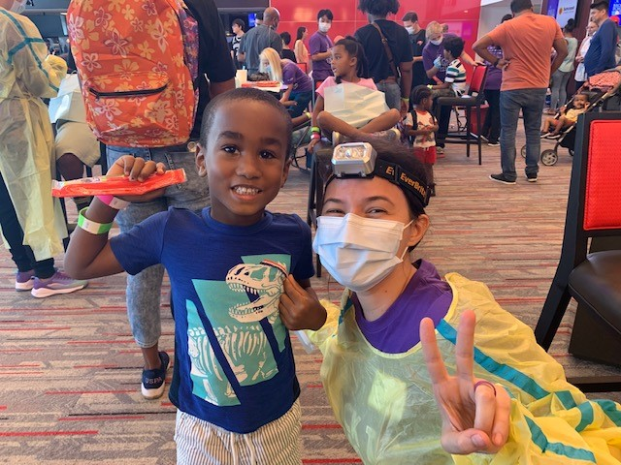
Education: $4,230

