Milwaukee Brewers
June 30, 2022
Location of Dental Clinic: American Family Field
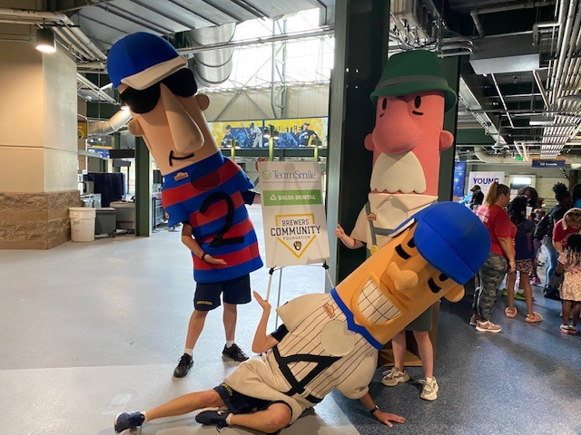
Boys and Girls Club and COA Family Youth Centers
286 Children Served
286 Children Education with Colgate

Total Preventative Care & Education Provided $128,853
Average Dental Care & Oral Health Education per patient visiting Program $375.53
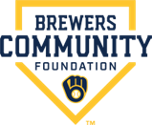
Sponsored by:
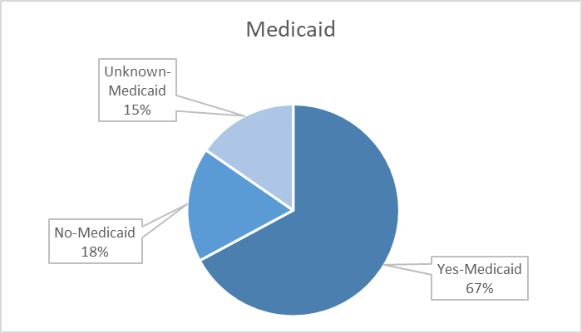
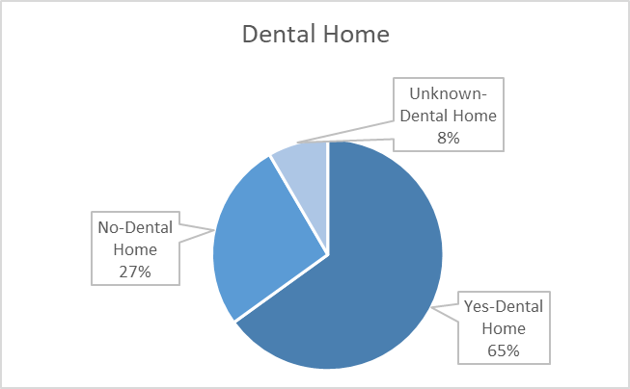
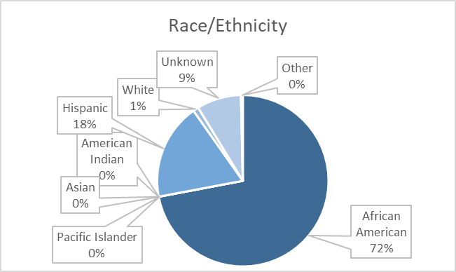
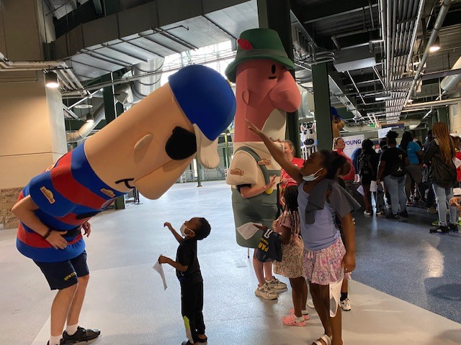
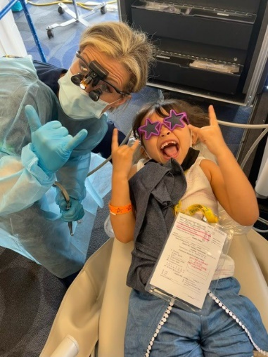
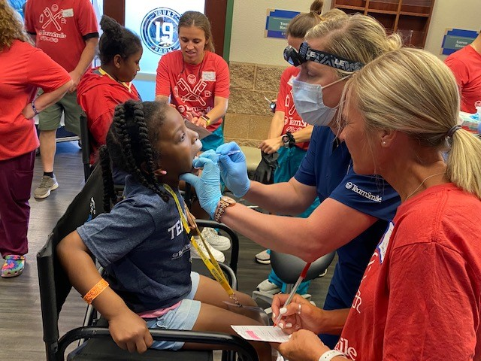
Volunteers
Thank you to our volunteers for your time and talents.
Thank you our lead Dentist Dr.Frady.
Dentists | 16 | 14
Hygienists | 13 | 12
Dental Assistants | 28 | 23
Dental School Students | 26 | 22
General Volunteers | 66 | 51
Total Volunteers | 149 | 122

Signed up Attended
82% Of the volunteers that signed up through our website attended the event.
Screenings | 286
X-Rays | 198
Prophy Cleanings | 254
Fluoride Varnish | 284
Sealants | 352
Fillings | 48
Extractions | 26
Pulpotomies | 3
Silver diamine fluoride | 52
Crowns | 4
Oral Health Education | 286

Services

Total Value: $128, 853
Dental Services: $107,403
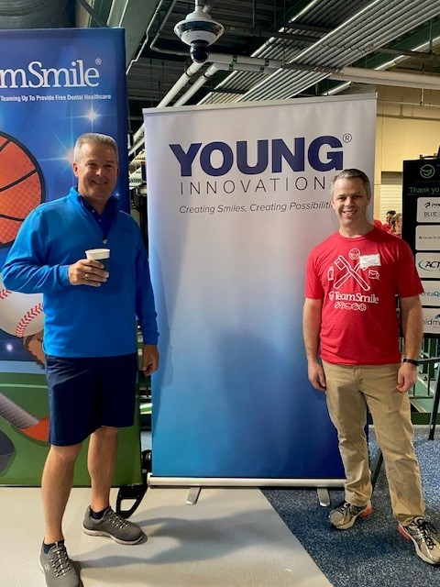
Education: $21, 450

