Arizona Coyotes

Tucson Roadrunners

Phase II Plus

March 24 & 25, 2022

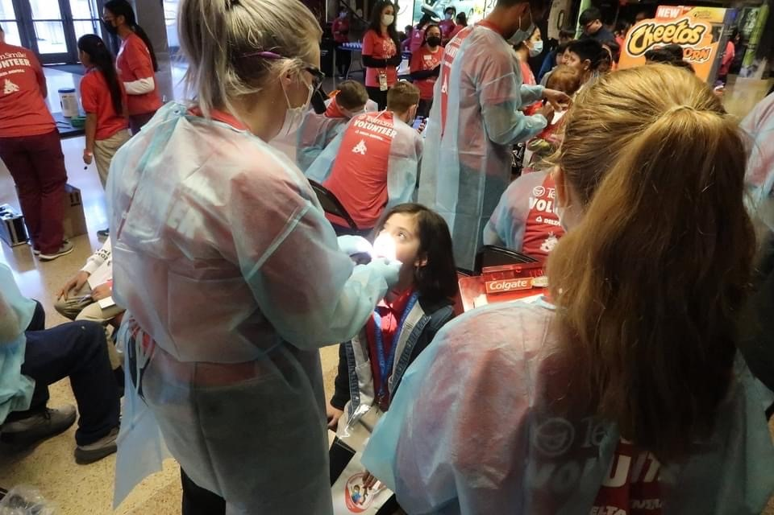

Phoenix Advantage Charter School
63 Kids

Appola Middle School
39 Kids

Doolen Middle School
47 Kids

Total Preventative Care & Education Provided $15, 182.

Average Dental Care & Oral Health Education per patient visiting clinic $370

Total Preventative Care & Education Provided $44,041
Average Dental Care & Oral Health Education per patient visiting Program $370

Sponsored by:

PATIENT DATA

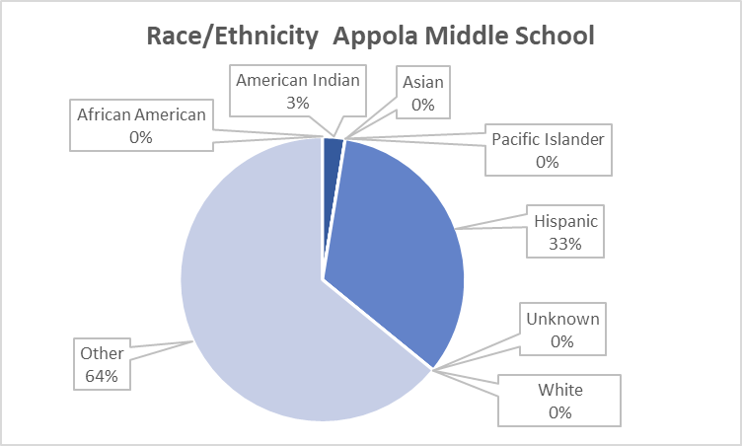
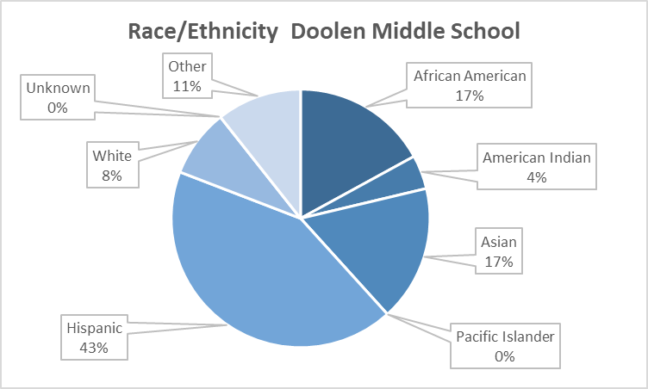
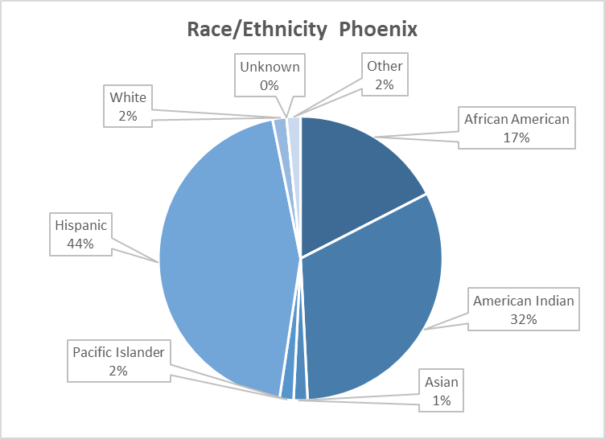

PATIENT DATA

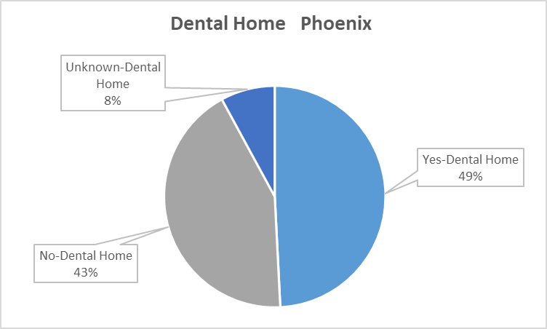
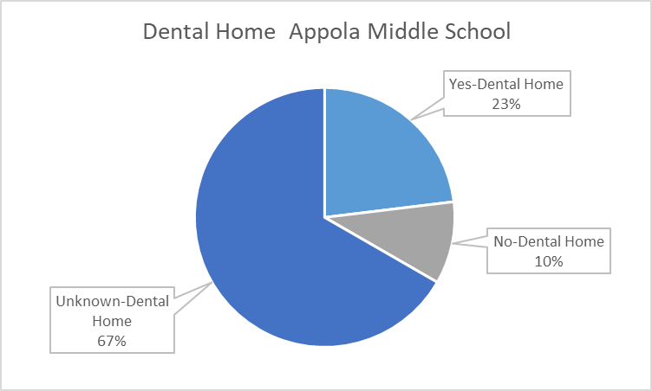
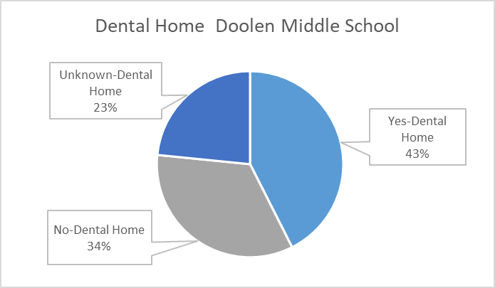

Total combined treatment

Screenings | 149
Fluoride Varnish | 149
Prophy Cleanings | 91
Silver Diamine Fluoride | 252
Oral Health Education | 149

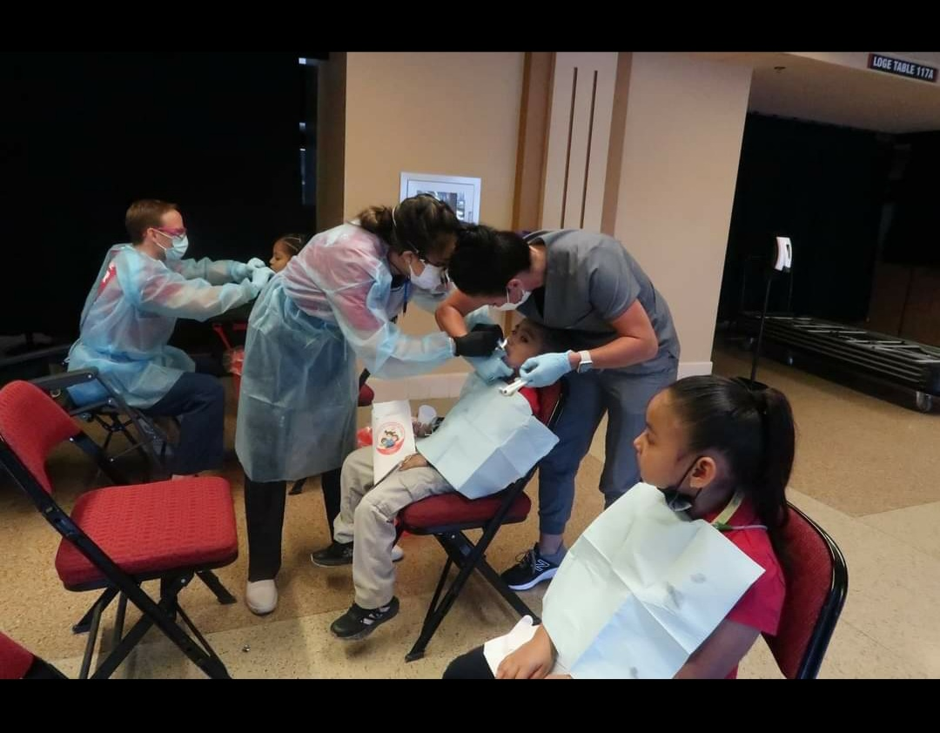

Our Volunteers

Volunteers Signed up Attended
Dentist | 5 | 3
Hygienists | 2 | 2
Dental Assistants | 5 | 3
General Volunteers | 16 | 16
Total Volunteers | 70 | 60

90%
Of the volunteers that signed up through our website attended the event.
Thank you to all our volunteers’ who gave their time and talent.

