TeamSmile
Operations Manual

Patient Examination Area

Purpose: This area is the heart of the TeamSmile program, as all patients flow through this area. Dental Professionals provide an initial visual screening for each patient to determine baseline oral health and possible dental treatment and hygiene needs. The patient is then directed to the appropriate areas for care.

Volunteers Required: 10-12
4 Dentist
4 Dental Assistants
General Volunteers
1-2 Receivers
1-2 Runners

Patient Examination Area Inventory
Located in Patient Examination Crate Item Location
Clipboards (6) | Patient Examination Crate
Design for Vision Glasses (3) | Patient Examination Crate
Instruction Card with Sample Patient Card (6) | On Clipboard
Masks (1) | Patient Examination Crate
Mirrors (disposable) – 10 boxes of 72 | Patient Examination Crate
I Paks which contains explorers/props | Patient Examination Crate
Blue Tape | Blue Plastic Container (in PE Crate*)
Pin Lights (3) | Blue Plastic Container (in PE Crate*)
Disposable Shields for Pin Lights (1) | Blue Plastic Container (in PE Crate*)
Glasses (6) | Blue Plastic Container (in PE Crate*)
Headlights (6) & Handheld Flashlights (2) | Blue Plastic Container (in PE Crate*)
Red Ink Pens (10) | Blue Plastic Container (in PE Crate*)
Stamps (6) | Blue Plastic Container (in PE Crate*)

Additional Inventory Item Location
Gloves | PPE Area
Face Shields | PPE Area
Gowns | PPE Area
Hand Sanitizer (2) | Central Distribution
Disinfectant Wipes (1) | Sterilization Area
Sharps Container (1) | Sterilization Area
*PE = Patient Examination *PPE= Personal Protection Equipment

Patient Examination Area Setup
Locate the Director Chair Crate
Director Chairs (4)
- Cover crate with a sponsor tablecloth found in the Purple Suitcase.
- Set Up: 4 Stations – 1 Station on each of the corners of the crate - but note: this also depends on the number of dentists registered
- Each station consists of the following:
  - Clipboard
Place the following items on top of the Clipboard
- Instruction Card and Sample Patient Card
  - Headlight
  - Red Ink Pen
  - Stamp
  - Glasses
- Set in the middle of the table
- Hand Sanitizer
- Masks
- Mirrors – 5 boxes
- I Pak Box which contain explorers and probes– 1 Box
- Disinfectant Wipes
- Pin Lights & Disposable Shields
- Sharps Container
Leave the Design for Vision and extra mirrors inside of the Patient Examination Crate

Set Up – See Diagram
- Director chairs near the table yet face away table.
- Place 2 trash cans intermittently between chairs.
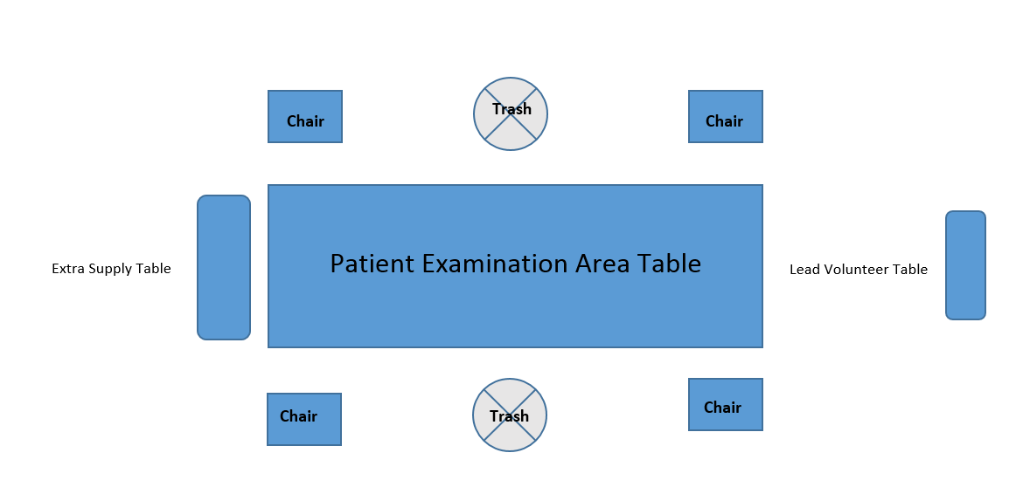

Patient Examination Area Procedures -Volunteer Descriptions

Personal Protection Equipment Requirement for Dentists
- Mask and Eye Protection should always be worn
- Gloves required and changed between each patient
- Since low risk of coming in direct contact with patient or blood borne pathogens, gowns are not required BUT recommended

Dentists will:
Screen Patient, below is how treatment is prioritized:
- Teeth that hurt patient
- Removal of infected, painful, or non-restorable teeth
- Basic restoration of permanent teeth
- Basic restoration of primary teeth
- Sealants and/or SDF

- Determine if the patient is in any pain.
- Check for treatment consent
- Red wristband – means STOP – no consent for treatment, NO screenings
- Orange wristband –means CAUTION – consent for certain procedures – please look at the consent area of patient card and see what is highlighted. Highlighted items cannot be performed and should not be listed.
- Green wristband – means GO - consent for ALL dental procedures and preventative care procedures
- Fill out Patient Exam Card in RED INK as indicated below:

Filling out Patient Exam Card
Each red clipboard has information sheets walking you through the card with a tooth chart on the backside which includes primary and permanent dentition. All treatment needs are recorded regardless of consent (green bands only)
- #1 Clinical Findings - Circle the Yes or No next to each category-
  - Treated Decay: Has the patient ever had any restorative care, including extractions.
  - Sealants: Does the patient have a sealant or partial sealant present in their mouth?
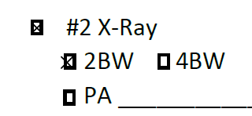
  - #2 X-Ray: X-rays should be taken on any patient with suspected decay with consent for treatment (orange and green band only)
√
- 2 BW if only 1st molars are present
√
- 4 BW if 2nd molars are present
- PA’s if extractions or possible Pulpotomy/Root Canal

  - #3 Tentative Restorative Needs: Treatment that needs to be completed to eradicate the dental need present in the patient’s mouth
- Write down treatment needs by quadrant - even if patient does not have permission for restorative needs. This information will be used on referral project.
- List the tooth number / letter and surface(s) in question ONLY IF THE PATIENT HAS CONSENT FOR TREATMENT (green band).
Possible treatment could include:
- Stainless Steel Crown
- Extraction
- Composite Resin / Glass Ionomer
- Pulpotomy / Root Canal
- Sealants
- SDF/SMART Restoration

- If there is ONLY consent for preventative care, LIST THE TOOTH NUMBER / LETTER – do not list the surfaces of the tooth – orange band.
- List all dental needs present for each quadrant
- ONLY MARK RESTORATIVE NEED BOX IF CONSENT IS CIRCLED “YES” ON THE PATIENT CARD – THIS CAN BE FOUND UNDER THE PATIENT NAME
√

  - #4 Sonic Scaler: If a patient has visible calculus or excessive bleeding/gingivitis
√

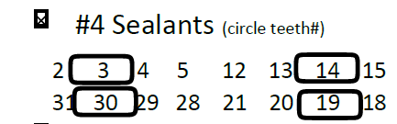
  - #4 Sealants: If a patient has a fully erupted decay free permanent tooth, a sealant may be recommended.
√
- Circle all teeth that qualify

  - #5 Polish & Fluoride: All patients should stop at this station
√
If the patient has no obvious decay and they are only going to polishing station, place a stamp over the quadrant lines on the right side of the card.
THE SCREENING DENTIST NAME MUST BE PRINTED IN THE PATIENT EXAMINATION SECTION OF THE CARD
Additional Instructions
- Disposable shields must be used when using the pin lights.
- Mirrors can be given to the patient but DO NOT give them the explorer/probe.
- Doctors MUST change gloves between each patient

Personal Protective Equipment requirements for Dental Assistants and General Volunteers: Mask

Dental assistants or General volunteers will:
- Provide the dentist with necessary supplies.
- Fill out the patient card with red ink pen for the dentist.
- Place the stamp on the patient over the quadrant section if no decay or treatment is needed.
- Make sure the dentist’s name is on the card.
- Take patient to the runner.
- At the end of the day, make sure all supplies are wiped down with disinfectant wipes and placed back in the appropriate container. See Tear Down Instructions.

Personal Protective Equipment required for Receivers/Runners: Mask

General Volunteers will:
Receiver (2) will receive the patient from the Front Desk Area and place in line*
- Receiver’s goal is to keep all director chairs filled to keep area flowing.
- *Place line on floor with tape to give enough space for patient privacy and to prevent crowding.
- If waiting time starts to get too long, utilize the “Head” guessing game.

Runner (2) will escort the patient to the next waiting station’s check-in table either Preventative Care/ Sealants or X-Ray.

.

Patient Examination Area Inventory
Disposable Shields for Pin Lights | ½ full ¼ full box is empty
Mirrors | Boxes 1 2 3 4 5 6
Headlights (6) | Headlights 1 2 3 4 5 6
Red Ink Pens (10) | Left______
Stamps | Need more ink

Patient Examination Area Tear-down
- Use Disinfectant wipes on all ink pens, headlights, pin lights, laminated instruction cards/sample patient card and clip boards prior to putting these items away in the Patient Examination Crate.
- Return Patient Examination inventory items and additional inventory items back to their original locations per the Inventory Checklist. (See inventory section)
- Close hand sanitizer bottles by turning pump to the counterclockwise then return to Central Distribution
- Combine gloves, by size, in boxes prior to returning to PPE Area.
- Please pick up any trash found on the floor to make area look clean.
- Return Sharps container to Sterilization Area
- Once all items are off the Director Chair/Signage Crate, place the collapsed director chairs inside. Alternate the tops and the bottoms to make the pile level. Chairs much be pushed as far to one side as possible to allow for the banners (2 rows of 6) to be placed upright at the end.

IMPORTANT: Always wear gloves when handling disinfectant wipes. Gloves are in the PPE Area.

