Indiana Pacers

May 14, 2021

May 15, 2021

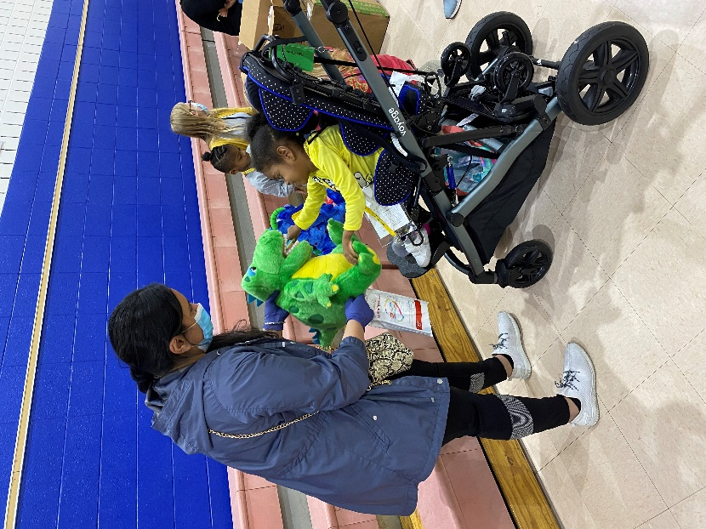

Ignite Achievement Academy

Participated in Event: 141

Total Care & Education Provided $23,089

Average Dental Care & Oral Health Education per patient visiting clinic $194

# PATIENT DATA

Sealants Present

34%

16%

Treated Decay

Untreated Decay

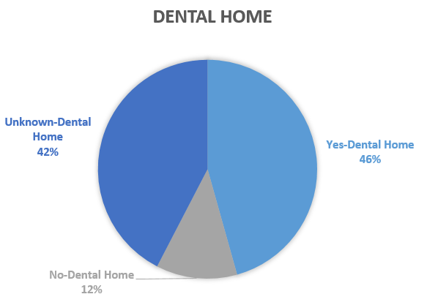

|  |  |  |
| --- | --- | --- |
| Screened | 119 | $9,639 |
| Fluoride Varnish | 85 | $3,910 |
| Silver Diamine Fluoride | 71 | $3,195 |
| Oral Health Education | 141 | $6,345 |
| Total Dollar Amount |  | $23,089 |

