TeamSmile
Operations Manual

Check-In Area

Purpose: To review each patient’s registration and health history form to ensure the form has been completed correctly and then use this information to create a Patient Card. From this point on, each patient must have an accurate Patient Card accompanying him/her throughout the clinic.

Total Volunteers Needed:
1 Lead TeamSmile “Point of Contact”
1 Health Professional
7 Desk Volunteers
15 General Volunteers

Check-in Area Inventory  Items located in Registration Crate | Item Location: Black Bins (2)
Chaperon Buttons | Bin 1
Photo Buttons | Bin 1
Translator Buttons | Bin 1
Clock, Power Cord, Scissors, Tissue | Bin 1
Pens, TeamSmile Pens, Markers, Highlighters | Bin 1
Registration Forms (English & Spanish) | Bin 1
Video Player | Bin 1
Lanyards | Bin 2
Patient Cards | Bin 2
Wristbands – 4 Containers | Registration Crate
Mint Container | Registration Crate
White Plastic Table Cloth | Registration Crate
Additional Inventory | Item Location
Computers (2) and Cords | Computer Crate
Hand Sanitizer | Central Distribution
Server and Router | Computer Crate
Patient T-Shirts | Black with yellow lid containers (8)
Tablecloth (Blue with TeamSmile Logo) | Program Bin

Check-in Area Setup (Refer to diagram below.)
8-foot Tables (3)
- Flow: Entrance → Check In → Patient Examination
- Table Setup: Refer to “Check-in Area” diagram.
- Cover tables with TeamSmile tablecloth or white, plastic table cover if needed.
- Take out the 4 “Stop” signs and place on the tables. (See Check-in Setup Photo).

Check-in Area Setup Diagram
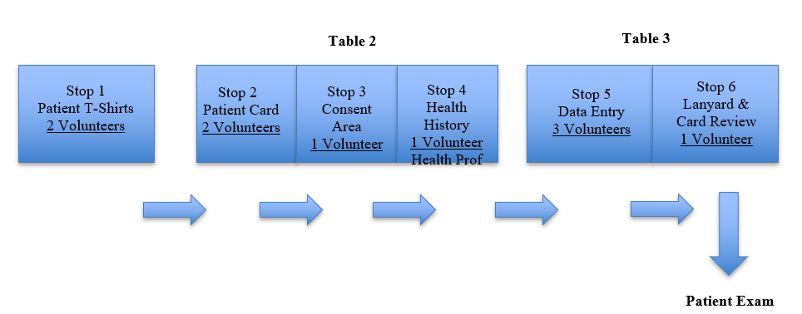

Stop One
T-shirts
- Put the plastic containers in order from Youth S through Adult XL

Table: Check-in
Stop Two
- TeamSmile tablecloth – place on table
- Tissue
- Hand Sanitizer
- TeamSmile Ink Pens and Black Markers
- Registration Forms (English & Spanish)
- Patient Cards
- Clock
- Extra Wrist Bands

Stop Three
- Pens & Yellow Highlighters
Stop Four
- Pens & Yellow Highlighters

Table Three: Computer Data Entry
- Computers (2) marked “Check-in” and “Server” with Router
- File folder for completed Registration Forms - file alphabetically by last name.
- Data Entry Instruction Sheet titled “Important Computer Information”
- Pens
- Lanyards

Check-in Area Procedures

- Group Patient Arrival Procedures
Staff: Lead TeamSmile “Point of Contact”.
General Volunteers: 1 Lead Volunteer & 3-4 general volunteers to help

3 Lead Chaperone Volunteers
- Gather patients into 3 groups (50 max per group) with one chaperone per group - patients will be divided as instructed by Lead TeamSmile Director.
- Chaperones will escort patients to the following areas and should stay with their group.
- Dental Clinic – Patients should be in possession of their registration forms.
- Nutritional Education Area - Chaperones should be in possession of the registration forms.
- Physical Fitness Area - Chaperones should be in possession of the registration forms.
- Other (DJ, Face Painting, Special Activity, etc.) – Waiting Area for after the patients are finished with dental clinic.

**On the registration form, if the box associated with the photo release is not checked, the school is responsible for identifying those patients prior to allowing them to participate in the program. The patient would then receive a yellow tooth button to wear on his or her shirt that indicates no photos should be taken.

B. Dental Clinic Check-in Procedures
Check-in Desk
Each patient should be in possession of his/her own completed registration form BEFORE coming to Check-in Area. No patient can enter this area without a completed and signed registration form – NO EXCEPTIONS. If a patient does arrive at program without a registration form, he or she can only participate in the education and physical fitness areas.
Prior to entering the clinic, a Lead Volunteer will review the registration form and instruct the General Volunteers to band the children accordingly:
Red – no consent – these children need to be escorted to DJ area
Green – consent for hygiene only
Orange – consent for dental treatment
If the area is left blank, please treat this as a “no” for services

Stop 1 – T-shirts Area (2 Volunteers)
- Distribute one TeamSmile T-shirt to each patient.
Stop 2 – Table 2: Patient Registration (2 Volunteers)
- Collect each patient’s consent form upon check-in and make sure it is COMPLETELY filled out and SIGNED.
- On Patient Card, fill in patient’s first name, last name, and age.
- Time stamp the Patient Card.
- If a patient’s Registration Form is missing a parent signature or the health history information is not filled out, the patients’ group leader needs to call that parent at Check-in before proceeding to the next Stop.

Stop 3 – Table 2: Patient Consent (1 Volunteer)
- Check consent area of consent form.
- If a box is not marked, note this on consent area of Patient Card and check to make sure the child has the correct wrist band.
- If no consent for treatment, highlight the lines on the Patient Card.
- Circle indicated response on the Patient Card.
Stop 4 – Table 2: Patient Health History Review (1 Health Professional Volunteer)
- A health professional reviews patient’s health history, which is on the back of the registration form, and notes pertinent “health concerns” on Patient Card and then highlights the concerns in YELLOW or marks “N/A” if there are no health concerns. Mark this in both “Allergies “ and “Medical History”. The health professional then signs the Patient Card.

Stop 5
Computer Data Entry Desk
Table 3 (3 Volunteers), 3 Stations – Login: TeamSmile1
1. Enter patient information from registration form into Dentrix System, per the laminated card instructions.
2. Once patient’s information is entered, a chart # will be assigned, place this chart # on the Patient Card.
3. File registration forms in file folder, by patient’s last name, and in alphabetical order.
- After the general announcements, TeamSmile staff will walk volunteers through the Front Desk Check-in Procedures.
Stop 6
- Volunteer reviews the Photo Area of the Registration Form and places a yellow tooth button on the patient where this area is not filled out.
- Place the Patient Card in the lanyard

Chaperones
- Guide patient to Patient Examination.

Check-in Area Tear-down
Return Check-in Area inventory items back to bins 1 & 2 and areas of storage per the Inventory Checklist.

Special Instruction Items
- T-shirts: pile up the rubbermaids.
- Computers: shut down completely and return to computer crate with instruction sheet. Put file folder in program bin. DO NOT SHUT DOWN THE SERVER!!
- Place the TeamSmile tablecloth in program box
- The patient registration file folder take to Check-Out.
- Sanitize all ink pens, markers, lanyards and clear plastic holders prior to putting these items away. Sanitation Wipes can be found at Central Distribution Area.
- Lock hand sanitizer lids in place by pushing down and turning clockwise to prevent spilling.

IMPORTANT: Always wear gloves when handling Sanitization Wipes.

