Dental Workstation Inventory
Air/Water Syringe*
Bib Clip
Bibs - patient*
Disinfectant Wipes*
Chair Covers*
Composite Gun
Cotton Gauze 2x2*
Cotton Rolls*
Cotton Tip Applicators*
Dri-Angles*
EZ Props*
Floss*
Glasses – Kids – can be given to kids
Glasses – Kids
HVE Tips*
Masks*
Needles – Long & Shorts*
Rubbing Alcohol
Saliva Ejectors*
Tongue Depressors*

Items marked with (*) are DISPOSABLE or SINGLE USE and SHOULD NOT be used again.

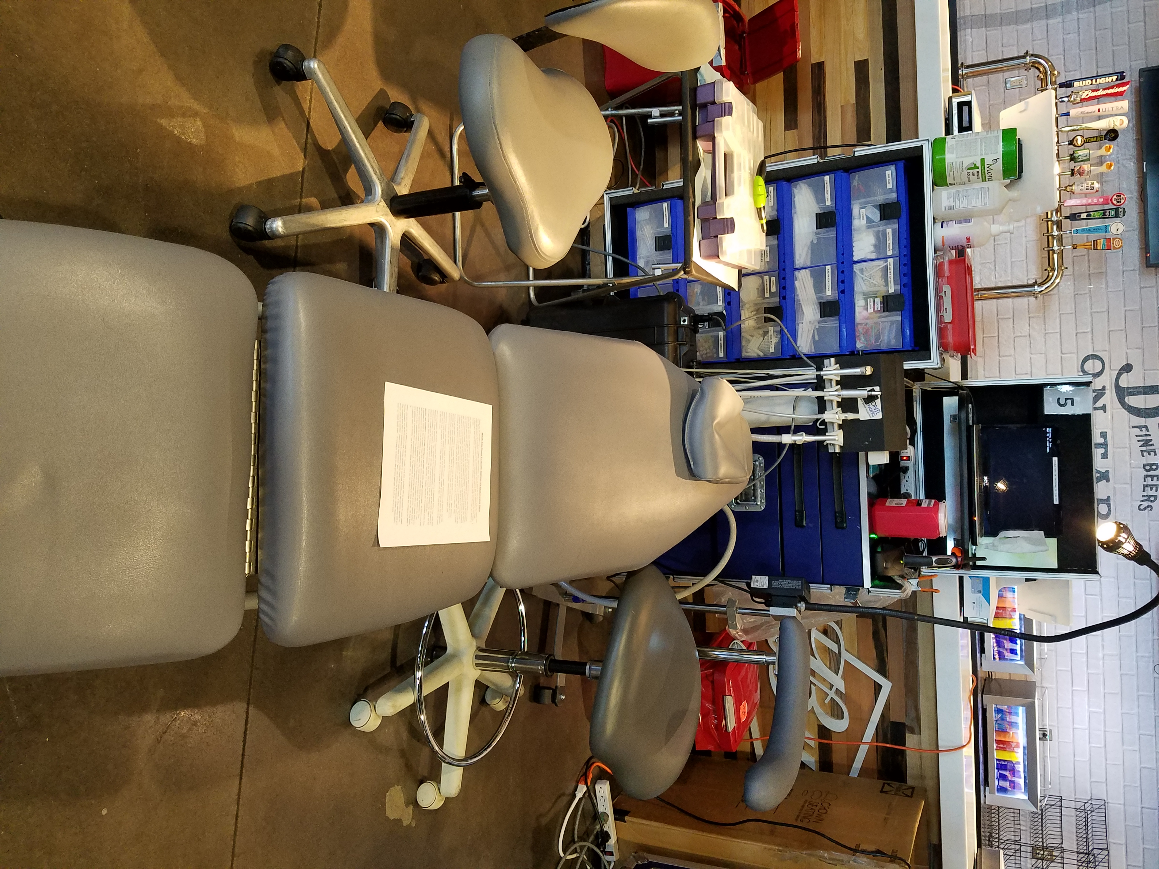
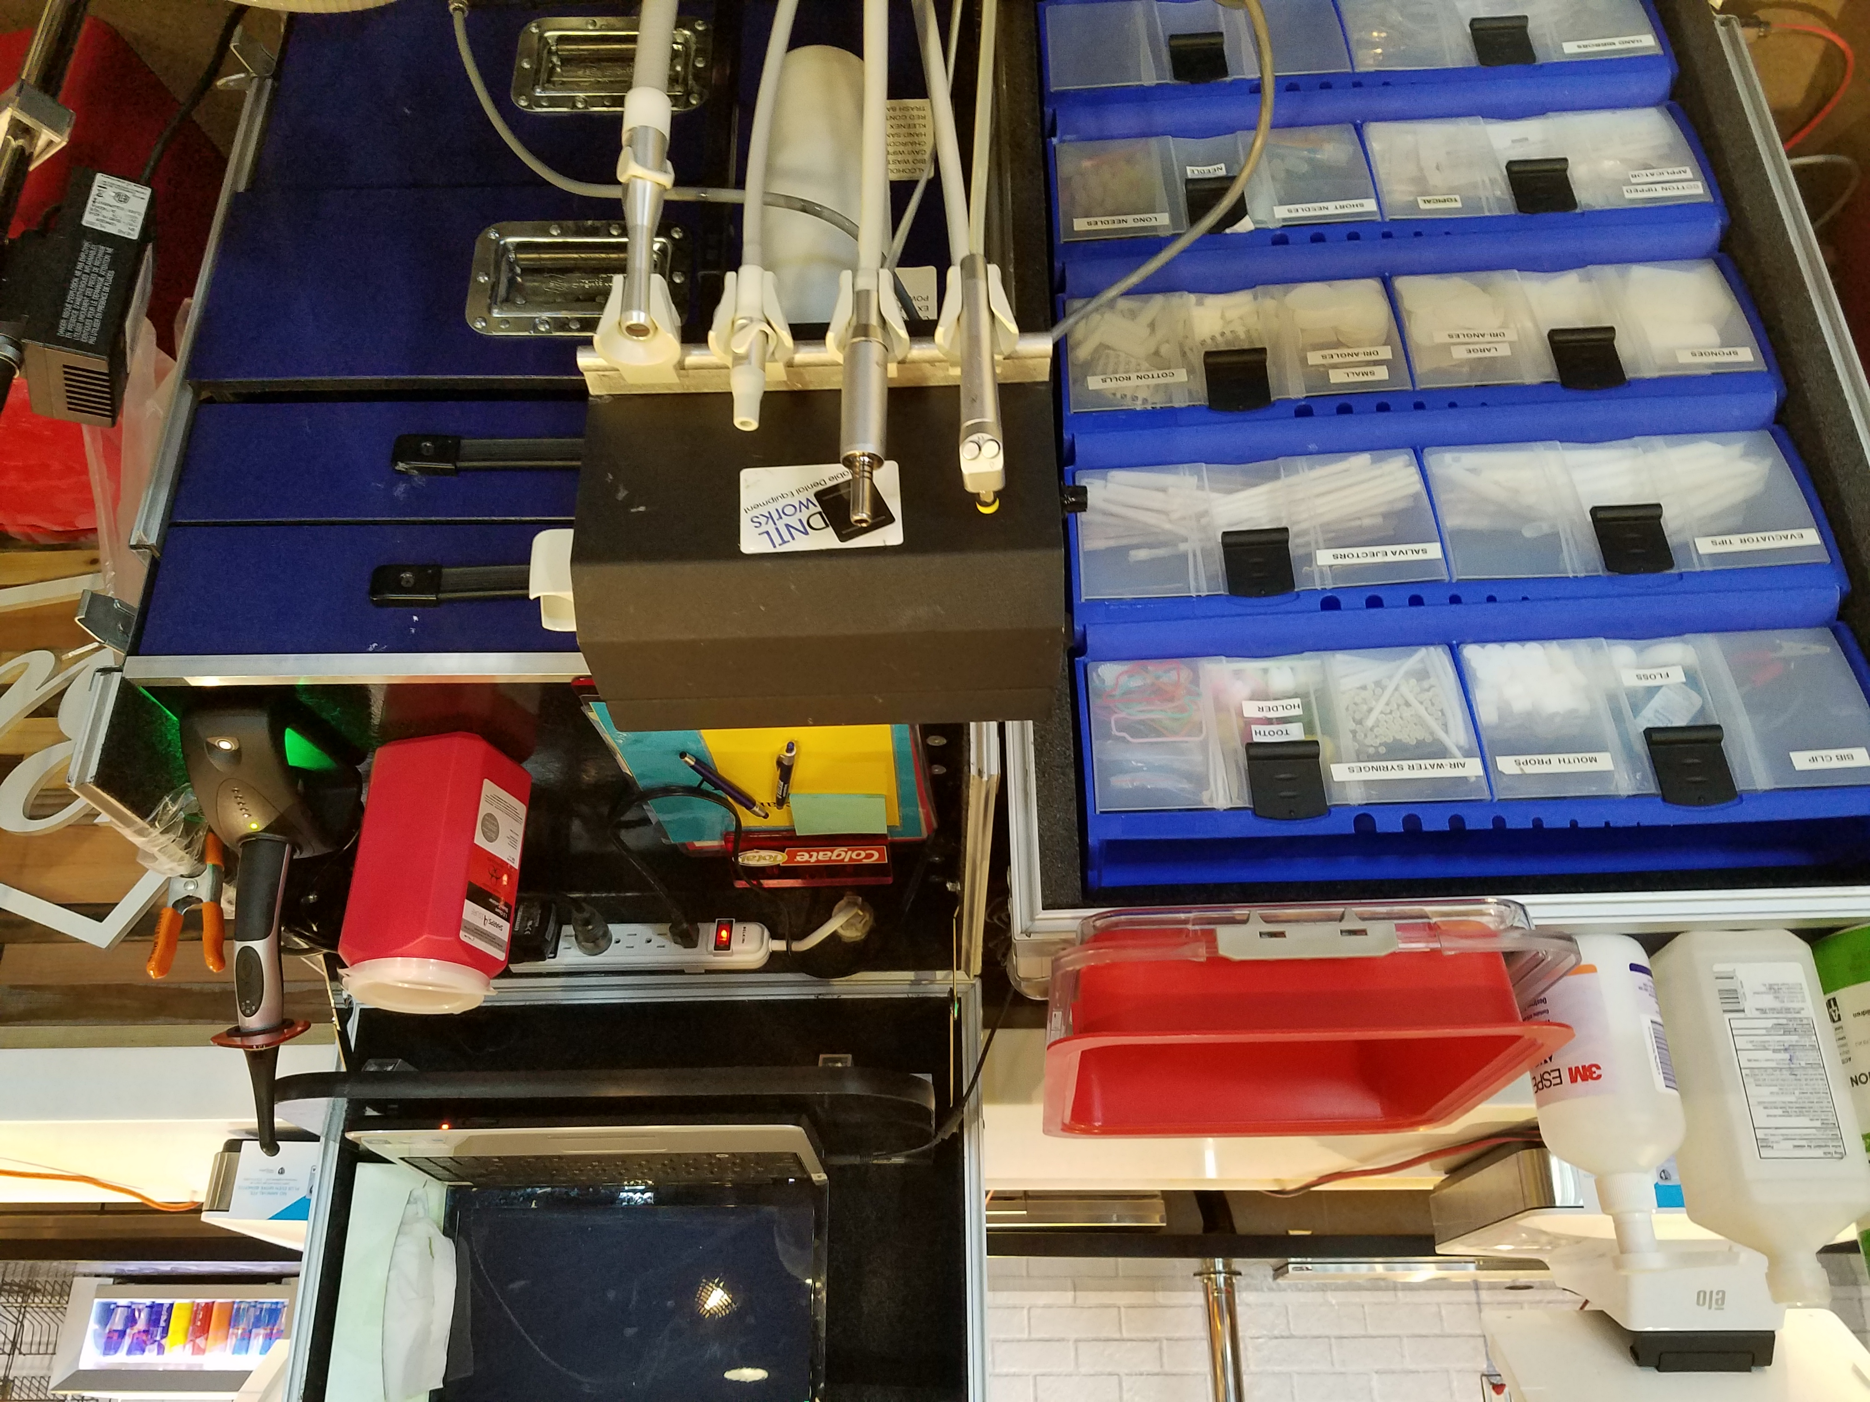

Dental Operatory Area Patient Procedures
IMPORTANT
All surfaces of the Dental Workstations must be disinfected with disinfectant wipes prior to the first patient of the program because workstations were left unattended overnight.
- When ready for a new patient hold up the green laminated READY card.
- Greet your patient and take out the patient card found in the lanyard to review patient consent at the top of the patient card, the recommended highlighted treatment and sealants needed under “Station 1”.
- View patient’s x-rays on either the printed sheet found in lanyard that will be sent home with patient or on the computer. These are the same films. To pull up the films on the computer, pull up the patient chart in Dexis. Click File, Select Patient, and type in Patient’s chart number located in the upper right corner of the patient card. Once the chart is pulled up then double click the small tooth icon located on desktop to open the linked chart in Sopro Imaging. Please reference the “X-ray” PDF located on your desktop if you are having trouble.
- Examine the patient and determine treatment to be provided, including sealants. (20-30 minutes is the allotted treatment time)
- Dental assistant /runner may gather instruments, burs, anesthetic, SDF kits and any dental materials not found in the composite kit or Dental Operatory Area from the Central Distribution Area – see list of items on page 7.
- Dental assistant/runner must transfer necessary items on a COVERED PLASTIC TRAY from Central Distribution.
- When treatment is complete, DOCTOR MUST FILL OUT STATION #3, STATION #4 (IF SEALANTS WERE COMPLETED) AND If FOLLOW UP TREATMENT IS NEEDED ON THE BACK OF THE PATIENT CARD AND PRINT DR’S NAME ON BACK OF CARD. Place patient card and x-ray papers back in lanyard, and then hold up the STATION #5 card so that a volunteer will know to collect the patient. If all escorts are occupied, please feel free to take the patient to the Preventative Care Area Station #5

Between Patients
- Sterilize all surfaces with disinfectant wipes between patients.
- Utilize the chair covers provided (located in Drawer 4 of the Dental workstation) OR you must disinfect the patient chair twice prior to each new patient using two different disinfectant wipes.
- Dispose of all non-reusable burs and sharps in the sharps container found at your workstation.
- Dispose of materials that are blood-soaked in the Bio Waste bag found at your workstation.
- Dispose of trash in trash bag attached by the orange clip found at your workstation.
- Remove and dispose of all disposable items on delivery system in the trash bag found at your workstation.
- Take dental instruments, syringes, hand pieces and tray to Sterilization Area in the RED bin provided. MUST LOCK RED BIN PRIOR TO TRANSPORTING TO STERILIZATION AREA. After you have dropped off the instruments, please bring back your sanitized Red Bin.
- Place a new bib on the side table.

IMPORTANT
Gloves must be worn when handling disinfectant wipes.

Central Distribution Additional Items:
- Silver Diamine Fluoride Kits
- Amalgamators
- Endo Supplies / Apex Locator
- Anesthetic
Lignospan 1:100,000
Scandonest HCI 3%
Septocaine 1:100,000
Septocaine 1:200,000

- Dental Material
Activa BioActive Product Line | OptiBond All-in-One
Alvogyl | OptiBond Solo Plus
Calcium Hydroxide | Ketac-cem
ChlorCid | Retreat Clear Hemostatic Gel
Consepsis | Rubber Dam
Desensitizer | Sealant
Dry Socket Paste | Viscostat
Durelon Cement | Vitrebond
EDTA | Zoe B
EndoRez | Composite
Etch | A1
ExcITE bonding | A2
Fuji I Glass Ionomer | A3
Fuji II | B1
Fuji IX | Flowable
Fuji Triage | A1
Gel Foam | A2
Hemo-stat solution | Opaque
IRM
IRM- Capsules

Dental Operatory Area Tear-down
Clean Up:
After your last patient - Properly sterilize your entire workstation with disinfectant wipes:
- PPE glasses, mirror
- Laminated Signs
- Curing Light, charging workstation and power cable
- Doctor Chair
- Light
- Patient Chair
- Assistant Chair
- Side Table
- Delivery System – Wipe all surfaces including tube lines. Techs will break down the system.

Return the Following Items to their labeled drawer inside Dental Workstation:
  - Drawer 1 – PPE glasses
  - Drawer 2 – Laminated Signs, Post-it notepad and pen
  - Drawer 3 –
Take the composite kit to central distribution then put away curing light.
Unplug the power cord from behind the dental workstation. Place the power strip in drawer.
- Drawer 4 –
Take trash bag, bio trashcan and Sharps container to Central Distribution.
Close hand sanitizer by pushing the pump down and turning to lock it in place.
Put away orange clip, disinfectant wipes, hand sanitizer, hydrogen peroxide, tissue box and red bin.
Additional Items
- Take any extra material and instruments including the topical to Central Distribution. Check all the drawers to be sure all materials and instruments are accounted and found. Don’t forget to take all personal items.

- Combine glove boxes and take to PPE area. Dispose of your apron at your workstation.

- Computer – Close all open Dentrix and Sopro windows then properly shutdown the system. Click on the “Start” button on the bottom left of the screen then select “Shutdown”. Wait for the laptop to turn off. Unplug the laptop then take it and the power cord to the computer case. Place the laptop vertically in a slot and place the power cord in the bin behind the slots.

- Unlock the Dental Workstation door wheel then close it. Fold the bottom tray up and secure it with the velcro straps then close the top and lock the workstation.

- Place the black cover over the Dental Workstation. Make sure the handles line up with the openings on both sides of the cover.

- Check around your workstation for trash, material or instruments

IMPORTANT - Please check out with Program Director prior to leaving for the day.

